Python Book

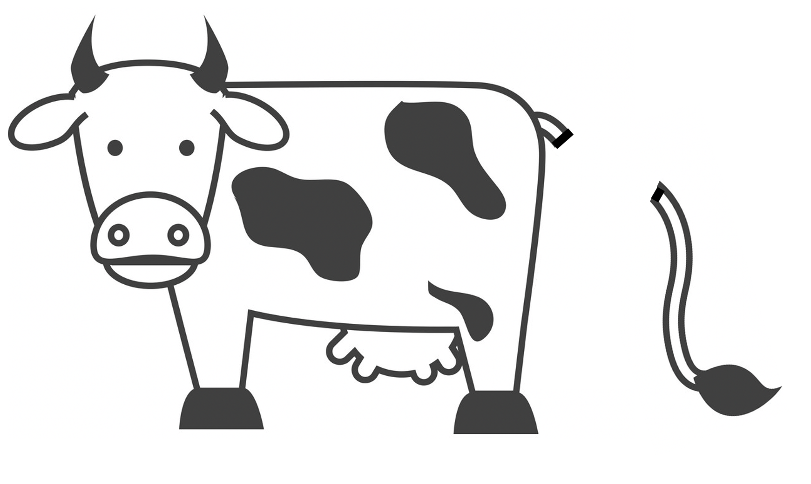



The IT industry is booming with Data science applications using,

* Artificial intelligence,
* Deep learning and
* Machine learning algorithms.

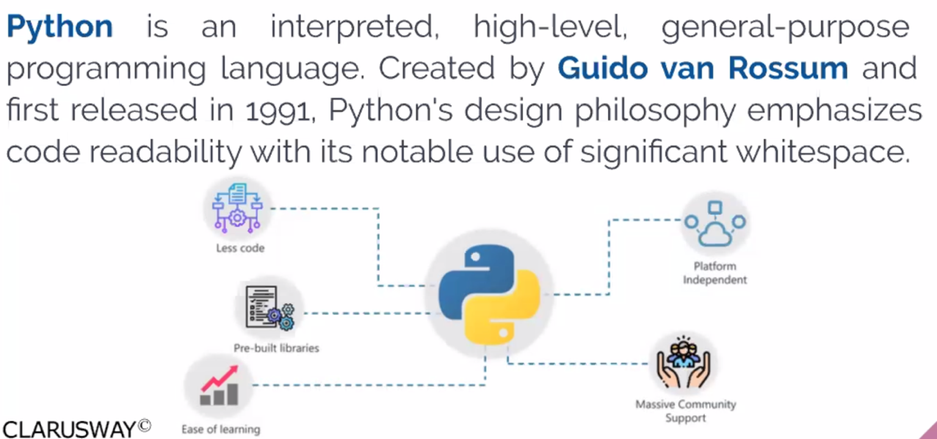

Python is the most widely used technologies in this domain. With the new-age applications, demand for a Python developer has also increased.

According to the [Google search trends](https://trends.google.com/trends/explore?q=%2Fm%2F05z1_,%2Fm%2F07sbkfb,%2Fm%2F02p97,%2Fm%2F0jgqg" \t "_blank), in 2019, Python is the most popular searched term, among all programming languages.

According to Tiobe.com's index of programming languages, Python is the fastest-growing language.

Programs can be developed very quickly with this language. In addition, the simple and clean syntax of the Python programming language has made it a preferred language by many programmers. It's easy to write programs and read a program written by others. So, it has been widely used - especially in Data Science - and has received lots of demands in recent years.

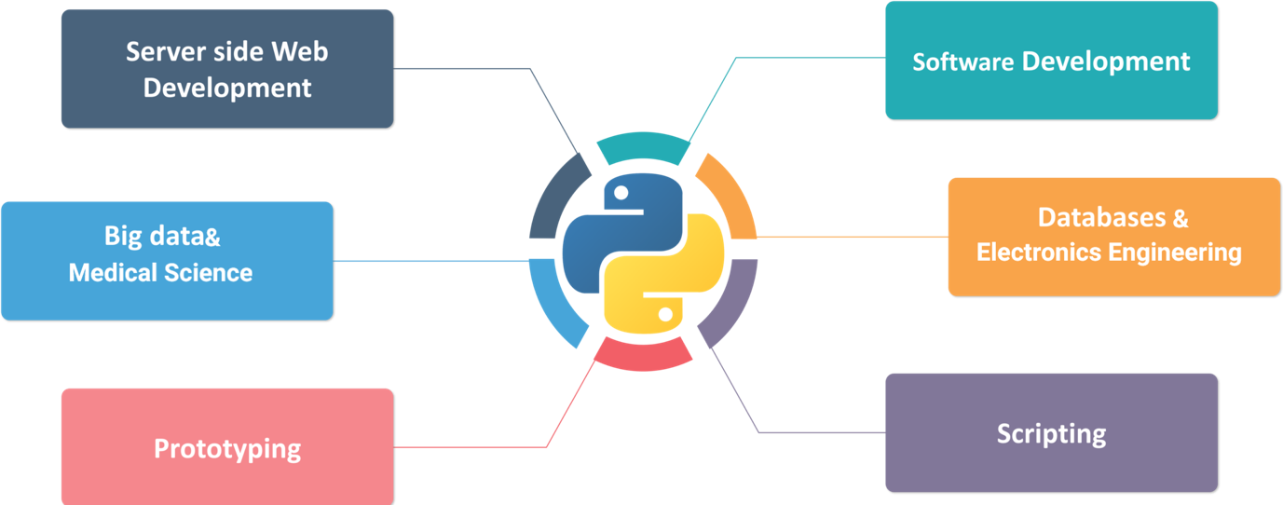

**Q**: What is Python?  
**A**: Python is a programming language. It allows you to control the computer. The benefits of Pythons are that it is simple and easy, portable, extensible.

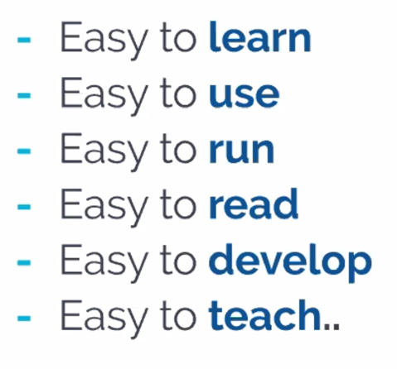

## General Information about Python

Agility is the hallmark of our times and Python is the programming language of the agile era. The Python universal programming language is the turbocharger of the IT department. Compared with other modern programming languages such as Java or C, Python achieves superior results in significantly shorter timescales for a number of different reasons.

For example, Python is a very lean programming language. Python programs are a great deal shorter than code written in other modern programming languages. As a result, both development times and maintenance costs are drastically reduced. Less code means fewer errors, meaning the cost of identifying and eliminating these errors is also reduced.

A comprehensive standard library and thousands of additional libraries in the Python Package Index provide developers with high-quality solutions that they can easily integrate into their applications to meet virtually any requirement.

In this way, Python frees up vast resources, which can be earmarked for more productive use elsewhere.

### The Master Key for System Integration :

Python offers unique benefits for system integration. On the one hand, there are huge numbers of Python libraries, with which virtually any third-party system can be integrated. On the other hand, the libraries of many other programming languages can also be used in Python.

Once they have been programmed, Python applications can run on all operating systems for which a Python interpreter exists, significantly reducing the cost of operating-system-specific applications.

### The Language that has Changed Everything :

For over 20 years, Python has been used successfully throughout the world as a programming language in industry, in the service sector, and also in research and science to meet a wide range of different requirements. In this time, the language has changed many things.

### Historical Development of Python

This programming language was developed in the early 90s by a Dutch programmer called Guido van Rossum. Most people think that this programming language is named after the python snake, assuming its name is Python.

However, contrary to the assumption, the name of this programming language does not come from the python snake. Guido van Rossum named this programming language inspired by the show of **Monty Python’s Flying Circus** from an English comedy group called **The Monty Python**.

## PEP 8 Conventions

**PEP** stands for Python Enhancement Proposal. PEP 8 is a coding convention, a set of recommendations, about how to write your Python code more readable.

In other words, PEP 8 is a document that gives coding conventions for the Python code comprising the standard library in the main Python distribution. One of Guido's (author of Python) key insights is that code is read much more often than it is written.

The guidelines **(PEP 8)** provided **[here](https://www.python.org/dev/peps/pep-0008/" \l "introduction)** are intended to improve the readability of code and make it consistent across the wide spectrum of Python code.

A style guide is about consistency. Consistency with this style guide is **important**. Consistency within a project is **more important**. Consistency within one module or function is the **most important**.

The main idea of PEP 8 is to use the same code style for all Python projects as if they were written by the same programmer. PEP 8, even for beginners, assures that it will easily understand the code written by any other developer.

Q: What is PEP 8?  
A: PEP stands for Python Enhancement Proposal. PEP 8 is a coding convention, a set of recommendation, about how to write your Python code more readable. In other words, PEP 8 is a document that gives coding conventions for the Python code comprising the standard library in the main Python distribution.

* Limit all lines to a maximum of **79 characters**. For flowing long blocks of text with fewer structural restrictions (docstrings or comments), the line length should be limited to **72 characters**. During this course, we will learn some ways of reducing the length of lines.
* **Spaces**are the preferred indentation method. **Tabs** should be used solely to remain consistent with code that is already indented with tabs. Python 3 disallows mixing the use of tabs and spaces for indentation.
* Avoid extraneous **whitespaces** in the following situations:

Immediately inside parentheses, brackets or braces :

**YES** : spam(meat[1], {milk: 2}) , **NO** : spam( meat[ 1 ], { milk: 2 } )

Between a trailing comma and a following close parenthesis :

**YES** : df[0,] or foo = (2,) , **NO** : df[0, ] or foo = (2, )

Immediately before a comma, semicolon, or colon :

**YES** : if y == 3: print x, y; x, y = y, x , **NO** : if y == 3 : print x , y ; x , y = y , x

Immediately before the open parenthesis that starts the argument list of a function call:

**YES** : print('peace') , **NO** : print ('peace')

More than one space around an assignment (or other) operator to align it with another:

| **YES** | **NO** |
| --- | --- |
| x = 3 | x =mmmmm3 |
| y = 4 | y =mmmmm4 |
| long\_vars = 5 | long\_vars = 5 |

* Avoid trailing whitespace anywhere. Because it's usually invisible, it can be confusing: e.g. a backslash followed by a space and a newline does not count as a line continuation marker.
* Always surround these binary operators with a single space on either side: assignment (=), augmented assignment (+=, -=, etc.), comparisons (==, <, >, !=, <>, <=, >=, in, not in, is, is not), Booleans (and, or, not).

Failure to follow the basic rules of PEP 8 does not make your program wrong or unable to work. In the near future, you will learn a lot about Python and become a more skilled programmer, but it will always be important to follow the code style.

There's nothing to worry about following PEP 8. You don't need to learn the traditional PEP 8 rules all at once right away. When you need it, you can open and read it now and then. We will also show you some PEP 8 conventions throughout this course.

## Comments and Docstrings

### Comments

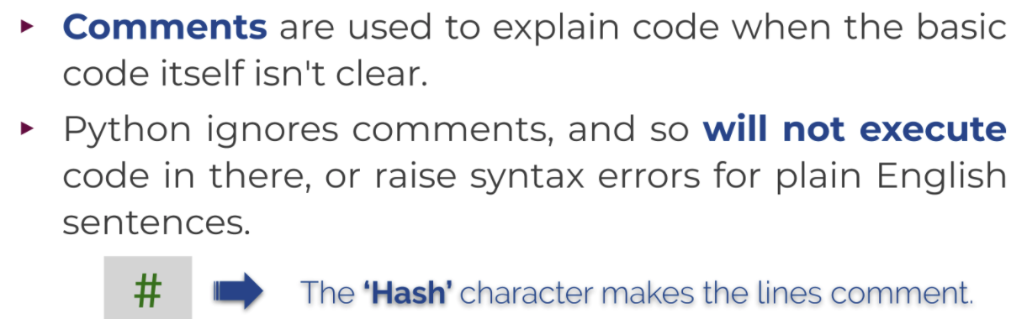

#### Single Line

# This is a single line comment

#### Inline

print('the cosmos has no superiority to chaos') # This is an inline comment

#### Multi-line

# First multi-line comment

# Second multi-line comment

# Third multi-line comment

Usually, comments should answer the question **why** as opposed to **what**.

**💡Tips:**

* To begin with, after 👉🏻 **#** there should be one space,
* and in the inline comments, there should be at least two spaces between the end of the code and 👉🏻 **#**.

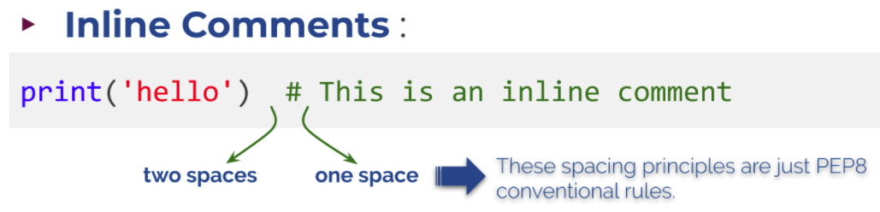

* A comment is not a piece of code. It should be short. It's better to split a long comment into multiple lines. You have to add 👉🏻 **#** at the beginning of each new line.

Q: What are the comments and how do you write it in Python?  
A: Comments are used to explain code when the basic code itself isn't clear. Python ignores comments, and so will not execute code in there, or raise syntax errors for plain English sentences. Comments in Python start with a # character. '#' character converts all subsequent characters to the comment form that Python does nothing.

**⚠️Avoid ! :**

* More comments don't necessarily need to be better. If code is self-explanatory, comments are unnecessary.
* Do not make unnecessary comments. Usually, comments should answer the question **why** as opposed to **what**.
* When necessary, **update your comment**. Be sure that your comments will not be in contradiction to the code.

### Docstrings

**Docstrings** are - unlike regular comments - stored as an attribute of the function or the module they document, meaning that you can access them programmatically. Docstring runs as an explanatory text of codes and it should be written between triple quotes. Like: """docstring""".

Q: What is docstring in Python?  
A: Docstrings are - unlike regular comments - stored as an attribute of the function or the module they document, meaning that you can access them programmatically. Docstring runs as an explanatory text of codes and it should be written between triple quotes.

print(map.\_\_doc\_\_) #map fonksiyonunun kullanimini verir

OUTPUT>>

map(func, \*iterables) --> map object

Make an iterator that computes the function using arguments from

each of the iterables. Stops when the shortest iterable is exhausted.

To see the docstring of a function, bring the cursor between paranthesis and press shift + tab 2 times

## Data Types

some simple data types commonly used in Python:

* String,
* Signed Integer,
* Floating Point,
* Complex,
* Boolean.

Do not use l 1 0 O specific python keywords

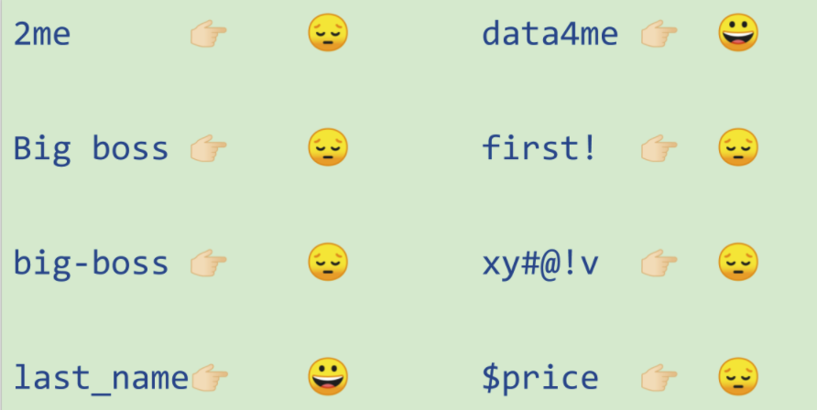

### String (str)

|  |
| --- |
| name = "Michael"  day = "Saturday" |
| print(name + day) |
| MichaelSaturday |
| print(‘ali’+’veli’) |
| aliveli |

### Numeric types

* **Signed Integer** type is called int, they are whole numbers (positive, negative or zero), including no decimal point. For example: 71, -122, 0
* **Floating point** type is called float and they stand for real numbers with a decimal point. For example: 71.0, -33.03
* **Complex** type is called complex and they are written in the form, **x + yj** , where x is the real part and y is the imaginary part. For example: 3.14j. Imaginary numbers, also called complex numbers, are used in real-life applications, such as electricity, as well as quadratic equations. In quadratic planes, imaginary numbers show up in equations that don't touch the x-axis. Imaginary numbers become particularly useful in advanced calculus. We will not use this type much.

Q: What are the numerical data types in Python and their properties?  
A:

* **Integers :** they are whole numbers (positive, negative or zero), including no decimal point.
* **Floats :** they stand for real numbers with a decimal point.
* **Complexes :** they are written in the form, **x + yj** , where x is the real part and y is the imaginary part.

### Boolean

Boolean types are called bool and their values are the two constant objects **False** and **True**.

Q: Describe the Boolean types in detail.  
A: **Boolean** types are called bool and their values are the two constant objects **True** and **False**. They are used to represent truth values (other values can also be considered false or true).  
  
In numeric contexts (for example, when used as the argument to an arithmetic operator), they behave like the integers 0 and 1, respectively.  
  
**Bools** are important data types that are widely used in Python as they can find use in every aspect of our daily lives. For example, imagine, whether the TV is turned on or off in your home or if the weather is rainy can be explained easily with bools.

## Type Conversion

We can convert the types of data to each other if the type allows to be converted. There are some functions to convert the types:

* str() converts to **string** type tirnak icine yazilan her sey string’tir
* int() converts to **signed integer** type
* float() converts to **floating point** type
* bool() converts to **boolean** type

We can print the types of data using type() function.

|  |
| --- |
| example1 = 'sometimes what you say is less important than how you say it'  print(type(example1)) |
| <class 'str'> |

|  |
| --- |
| f = 3.14 # the type is float  s = str(f) # converting float to string  print(type(s)) |
| <class 'str'> |

|  |
| --- |
| x = 39  v = "11"  y = "2.5"  z = "I am at\_"  print(x-int(v))  print(x-float(y))  print(z+str(x)) |
| 28  36.5  I am at\_39 |

|  |
| --- |
| a = 36.5  b = '30'  c = '3.5'  d = ' F is enough for room temperature.'  print(str(a+int(b)+float(c))+d). |
| 70.0 F is enough for room temperature. |

|  |
| --- |
| color = 'red' # str type variable  season = 'summer'  price = 250 # int type variable  pi = 3.14 # float type variable  color = 'blue' # You can always assign a new value to a created variable  price = 100 # value of 'price' is changed  season = 'winter'  print(color, price, season, sep=', ') |
| blue, 100, winter  # sep=', ' olmasaydi cikti >> blue 100 winter |

|  |
| --- |
| a, b, c = 5, 3.2, 'Hello'  print(a)  print(b)  print(c) |
| 5  3.2  Hello |

Note that, If you use undefined name of a variable in the code you write, you will get an 'NameError' message.

If you dont know the value of a variable in the code, you write None

Q: What is the 'variable' and how do you assign a value to it?  
A: **Variable** is a location designated where a value can be stored and accessed later. Imagine a box where you store something. That's a variable.  
  
Python variables do not need an explicit declaration to reserve memory space. The declaration happens automatically when you assign a value to a variable.  
  
To create a variable in Python, all you need to do is specify the variable name and then assign a value to it

int + float = float

int + str = Error

## Arithmetic Operations

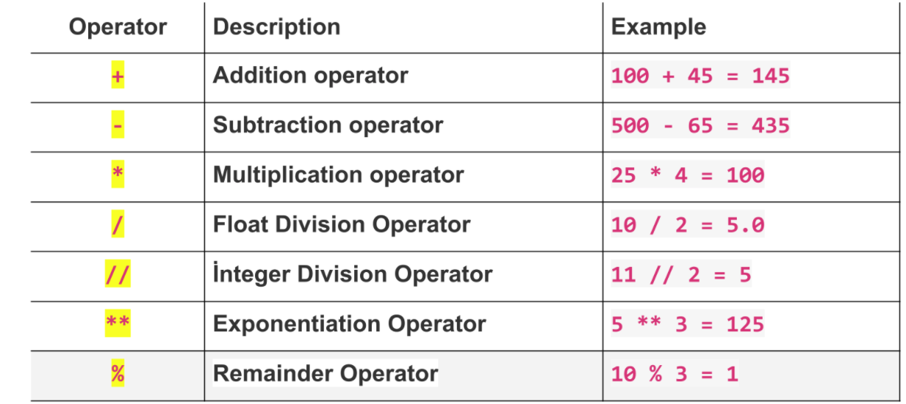

Division gives a result in float type

Modulus % remainder after division 27%5 = 2

Floor division whole number in division 7//2 = 3

Exponention \*\* 2\*\*3 = 8

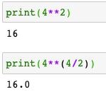

A float type makes everything float

x += 3 x = x + 3

x \*= 3 x = x \* 3

x \*\* = 3 x = x \*\* 3

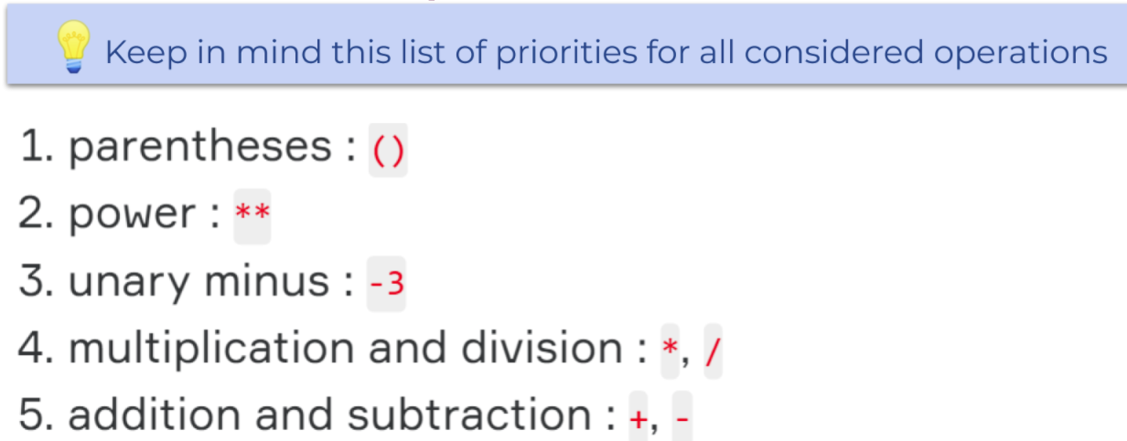

## Operations with 'print( )' Function

Here are the keyword arguments that run in the background of the print() function :

print(value, ..., sep=' ', end='\n', file=sys.stdout, flush=False)

|  |
| --- |
| number = 2020  text = "children deserve respect as much as adults in"  print(text, number) |
| children deserve respect as much as adults in 2020 |

When you type more than one expression in print(), you notice that the expressions are joined to each other by spaces. This is due to the default value of keyword argument **sep** in the print() function. This argument, which is defined as a **space** 👉🏻" " by default, is not visible in the background in the print().

|  |
| --- |
| print("yesterday I ate", 2, "apples") |
| yesterday I ate 2 apples |
| print('i', end=' ')  print('will say', end=' ')  print("'i missed you'", end=' ')  print('to my mother') |
| i will say 'i missed you' to my mother # So that all are in one line but not 4lines |

👉🏻\n represents next line.

|  |
| --- |
| x = 5  print ('value of x : ', x)  x += 2  print ("2 more of x : ", x, "\n") # using string expression '\n',  # we produce extra line.  # So that we had empty line.  y = 10  print ('value of y : ', y) |
| value of x : 5  2 more of x : 7  value of y : 10 |

|  |
| --- |
| print("ali","veli", sep ="\n")  print(50) |
| ali  veli  50 |

|  |
| --- |
| print('smoking', 'is', 'slowly', 'killing me', sep='+') |
| smoking+is+slowly+killing me |
| print('smoking', 'is', 'slowly', 'killing me', sep='\_???\_') |
| Smoking\_???\_is\_???\_slowly\_???\_killing me |

## Escape Sequences

Actually, the examples in the previous lesson show us how backslash 👉🏻\ works. 👉🏻\ is a special sign used in expressions called **escape sequences**, which behaves according to the character immediately after 👉🏻\. Here are basic escape sequences in Python:

* **\n** : means new line,
* **\t** : means tab mark,
* **\b** : means backspace. It moves the cursor one character to the left.

|  |  |
| --- | --- |
| print('C:\\november\number\_expenditure.txt') | C:\november  umber\_expenditure.txt |
| print("one", "two", "three", sep="\t") # separated by tab marks | one two three |
| print('we', '\bare', '\bunited')  # remember, normally print() function  # separates expressions by spaces | weareunited |
| Normally when we use 👉🏻**'** inside the 👉🏻**' '**, Python will give error. Because single-quote in single quotes gives an error. But here, in the example below, 👉🏻**\** allows single-quote 👉🏻**'** to be ignored. So it gives no error.  print('it\'s funny to learn Python')  **⚠️Avoid ! :**   * Be careful, when using 👉🏻**\** in the long string. It may cause error because of its functionality described above. Using 👉🏻**\\** guarantees no error. | it's funny to learn Python |
| print("benim \"en mutlu\" gunum bugun") | benim "en mutlu" gunum bugun |
| print('it\\\'s funny to learn Python') | it\'s funny to learn Python |
| print('it\\'s funny to learn Python') | SyntaxError: invalid syntax |

## Boolean Operations

Boolean or bool can only have two values. True and False.

To put it easily, we can say that bool represent 1 and 0. In other words, yes & no or exist & nonexistent can be expressed by bool type.

For example, let's define a variable as to whether students have passed a course. Let the variable be called is\_pass. Then;

If you pass the course : is\_pass = True,  
If you did not pass the course : is\_pass = False

Q: What is a boolean in Python?  
A: Boolean is one of the built-in data types in Python, it mainly contains two values, and they are **True** and **False**.

### Boolean Logic Expressions

Python has three built-in boolean operators: and, or and not. Except not, all are binary operators, which means two arguments are required.

Q: Python has three built-in Boolean operators. What are they?  
A: They are and, or, not.

### Order of Priority

It is important to remember that, logical operators have a different priority and it has an effect on the order of evaluation. Here are the operators in order of their priorities:

1. **not**
2. **and**
3. **or**

For example : x = True and not True, the value of x returns False.

It evaluates not True first and gives False. It becomes x = True and False and gives False.

|  |
| --- |
| logic = True and False or not False or False  print(logic) |
| True |

**💡Tips:**

* Note that and and or return one of its operands, not necessarily a bool type. But not always returns bool type.

### Truth Values of Logic Statements

Although Python has its own boolean data type, we often use non-boolean values in logical operations.

The values of non-boolean types (integers, strings, etc.) are considered truthy or falsy when used with logical operations, depending on whether they are seen as True or False.

The following values are considered False, in that they evaluate to False when applied to a boolean operator:

* None
* Zero of any numeric type: 0, 0.0, 0j
* Empty sequences and collections: '', [], {}.

Python chooses the value on the rightmost, if operation is AND and both are True.

If both are False, first False is chosen in AND

* Any remaining value is evaluated as True.

|  |  |
| --- | --- |
| print(2 and 3) | 3 |
| Print(None and ()) | None |
| print(1 and 0) | 0 |
| print(1 and "I am doing good!") | I am doing good! |
| print([] and "Hello World!") | []  It is the opposite in OR operand |
| print(2 or 3) | 2 |
| print(0 or {}) | {} |
| print([] or "Hello World!") | Hello World! |
| print(None or 1) | 1 |

## The Strength of String in Python

### Indexing String

One of the most powerful aspects of Python is its string processing capability. You can access all elements of a string type data very easily. Accordance with the sequence of string letters, you can specify them from left to right in brackets, as follows:

|  |  |
| --- | --- |
| fruit = 'Orange'  print('Word : ' , fruit)  print('First letter : ' , fruit[0])  print('Second letter : ' , fruit[1])  print("3rd to 5th letters : " , fruit[2:5])  print("Letter all after 3rd : " , fruit[2:]) | Word : Orange  First letter : O  Second letter : r  3rd to 5th letters : ang  Letter all after 3rd : ange |

2 included, 5 excluded

Enumeration starts with zero

**The formula syntax of string indexing is : string[start:stop:step]**.

**string[:]** : returns the full copy of the sequence

**string[start:]** : returns elements from start to the end element

**string[:stop]** : returns element from the 1st element to stop-1

**string[::step]** : returns each element with a given step

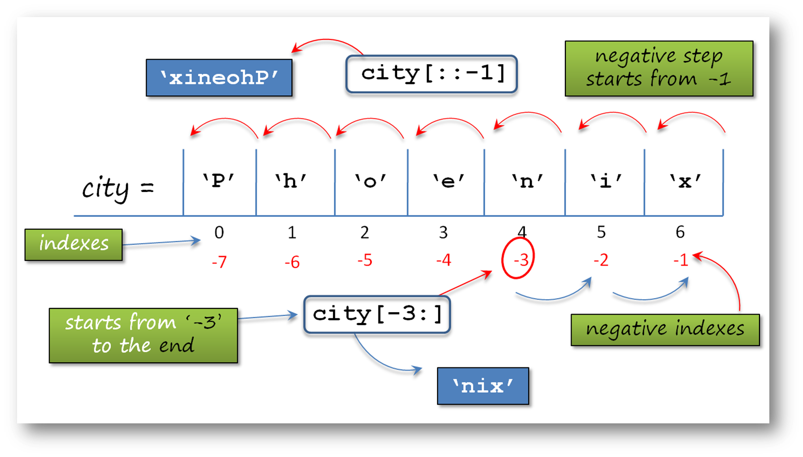

|  |  |
| --- | --- |
| city = 'Phoenix'  print(city[1:]) # starts from index 1 to the end  print(city[:6]) # starts from zero to 5th index  print(city[::2]) # starts from zero to end by 2 step  print(city[1::2]) # starts from index 1 to the end by 2 step  print(city[-3:]) # starts from index -3 to the end  print(city[::-1]) # negative step starts from the end to zero | hoenix  Phoeni  Ponx  hei  nix  xineohP |

You can use the len() function to find out the length (number of characters) of a text or a variable of any type.

|  |
| --- |
| vegetable = 'Tomato' |
| print('length of the word', vegetable, 'is :', len(vegetable))  # length of the word Tomato is: 6 |

### String Formatting with Arithmetic Syntax

There are several ways in Python that we use when processing and using string data structures. The most important of these are:

* Arithmetic syntax (**+**, **\***, and **=**),
* **%** operator formatting,
* **string.format()** method,
* **f-string** formatting.

We have stated to you what the **function** is? in the previous lessons. At this point, let us give the definition of the term **method**. A **method** is like a function, except it is attached to an **object**. We call a method on an object, and it possibly makes changes to that object (like string.format()). A method, then, belongs to a class.

#### Arithmetic syntax (**+**, **=**, **\***) :

We can use + operator for combining the two string together without any spaces. For example :

|  |  |
| --- | --- |
| print('clarus' + 'way') | clarusway |
| print(3\*'no way!') | no way!no way!no way! |
| fruit = 'Orange'  vegetable = 'Tomato'  print("using + :", fruit + vegetable)  print("using \* :", 3 \* fruit) | using + : OrangeTomato  using \* : OrangeOrangeOrange |
| fruit = 'orange'  fruit += 'apple'  print(fruit) | **Special use of \* in Python**  orangeapple |
| fruit = 'orange'  print(\* fruit)  print(\* ‘clarusway’) | o r a n g e  c l a r u s w a y |

**Q**: There are several ways in Python that we use when processing and using string data structures. What are the most important of these:  
**A**:

* Arithmetic syntax (**+**, **\*** and **=**),
* **%** operator formatting,
* **string.format()** method,
* **f-string** formatting.

#### String Formatting with '%' Operator

The other way that you will learn to format the strings is % operator. This one is not a frequently used way, but it's worth learning.

**'**%**'** operator formatting :

👉🏻% operator gets the values in order and prints them in order using several characters accordingly. Look at the example :

For now, we used only s, d and f characters to specify the data type in a string.

|  |
| --- |
| phrase = 'I have %d %s and %.2f brothers' % (4, "children", 5)  print (phrase) |
| I have 4 children and 5.00 brothers |

Here in the example, the % operator first takes '4' and puts it in the first % operator, then takes 'children' secondly and puts it in the second % operator and finally takes '5' and puts it in the third % operator.

**💡Tips:**

* In the '%s' syntax : s stands for 'string'.
* In the '%.2f' syntax : f stands for 'float'. In this example 2 digits after point.
* In the '%d' syntax : d stands for 'numeric'.

|  |
| --- |
| you can limit the character numbers of the strings |
| sentence = "apologizing is a virtue"  print("%.11s" % sentence)  # we get first 11 characters of the string |
| apologizing |

|  |
| --- |
| 👉🏻% operator to format the string. |
| print('%(amount)d pounds of %(fruit)s left' % {'amount': 33, 'fruit':'bananas'}) |
| 33 pounds of bananas left |
| we assign values to variables in curly braces **'{}'**. This format is a **dictionary** type |

#### String Formatting with 'string.format()' Method

You can make strings change depending on the value of a variable or an expression. The main methods of Python to format the output are :

**'**string.format()**' method :**

string.format() method is the improved form of % operator formatting.

As in this example below, the value of expression comes from .format() method in order.

|  |
| --- |
| Curly braces 👉🏻{} receives values from .format(). |
| fruit = 'Orange'  vegetable = 'Tomato'  amount = 4  print('The amount of {} we bought is {} pounds'.format(fruit, amount)) |
| The amount of Orange we bought is 4 pounds |

|  |
| --- |
| If you’ve written more variables than you need in the .format() method, the extra ones just will be ignored. Using keywords in 👉🏻{} makes string more readable. |
| print('{state} is the most {adjective} state of the {country}'.format(state='California', country='USA', adjective='crowded')) |
| California is the most crowded state of the USA |

**💡Tips:**

* If you have noticed, we do not have to write the keywords in .format() method in order.

There is no limit in Python language! You can combine both positional and keyword arguments in the same .format() method :

At this point, let us give you some explanations :   
**Positional arguments** are arguments that can be called by their position in the function or method definition.   
**Keyword arguments** are arguments that can be called by their names.

|  |
| --- |
| print('{0} is the most {adjective} state of the {country}'.format('California', country='USA', adjective='crowded')) |
| California is the most crowded state of the USA |

**⚠️Avoid ! :**Be careful not to write keyword arguments before positional arguments.

|  |
| --- |
| You can use the same variable in a string more than once if you need it. Also, you can select the objects by referring to their positions in brackets. |
| print("{6} {0} {5} {3} {4} {1} {2}".format('have', 6, 'months', 'a job', 'in', 'found', 'I will')) |
| I will have found a job in 6 months |

More trics>>>

|  |
| --- |
| text = "{:.2f}\t{:.1f}\t{:.5f}".format(3.1463, 5.367, 7.4352618)  #float nr of decimal digits |
| 3.15 5.4 7.43526 |

|  |
| --- |
| mext = "{:.2s}\t{:.1s}\t{:.5s}".format("3.1463", "5.367", "7.4352618")  #string nr of characters |
| 3. 5 7.435 |
| textt = "{:>12}".format("0123456789")  #Places to the rightmost side in given 12 cahacter length,  # there is also one more default space |
| \_ \_ \_0123456789 |

|  |
| --- |
| text3 = "XXX {:<10} XXX".format("01234")  # Places the expression to leftmost side in 10 character length  # Plus default «space»s each side |
| XXX\_01234\_ \_ \_ \_ \_ \_XXX |

|  |
| --- |
| text4 = "{:^10}".format("01234")  text5 = "{:^10}".format("0123")  #centers in 10 characters |
| '\_ \_01234\_ \_ \_'  '\_ \_ \_0123\_ \_ \_' |

#### String Formatting with 'f-string' #Best & Easisest Method

It is the easiest and useful formatting method of the strings.

**'**f-string**'** formatting :

It makes string formatting easier. This method was introduced in 2015 with Python 3.6.

**f-string** is the string syntax that is enclosed in quotes with a letter **f** at the beginning. Curly braces 👉🏻{} that contain variable names or expressions are used to replace with their values.

|  |
| --- |
| fruit = 'Orange'  vegetable = 'Tomato'  amount = 6  output = f"The amount of {fruit} and {vegetable} we bought are totally {amount} pounds"  print(output) |
| The amount of Orange and Tomato we bought are totally 6 pounds |

|  |  |
| --- | --- |
| result = f"{4 \* 5}"  print(result) | 20 |

|  |
| --- |
| my\_name = 'JOSEPH'  output = f"My name is {my\_name.capitalize()}"  print(output) |
| My name is Joseph |

|  |
| --- |
| name = "Joseph"  job = "teachers"  domain = "Data Science"  message = (  f"Hi {name}. "  f"You are one of the {job} "  f"in the {domain} section."  )  print(message) |
| Hi Joseph. You are one of the teachers in the Data Science section. |

**Spaces come automatically**

|  |
| --- |
| If you want to use multiple f-string formatting lines without parentheses, you will have the other option that you can use backslash 👉🏻**\** between lines. |
| name = "Joseph"  job = "teachers"  domain = "Data Science"  message = f"Hi {name}. " \  f"You are one of the {job} " \  f"in the {domain} section."  print(message) |
| Hi Joseph. You are one of the teachers in the Data Science section. |

**Q**: If you want to use multiple 'f-string formatting' lines without parentheses, what will be the other option that you can use?  
**A**: You can use backslashes 👉\ between f-lines.

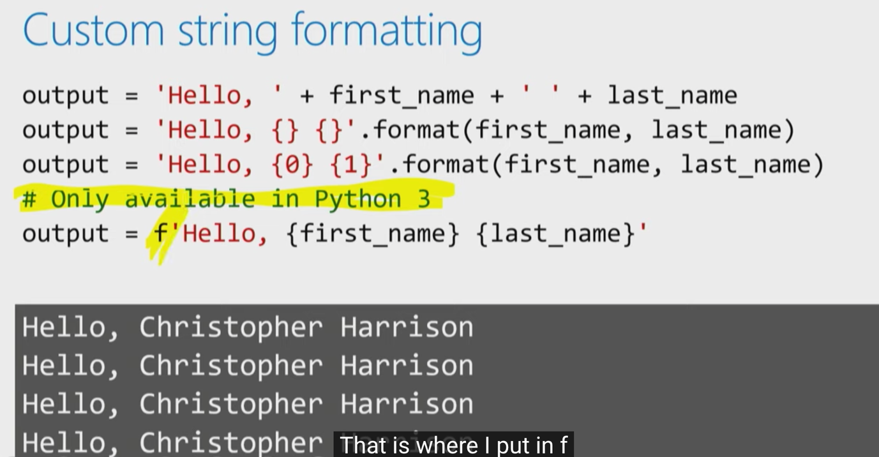

### Main String Operations

String processing is of great importance in the world of Data Science as a field of research and business in the world. Moreover, there seems to be much more to do in this field.

Good news! Python's string processing skills are very advanced that we will focus on some main parts of it.

A significant thing to keep in mind is that string is an immutable data type. This means you can't just change the string in place, so most string methods return a copy of the string. Well, how can we do that?

* **💡Tips:** This is the way you should follow: You must create a new variable for the copy you made or assign the same name to the copy to save the changes made to the string for later use.

#### Searching a String

To search patterns in a string there are two useful methods called startswith() and endswith() that search for the particular pattern in the immediate beginning or end of a string and return True if the expression is found. Here are some simple examples. Examine the basic syntax of those methods carefully.

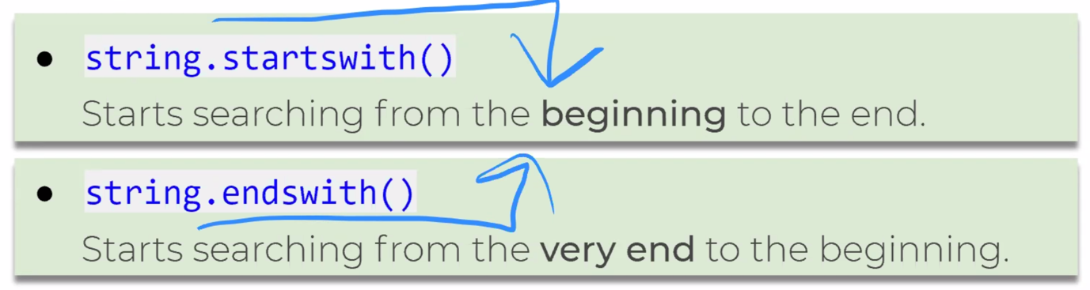

|  |
| --- |
| text = 'www.clarusway.com'  print(text.endswith('.com'))  print(text.startswith('http:')) |
| True  False |
| text = 'www.clarusway.com'  print(text.endswith('om'))  print(text.startswith('w')) |
| True  True |

These methods have optional arguments start and end. We can specify the search by adding arguments so that the area of search is delimited by start and end arguments.

**💡Tips:**

* Remember! Characters of string count from left to right and start with zero.

**The formula syntaxes are :**

* **string.startswith(prefix[, start[, end]])**
* **string.endswith(suffix[, start[, end]])**

|  |
| --- |
| email = "clarusway@clarusway.com is my e-mail address"  print(email.startswith("@", 9))  print(email.endswith("-", 10, 32)) #search from 10th index to 31st |
| True  True |

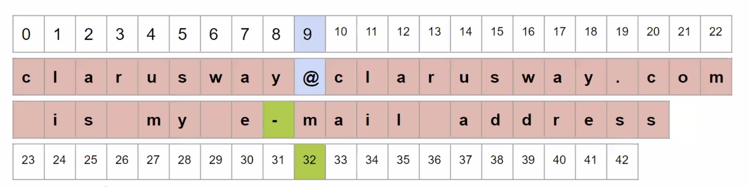

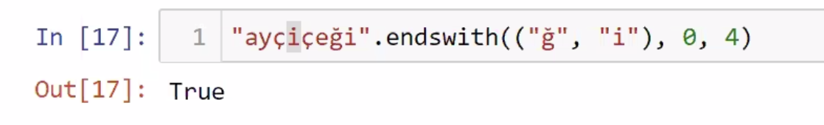

**Q**: What are the string.startswith() and string.endswith() method used for? Describe how?  
**A**: To search patterns in a string there are two useful methods called startswith() and endswith() that search for the particular pattern in the immediate beginning or end of a string and return True if the expression is found.

#### **Changing a String**

The methods described below return the copy of the string with some changes made.

How does the following syntax work?

A string is given first (or the name of a variable that represents a string), then comes a period followed by the method name and parentheses in which arguments are listed.

**The formula syntax is: string.method()**

Let's examine some common and the most important methods of string changing:

**str.replace(old, new[, count])** replaces all occurrences of old with the new.

The count argument is optional, and if the optional argument count is given, only the first count occurrences are replaced.

count: Maximum number of occurrences to replace. **-1** (the default value) means replace all occurrences.

**str.swapcase()** converts upper case to lower case and vice versa.

**str.capitalize()** changes the first character of the string to the upper case and the rest to the lower case.

**str.upper()** converts all characters of the string to the upper case.

**str.lower()** converts all characters of the string to the lower case.

**str.title()** converts the first character of each word to upper case.

|  |  |
| --- | --- |
| sentence = "I live and work in Virginia" | |
| print(sentence.upper()) | I LIVE AND WORK IN VIRGINIA |
| print(sentence.lower()) | i live and work in virginia |
| print(sentence.swapcase()) | i LIVE AND WORK IN vIRGINIA |
| print(sentence)  # note that, source text is unchanged | I live and work in Virginia |

If we assign the modified text to a new variable, we can have a new string.

|  |  |
| --- | --- |
| sentence = "I live and work in Virginia" | |
| title\_sentence = sentence.title()  print(title\_sentence) | I Live And Work In Virginia |
| changed\_sentence = sentence.replace("i", "+")  print(changed\_sentence) | I l+ve and work +n V+rg+n+a |
| print(sentence)   # note that, again source text is unchanged | I live and work in Virginia |
| swap\_case = sentence.swapcase()  print(swap\_case) | i LIVE AND WORK IN vIRGINIA |
| print(swap\_case.capitalize())  # changes 'i' to uppercase and the rest to lowercase | I live and work in virginia |

#### **Editing a String**

The methods described below remove the trailing characters (i.e. characters from the right side). The default for the argument chars is also whitespace. If the argument chars aren’t specified, trailing whitespaces are removed.

**The formula syntax is : string.method()**

**str.strip()** : removes all spaces (or specified characters) from both sides.

**str.rstrip()** : removes spaces (or specified characters) from the right side.

**str.lstrip()** : removes spaces (or specified characters) from the left side.

|  |
| --- |
| space\_string = "     listen first      "  print(space\_string.strip())  # removes all spaces from both sides |
| listen first |

|  |
| --- |
| source\_string = "interoperability"  print(source\_string.strip("yi"))  # removes trailing "y" or "i" or "yi" or "iy" from both sides |
| nteroperabilit |

|  |
| --- |
| space\_string = "     listen first      "  print(space\_string.rstrip())  # removes spaces from the right side |
| listen first |

|  |
| --- |
| source\_string = "interoperability"  print(source\_string.rstrip("yt"))  # removes "y" or "t" or "yt" or "ty" from the right side |
| interoperabili |

## Collection Types

### Lists

There are various collection types in Python. While types such as int and str hold a single value, collection types hold multiple values.

In your programs, you usually need to group several items to render as a single object. We use collection types of data to do this job.

One of the most useful collections in Python is a list. In Python, a list is only an **ordered collection** of valid Python values.

The list type is probably the most commonly used collection type in Python. In spite of its name, a list is more like an array in some other languages (e.g. JavaScript).

A list can be created by enclosing values, separated by commas, in square brackets 👉🏻[].

|  |
| --- |
| country = ['USA', 'Brasil', 'UK', 'Germany', 'Turkey', 'New Zealand']  print(country) |
| ['USA', 'Brasil', 'UK', 'Germany', 'Turkey', 'New Zealand'] |

**💡Tips:** All the country names are printed in the same order as they were stored in the list because lists are **ordered**.

Another way to create a list is to call the 'list()' function.

You do this when you want to create a list from an iterable object: that is, type of object whose elements you can import individually. The lists are iterable like other collections and string types. Let's create another list using list() function and compare with 👉🏻'[]'.

|  |
| --- |
| string\_1 = 'I quit smoking'  new\_list\_1 = list(string\_1) # we created multi element list  print(new\_list\_1)  new\_list\_2 = [string\_1] # this is a single element list  print(new\_list\_2) |
| ['I', ' ', 'q', 'u', 'i', 't', ' ', 's', 'm', 'o', 'k', 'i', 'n', 'g']  ['I quit smoking'] |

# Creating empty list

empty\_list1 = []

empty\_list2 = list()

**Tips:**

* Note that, using **list()** function, all characters of string\_1 including spaces was moved into a new\_list\_1.
* If you noticed, **lists** can contain **more than one** of the **same** value.

As it appears, the list() function creates a list that contains each component of a specific iterable object, such as a string. You can use square brackets or list() functions, depending on what you are going to do.

The components of a list are not limited to a single data type, given that Python is a dynamic language: e.g.

#### Append Operation

In most cases, we'll have to make an empty list to fill it later with the data you want.

empty\_list\_1= []

empty\_list\_2 = list()

* Append an object to end of a list.
* Using only list.append(element) syntax, returns none.
* If you want to see the new appended list, you have to call or print it.

|  |
| --- |
| empty\_list\_1 = []  empty\_list\_1.append('114')  empty\_list\_1.append('plastic-free sea')  print(empty\_list\_1) |
| ['114', 'plastic-free sea'] |

|  |
| --- |
| city = ['New York', 'London', 'Istanbul', 'Seoul', 'Sydney']  city.append('Addis Ababa')  print(city) |
| ['New York', 'London', 'Istanbul', 'Seoul', 'Sydney', 'Addis Ababa'] |

Comes to the end of the list

#### Insert Operation

**.insert()** : Add a new object to list at a speciﬁc index.

The syntax looks like list.insert(index, object)

|  |
| --- |
| city = ['New York', 'London', 'Istanbul', 'Seoul', 'Sydney', 'Addis Ababa']  city.insert(2, 'Stockholm')  print(city) |
| ['New York', 'London', 'Stockholm', 'Istanbul', 'Seoul', 'Sydney', 'Addis Ababa'] |

#### Remove Operation

|  |
| --- |
| city = ['New York', 'London', 'Stockholm', 'Istanbul', 'Seoul', 'Sydney', 'Addis Ababa']  city.remove('London')  print(city) # we have deleted 'London' |
| ['New York', 'Stockholm', 'Istanbul', 'Seoul', 'Sydney', 'Addis Ababa'] |

#### Sort Operation

|  |
| --- |
| city = ['New York', 'Stockholm', 'Istanbul', 'Seoul', 'Sydney', 'Addis Ababa']  city.sort() # lists the items in alphabetical order  print(city) |
| ['Addis Ababa', 'Istanbul', 'New York', 'Seoul', 'Stockholm', 'Sydney'] |

**💡Tips:**

* Remember! Elements of a list are counted from left to right and start with zero as in string types.

#### Other operations (len, \*, [1])

|  |
| --- |
| city = ['Addis Ababa', 'Istanbul', 'New York', 'Seoul', 'Stockholm', 'Sydney']  print(len(city)) |
| 6 |

|  |
| --- |
| my\_list = [1, 3, 5, 7]  print(my\_list \* 3) |
| [1, 3, 5, 7, 1, 3, 5, 7, 1, 3, 5, 7] |

|  |
| --- |
| city = ['New York', 'Stockholm', 'Istanbul', 'Seoul', 'Sydney', 'Addis Ababa']  city[1] = 'Melbourne' # we assign 'Melbourne' to index 1  print(city) |
| ['New York', ‘Melbourne’, 'Istanbul', 'Seoul', 'Sydney', 'Addis Ababa'] |

### Accessing Lists

#### Indexing a List

If we want to access or use the elements of a list, we can do that using index numbers of the list enclosed by **square brackets**.

|  |
| --- |
| colors = ['red', 'purple', 'blue', 'yellow', 'green']  print(colors[2]) # If we start at zero,  # the second element will be 'blue'. |
| blue |

|  |
| --- |
| city = ['New York', 'London', 'Istanbul', 'Seoul', 'Sydney']  city\_list = []  city\_list.append(city) # we have created a nested list  print(city\_list) |
| [['New York', 'London', 'Istanbul', 'Seoul', 'Sydney']]  # city\_list includes only **one** element which is the city list. |
| city\_list = [['New York', 'London', 'Istanbul', 'Seoul', 'Sydney']]  print(city\_list[0]) # access to first and only element  print(city\_list[0][2])  print(city\_list[0][2][3]) |
| ['New York', 'London', 'Istanbul', 'Seoul', 'Sydney']  Istanbul  a |

#### Slicing a List

|  |
| --- |
| numbers = [1, 3, 5, 7, 9, 11, 13, 15, 17]  print(numbers[2:5])  # we get the elements from index=2 to index=5(5 is not included) |
| [5, 7, 9] |

**💡Tips :**

* Slicing is just similar to indexing. The difference is adding **colon** or **colons** in square brackets.

You can keep in mind the formula syntax below for slicing a sequence. From '**start**' to '**stop-1**', by '**step**'.

**The formula syntax is : sequence[start:stop:step]**

Now let's apply this formula on a few examples. In this example, we will create a list of numbers from 1 to 10 using 'range()' function and select even ones:

|  |
| --- |
| count = list(range(11))  print(count)  print(count[0:11:2]) |
| [0, 1, 2, 3, 4, 5, 6, 7, 8, 9, 10]  [0, 2, 4, 6, 8, 10] |

**The formula syntax is : range(start, stop[, step])**

* **my\_list[:]**: returns the full copy of the sequence
* **my\_list[start:]** : returns elements from start to the end element
* **my\_list[:stop]** : returns element from the 1st element to stop-1
* **my\_list[::step]** : returns each element with a given step

|  |  |
| --- | --- |
| animals = ['elephant', 'bear', 'fox', 'wolf', 'rabbit', 'deer', 'giraffe'] | |
| animals[:] | ['elephant', 'bear', 'fox', 'wolf', 'rabbit', 'deer', 'giraffe'] |
| animals[3:] | ['wolf', 'rabbit', 'deer', 'giraffe'] |
| animals[:5] | ['elephant', 'bear', 'fox', 'wolf', 'rabbit'] |
| animals[::2] | ['elephant', 'fox', 'rabbit', 'giraffe'] |

Q: In Python what is slicing?  
A: A mechanism to select a range of items from sequence types like list, tuple, strings etc. is known as slicing.

|  |
| --- |
| print(len([[12, 34, 56]])) |
| 1 |

|  |
| --- |
| print(len([[12, 34, 56]][0])) |
| 3 |

#### Negative Indexing & Slicing

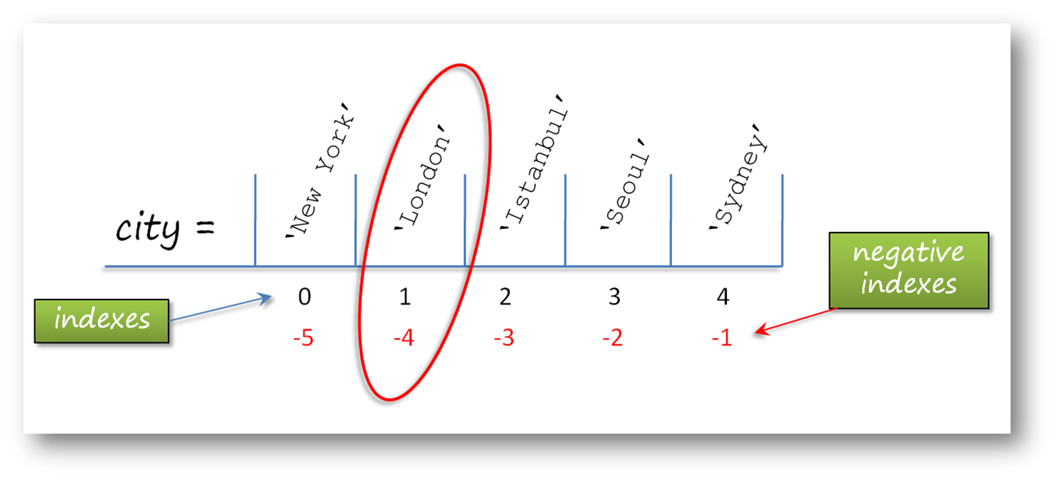

|  |  |
| --- | --- |
| reef = ['swordfish', 'shark', 'whale', 'jellyfish', 'lobster', 'squid', 'octopus'] | |
| reef[-3:] | ['lobster', 'squid', 'octopus'] |
| reef[:-3] | ['swordfish', 'shark', 'whale', 'jellyfish'] |
| reef[::-1] | ['octopus', 'squid', 'lobster', 'jellyfish', 'whale', 'shark', 'swordfish'] |
| reef[::-2] | ['octopus', 'lobster', 'whale', 'swordfish'] |

|  |  |
| --- | --- |
| odd\_no = [0,1, 2, 3, 4, 5, 6, 7, 8, 9] | |
| odd\_no[7:3:-1] | [7, 6, 5, 4] |
| odd\_no[2:6:-1] | [] |

**Q**: What does list[::-1] do?  
**A**: list[::-1] is used to reverse the order of a sequence of the elements in the list.

## Tuples

A tuple is another collection type that can hold multiple data very similar to the list.

The most important difference from the list is that the tuple is **immutable**.

Therefore, methods like append() or remove() do not exist in the operations of this type.

Tuples are commonly used for small collections of values that will not need to change, such as an IP address and port. If we have unchanged data, we should choose **tuples** because it is much **faster than** **lists**.

We used square brackets 👉🏻'[]' to define the lists. In the tuple, normal parentheses 👉🏻'()' are used.

The same indexing rules for lists also apply to tuples. Tuples can also be nested and the values can be any valid Python valid.

Q: What is the difference between list and tuple?  
A:  
LISTs :

* Lists are mutable i.e they can be edited.
* Lists are slower than tuples.
* Syntax: list\_1 = [True, ‘Space’, 20]

TUPLEs :

* Tuples are immutable (tuples are lists which can’t be edited).
* Tuples are faster than list.
* Syntax: tup\_1 = (True, ‘Space’ , 20)

#### Creating a Tuple

|  |
| --- |
| empty\_tuple = ()  print(type(empty\_tuple)) |
| <class ‘tuple’> |

|  |
| --- |
| try\_tuple = ('love')  print(try\_tuple)  print(type(try\_tuple)) # it's not tuple type. |
| love  <class 'str'> |

If you want to create a single element tuple, you should use a comma.

It occurs in only single element tuples and we can fix the problem using **comma** at the end of the element.

**💡Tips:**

* Remember to always use a comma when defining a singleton tuple.

|  |
| --- |
| try\_tuple2 = ('love',)  print(try\_tuple2)  print(type(try\_tuple2)) # Now it's a tuple type. |
| love  <class ‘tuple’> |

Actually, if your tuple contains more than one element, separating elements with commas will be enough.

Another way to create a tuple is to call the tuple() function. You do this when you want to create a tuple from an iterable object: that is, a type of object whose elements you can import individually.

The tuple is also iterable like other collections and string types. Let's create another tuple using tuple() function. With this function, you can create an empty tuple as well.

|  |
| --- |
| planets = 'mercury', 'jupiter', 'saturn'  # separating elements with commas will be enough.  print(planets)  print(type(planets)) |
| ('mercury', 'jupiter', 'saturn')  <class 'tuple'> |

|  |
| --- |
| empty\_tuple\_1 = tuple()  print(empty\_tuple\_1)  print(type(empty\_tuple\_1)) |
| ()  <class 'tuple'> |

It is easy to convert between list and tuple as in the examples below :

|  |
| --- |
| my\_tuple=(1, 4, 3, 4, 5, 6, 7, 4)  my\_list = list(my\_tuple)  print(type(my\_list), my\_list) |
| <class ‘list’> [1, 4, 3, 4, 5, 6, 7, 4] |

|  |
| --- |
| my\_list= [1, 4, 3, 4, 5, 6, 7, 4]  my\_tuple = tuple(my\_list)  print(type(my\_tuple), my\_tuple) |
| <class ‘tuple> (1, 4, 3, 4, 5, 6, 7, 4) |

An iterable string can be converted to a tuple :

|  |
| --- |
| mountain = tuple('Alps')  print(mountain) |
| ('A', 'l', 'p', 's') |

#### How can We Use a Tuple ?

Both lists and tuples are ordered. It means that when storing elements to these containers, you can sure that their order will remain the same. You can also duplicate values or mix different data types in tuples.

|  |
| --- |
| mix\_value\_tuple = (0, 'bird', 3.14, True)  print(len(mix\_value\_tuple)) |
| 4 |

Just like lists, tuples support indexing

|  |
| --- |
| even\_no = (0, 2, 4)  print(even\_no[0])  print(even\_no[1])  print(even\_no[2])  print(even\_no[3]) |
| 0  2  4  ----print(even\_no[3]) : IndexError: tuple index out of range |

One of the most important differences of tuples from lists is that 'tuple' object does not support **item assignment**. Yes, because tuple is immutable.

|  |
| --- |
| city\_list = ['Tokyo', 'Istanbul', 'Moskow', 'Dublin']  city\_tuple = tuple(city\_list)  city\_tuple[0] = 'New York' # you can't assign a value |
| TypeError: 'tuple' object does not support item assignment |

#### .index() and .count() methods of tuples

The count() method returns the number of times a specified value appears in the tuple.

|  |
| --- |
| thistuple = (1, 3, 7, 8, 7, 5, 4, 6, 8, 5)  x = thistuple.count(5)  print(x) |
| 2 |

The index() method finds the first occurrence of the specified value. The index() method raises an exception if the value is not found.

|  |
| --- |
| thistuple = (1, 3, 7, 8, 7, 5, 4, 6, 8, 5)  x = thistuple.index(8) y = thistuple.index(77)  print(x)  print(y) |
| 3  ValueError: tuple.index(x): x not in tuple |

#### Benefits of Immutability

Let's take a look at the basic advantages of tuples :

* Tuples are faster and more powerful in-memory than lists. You should give it a thought whenever you need to deal with large amounts of data. If you don't want to change your data you may have to choose tuples.
* Because of its immutability, the data stored in a tuple can not be altered by mistake.
* A tuple can be used as a dictionary (we will see in the next lesson) key, while 'TypeError' can result in lists as keys. And this is the usefulness of tuples in the data processing.

## Dictionaries

In this topic, we will examine the collection types which store **item pairs**. What does it mean?

Think of a real dictionary. It contains words and their meanings. In Python, you can accept the words as key and the meaning of the words as value.

A dictionary in Python is a collection of key-value pairs called **items** of a dictionary. The dictionary is enclosed by curly braces 👉🏻**{}**.

Each pair (item) is separated by a comma and

the key and value are separated by a colon.

### Creating a Dictionary

A dictionary also can be created by enclosing pairs, separated by commas, in **curly-braces**. Looks like list or tuple, right?

And of course, we can use a function to create a dictionary : 'dict()' function. Let's create a simple empty dict :

|  |
| --- |
| empty\_dict\_1 = {}  empty\_dict\_2 = dict()  print(type(empty\_dict\_1)) |
| <class 'dict'> |

The basic form of dict looks like :

my\_dict = {'key1': 'value1',

'key2': 'value2',

'key3': 'value3'

}

|  |
| --- |
| state\_capitals = {'Arkansas': 'Little Rock',  'Colorado': 'Denver',  'California': 'Sacramento',  'Georgia': 'Atlanta'  }  print(state\_capitals['Colorado']) # accessing method |
| Denver |

|  |
| --- |
| state\_capitals = {'Arkansas': 'Little Rock',  'Colorado': 'Denver',  'California': 'Sacramento',  'Georgia': 'Atlanta'  }  state\_capitals['Virginia'] = 'Richmond' # adding a new item  print(state\_capitals) |
| {'Arkansas': 'Little Rock',  'Colorado': 'Denver',  'California': 'Sacramento',  'Georgia': 'Atlanta',  'Virginia': 'Richmond'} |

**💡Tips:**

* Note that values can be of different types.

mix\_dict = {'animal': ('dog', 'cat'), # tuple type

'planet': ['Neptun', 'Saturn', 'Jupiter'], # list type

'number': 40, # int type

'pi': 3.14, # float type

'is\_good': True} # bool type

And now, let's use dict() function to create a dictionary :

|  |
| --- |
| dict\_by\_dict = dict(animal='dog', planet='neptun', number=40, pi=3.14, is\_good=True)  print(dict\_by\_dict) |
| {'animal': 'dog',  'planet': 'neptun',  'number': 40,  'pi': 3.14,  'is\_good': True} |

**⚠️Avoid ! :**

* Do not use quotes for keys when using the dict() function to create a dictionary.

**Q**: What is a dictionary in Python?  
**A**: Python dictionary is one of the supported data types in Python. It is an unordered collection of elements. The elements in dictionaries are stored as key–value pairs. Dictionaries are indexed by keys. For example, below we have a dict named my\_dict. It contains two keys, **fruit** and **vegatable**, along with their corresponding values, **banana** and **onion**.  
  
my\_dict = {'fruit':'banana', 'vegatable':'onion'}

### Main Operations with Dictionaries

#### .items() .keys() .values()

There are several methods that allow us to access items, keys, and values. You can access all items using the **.items()** method, all keys using the **.keys()** method, and all values using the **.values()** method:

|  |
| --- |
| dict\_by\_dict = {'animal': 'dog',  'planet': 'neptun',  'number': 40,  'pi': 3.14,  'is\_good': True}  print(dict\_by\_dict.items(), '\n')  print(dict\_by\_dict.keys(), '\n')  print(dict\_by\_dict.values()) |
| dict\_items([('animal', 'dog'), ('planet', 'neptun'),  ('number', 40), ('pi', 3.14), ('is\_good', True)])  dict\_keys(['animal', 'planet', 'number', 'pi', 'is\_good'])  dict\_values(['dog', 'neptun', 40, 3.14, True]) |

#### .update()

You have learned that you can add a new item by assigning value to a key that is not in the dictionary.

Likewise, you can add new items using the **.update()** method.

|  |
| --- |
| dict\_by\_dict = {'animal': 'dog',  'planet': 'neptun',  'number': 40,  'pi': 3.14,  'is\_good': True}  dict\_by\_dict.update({'is\_bad': False})  print(dict\_by\_dict) |
| {'animal': 'dog',  'planet': 'neptun',  'number': 40,  'pi': 3.14,  'is\_good': True,  'is\_bad': False} |

#### .del

**The formula syntax is : del dictionary\_name['key']**

|  |
| --- |
| dict\_by\_dict = {'animal': 'dog',  'planet': 'neptun',  'number': 40,  'pi': 3.14,  'is\_good': True,  'is\_bad': False }  del dict\_by\_dict[‘animal’]  print(dict\_by\_dict) |
| {'planet': 'neptun',  'number': 40,  'pi': 3.14,  'is\_good': True,  'is\_bad': False} |

#### in not in

Using the **in** and the **not in** operator, you can check if the key is in the dictionary.

* When we use the **in** operator; if the key is in the dictionary, the result will be True otherwise False.
* When we use the **not in**; if the key is not in the dictionary, the result will be True otherwise False.

|  |
| --- |
| dict\_by\_dict = {'planet': 'neptun',  'number': 40,  'pi': 3.14,  'is\_good': True,  'is\_bad': False}  print('pi' in dict\_by\_dict)  print('animal' not in dict\_by\_dict) # remember, we have deleted 'animal' |
| True  True |

### Nested Dictionaries

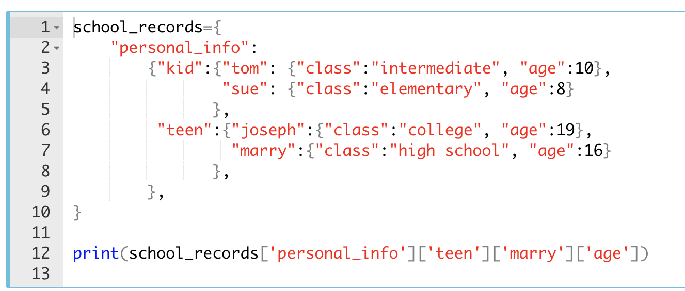

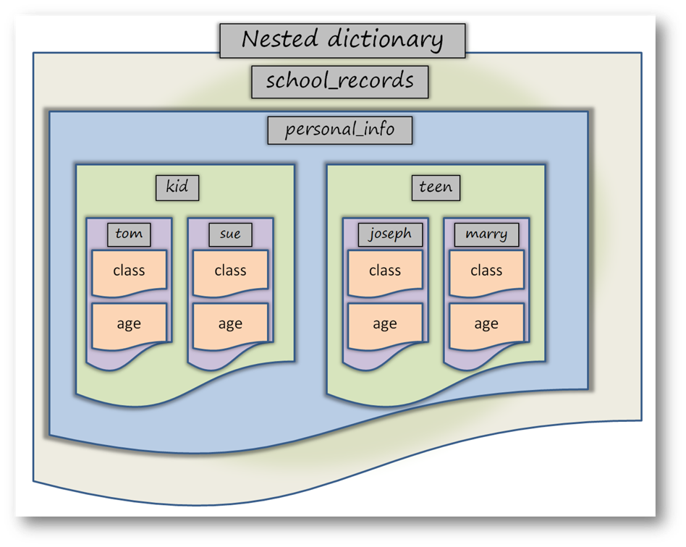

**💡Tips:**

* Dictionaries strongly resemble JSON syntax. The native json module in the Python standard library can be used to convert between JSON and dictionaries.

## Sets

A **set** is a collection of elements with no repeats and without insertion order but sorted order.

Basic uses include membership testing and eliminating duplicate entries. Set objects also support mathematical operations like union, intersection, difference, and symmetric difference.

They can hold multiple data in them, but only one of value.

They are used in situations where it is only important that some things are grouped together, and not what order they were included.

### Creating a Set

Curly braces **'{}'** or the **set()** function can be used to create sets. But the only way to create an empty set is: use the set() function.

**⚠️Avoid ! :**

* Note that, to create an empty set you have to use **set()** function. Do not use **{}** to create an empty set. Otherwise, you will create an empty dictionary.

|  |
| --- |
| empty\_set = set()  print(type(empty\_set)) |
| <class 'set'> |

|  |
| --- |
| f1 = {'rose', 'violet', 'carnation', 'orchid'}  f2 = {'rose', 'violet', 'carnation', 'rose', 'orchid'}  print(f1)  print(f2)  #We ignore the repeating elements |
| {'carnation', 'orchid', 'rose', 'violet'}  {'carnation', 'orchid', 'rose', 'violet'} |

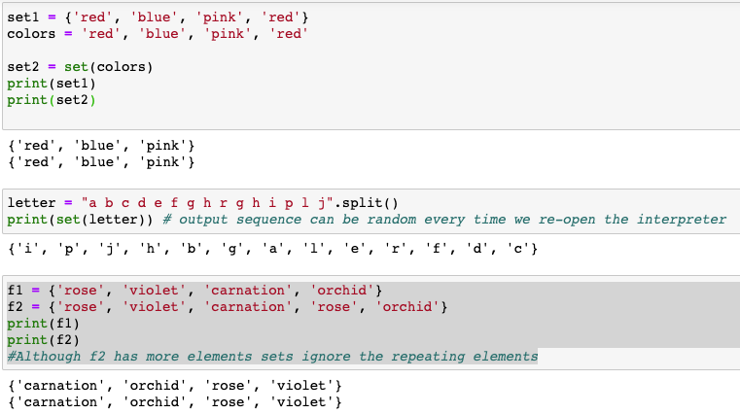

**Q**: Which one of the following is not the correct syntax for creating a set in Python?  
**A**:  
**a. set([[1,2],[3,4],[4,5]])**  
b. set([1,2,2,3,4,5])  
c. {1,2,3,4}  
d. set((1,2,3,4))  
  
**Explanation:** The argument given for the set must be an iterable

#### Main Operations with Sets

There are several methods that allow us to add and remove items to/from sets. Moreover, we have the methods of intersection, unification, and differentiation of sets :

These methods are :

* **.add()** : Adds a new item to the set.
* **.remove()** : Allows us to delete an item.
* **.intersection()** : Returns the intersection of two sets.
* **.union()** : Returns the unification of two sets.
* **.difference()** : Gets the difference of two sets.

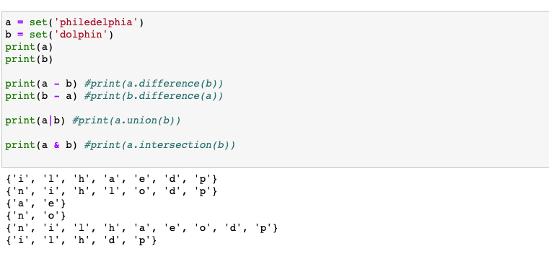

|  |
| --- |
| a = set('abracadabra')  a.remove('c') # we delete 'c' from the set  print(a) |
| {'a', 'b', 'd', 'r'} |

|  |
| --- |
| a = set('abracadabra')  a.add('c') # we add 'c' again to the set  print(a) |
| {'a', 'b', ‘c’, 'd', 'r'} |

Additionally, you can:

* Get the number of set’s elements using **len()** function,
* Checks if an element belongs to a specific set(in / not in operators), you get the boolean value.

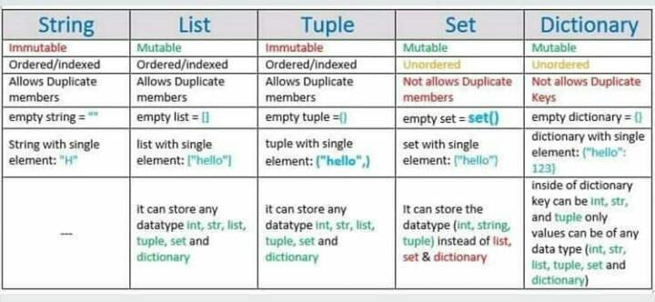

## Conditional Statements

### IF

The **if** statements check the **condition**. The **condition** is always a **Boolean** expression, that is, its value equals either True or False.

If it evaluates to True, it executes the **body** of the **if** statement. If it evaluates to False, it skips the **body**. This logic works like the English language.

|  |
| --- |
| empty\_seat = 14  if empty\_seat > 3: # in this case, 14>3=True, so the body will execute  print('there is still seat to sit') |
| there is still seat to sit |

**💡Tips :**

* Note that the condition ends with a colon and a new line starts with an indentation.

#### Comparison Operators

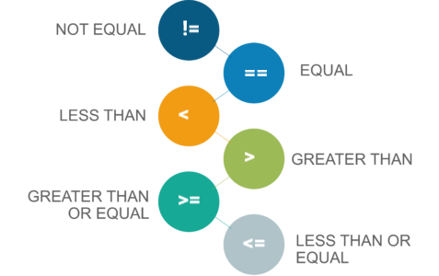

| **Operator** | **How it works ?** | **Sample** |
| --- | --- | --- |
| **==** | Returns True if two values are equal or False if different | 2 == 2 (True), 2 == 3 (False) |
| **!=** | Returns True if two values are not equal or False if equal | 2 != 2 (False), 2 != 3 (True) |
| **>** | Returns True if the value on the left is greater than the value on the right otherwise returns False | 3 > 2 (True), 2 > 3 (False) |
| **<** | Returns True if the value on the left is less than the value on the right otherwise returns False | 2 < 3 (True), 3 < 2 (False) |
| **>=** | Returns True if the value on the left is greater than or equal to the value on the right otherwise returns False | 3 >= 2 (True), 3 >= 3 (True), 2 >= 3 (False) |
| **<=** | Returns True if the value on the left is less than or equal to the value on the right otherwise returns False | 3 <= 2 (False), 3 <= 3 (True), 2 <= 3 (True) |

**⚠️Avoid ! :**

* Do not use assignment operator **=** in comparison statements. In comparisons, you have to use **==** operator for equality.

|  |
| --- |
| x = 6  y = 9  print ("is x equal to y? :" , x == y)  print ("is x not equal to y? :" , x != y)  print ("is x less than y? :" , x < y)  print ("is x greater than y? :" , x > y)  print ("is x less than or equal to y? :" , x <= y)  print ("is x greater than or equal to y? :" , x >= y) |
| is x equal to y? : False  is x not equal to y? : True  is x less than y?? : True  is x greater than y? : False  is x less than or equal to y? : True  is x greater than or equal to y? : False |

### IF-ELSE

An **if-else** statement is another kind of conditional statements in Python. It is used with an additional keyword: else.

else works like an if statement. If none of the conditions in if are ensured, "else" will be used to specify all remaining conditions. The simple structure of an if-else looks like :

|  |
| --- |
| course = 'clarusway'  if course == "clarusway":  print("you guaranteed the job")  else:  print("think about it again") |
| you guaranteed the job |

### IF-ELIF-ELSE

¨The elif statement is used when it requires to specify several conditions in our program.

In Python you can deﬁne a series of conditionals using :

* if for the **ﬁrst** one,
* elif for the **rest**, up until the ﬁnal (optional),
* else for **anything not caught by the other conditionals**.

|  |
| --- |
| weight = 80  if weight > 100:  print("That's too heavy!")  elif weight > 75:  print("I can lift that!")  else:  print("That's too light!") |
| I can lift that! |

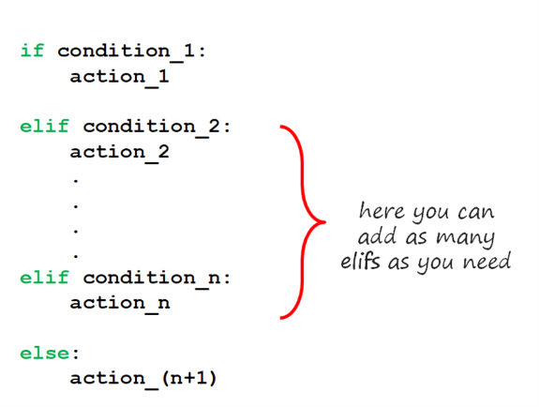

As we stated before, the code inside the else block is executed only if all conditions before it is False.

|  |
| --- |
| audience = "baby"  if audience == "kid":  print("it is free to go to cinema")  elif audience == "teen":  print("discounted price!")  elif audience == "adult":  print("normal price")  else:  print("No such audience, stay at your home!") |
| No such audience, stay at your home! |

In this program, we grouped the prices of movie tickets based on the age ranges of the audience going to the cinema. If you pay attention, after the True or False check-in each level, the flow continues according to the response received. In the last step, else can be reached if all the answers are False. See the flow diagram below :

**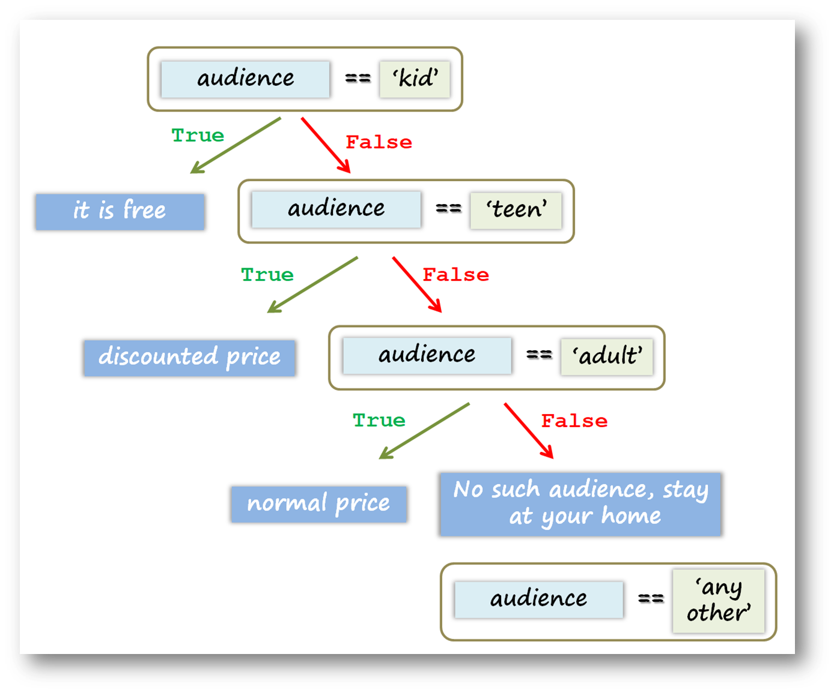**

### Nested IF-ELIF-ELSE Statements

Both if-else and if-elif statements can be nested. Let's see the nested structure on the same movie ticket example.

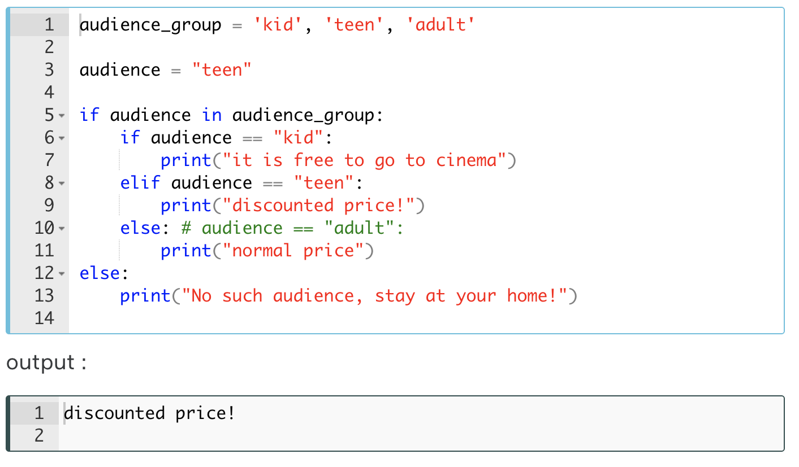

### Loops

When writing programs in Python, in some cases it is not enough to execute our block of code only once. The **loops** are used to repeat (iterate) the execution of a block of code.

As one of the most main functions in programming, loops are an important part of almost every programming language. Loops enable programmers to set certain sections of their code to repeat through a number of loops which are referred to as iterations.

This topic covers using multiple types of loops and applications of loops in Python. You will learn two types of loops which are :

* **while Loop**,
* **for Loop**.

Q: What are the two major loop statements?  
A: for and while loops.

#### WHILE LOOP

while loops have a boolean logic, similar to if statements. As long as the result of the condition returns True, the code block under while loop runs. When the condition returns to False, the loop execution is terminated and the program control moves further to the next operation. Here is the simple structure of a while loop :

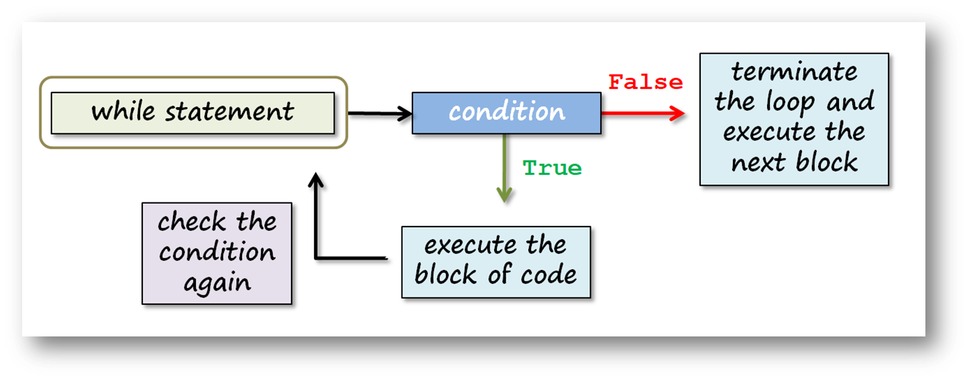

|  |
| --- |
| number = 0  while number < 6:  print(number)  number += 1  print('now, number is bigger or equal to 6') |
| 0  1  2  3  4  5  now, number is bigger or equal to 6 |

The variable *number* acts as a counter in this loop. This variable changes its value after each iteration. When the value of a counter reaches 6, the program control moves to the next operation and prints the text above.

**⚠️Avoid ! :**

* If we make a logical mistake in the loop variable (since you don’t increase your variable, a condition never becomes False and can work forever), we can start an infinite loop! For this reason, we have to specify a condition for the loop to give False to exit the loop.

We can call a list in while loop. Let's see an example :

|  |
| --- |
| my\_list=["a", "b", "c", "d", "e"]  a = 0  while a < len(my\_list):  print('square of {} is : {}'.format(a, a\*\*2))  a+=1 |
| square of 0 is : 0  square of 1 is : 1  square of 2 is : 4  square of 3 is : 9  square of 4 is : 16 |

Always use valid syntax and make comments. In the beginning, it may seem that the while loop is not so easy to apply, but several times later, you’ll understand that it’s a very useful tool. Lastly, let's play famous 'guessing a number game' using while loop :

|  |
| --- |
| answer = 44  question = 'What number am I thinking of? '  print ("Let's play the guessing game!")  while True:  guess = int(input(question))  if guess < answer:  print('Little higher')  elif guess > answer:  print('Little lower')  else: # guess == answer  print('Are you a MINDREADER!!!')  break |

In the example above;

* We have written a program that does not exit the while loop until you find the correct number,
* We used break keyword in order to quit and exit the while loop,
* When the user knows the answer (44) and enters input, it takes the value of 44 and assigns to variable guess, in the end, else works and breaks the loop.

#### FOR LOOP

You'll learn one of the most used, very simple and useful syntaxes in Python: for loop. When you want to iterate a block of code you will use for loop. To create a for loop, you need a **variable** and an **iterable object**. Here is the simple structure of a for loop :

for variable in iterable :

code block

|  |
| --- |
| for i in [1, 2, 3, 4, 5] :  print(i) |
| 1  2  3  4  5 |



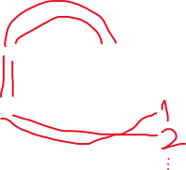

|  |
| --- |
| Seasons\_list = ['spring', 'summer', 'autumn', 'winter']  for season in seasons\_list :  print(season) |
| spring  summer  autumn  winter |

|  |
| --- |
| for i in {'n1' : 'one', 'n2' : 'two'} :  print(i) |
| n1  n2 |

Q: How does for loop and while loop differ in Python and when do you choose to use them?  
A: **For loop** is generally used to iterate through the elements of various collection types such as list, tuple, set and dictionary.  
  
**While loop** is the actual looping feature that is used in any other programming language. This is how Python differs in handling loops from the other programming languages.

#### Working with the Iterators

Let us explain the term **iteration** a little more.

**Iterable** object can be anything for which items are received one by one, forward only. In Python, the process of recurrent execution of a block of code is called an **iteration**.

We can basically classify iterations as two headings :

* If the number of repetitions is predetermined, it is called **definite** iteration.
* The repetition structure that makes the code block run as long as the predetermined condition generates True is called **indefinite** iteration.

**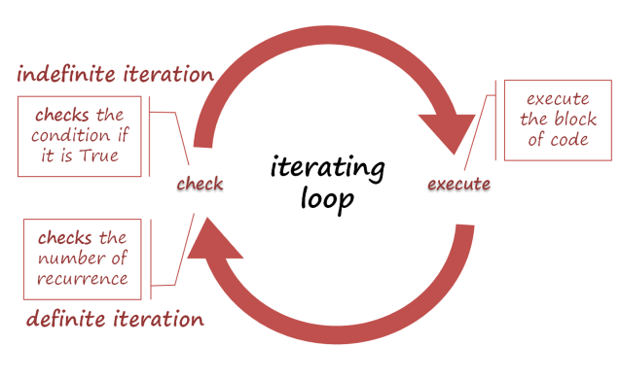**

For example; string, list, tuple, dictionary or set are the iterable types of data.

Let's use a string variable as an iterator in for loop :

|  |
| --- |
| course = 'clarusway'  for i in course :  print(i) |
| c  l  a  r  u  s  w  a  y |

⚠️ There is an unexpected situation regarding the use of for loop with dictionary. As in the example we expect to see the values as output, bit we have only keys instead.

|  |
| --- |
| user = {  "name" : "Daniel",  "age" : "30",  "class" : "3-C"  }  for x in user:  print(x) |
| name  age  class |
| for m, n in user.items(): #Using 2 variables for the same dictionary  print(m, ":", n) |
| name : Daniel  age : 30  class : 3-C |

Another example with a list made up of tuples:

|  |
| --- |
| tuple\_list = [("ali", "ayse"), ("bekir", "birgul")]  for a, b in tuple\_list:  print(a, " + ", b) |
| ali + ayse  bekir + birgul |
| for a in tuple\_list:  print(a) |
| ('ali', 'ayse')  ('bekir', 'birgul') |

**Q**: What are Python iterators?  
**A**: Iterators in Python are array-like objects which allow moving on the next element. We use them in traversing a loop, for example, in a for loop.

#### Operations with the 'for' Loop

In this topic, you will learn about how we use the for loop using several functions and methods.

In the example below, you'll get a number from the user and print a sentence the number of times we receive from the user.

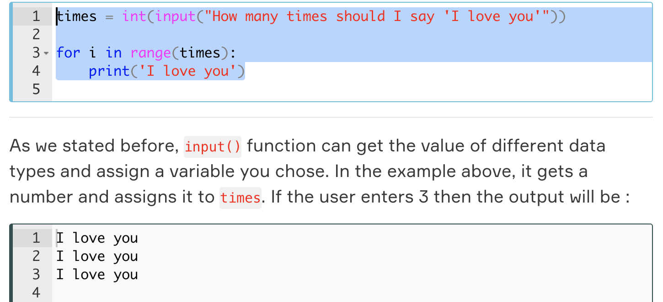

Now, let's write a code that asks the user a number between 1 and 10 and puts that number into the **multiplication table**.

|  |
| --- |
| n = int(input('enter a number between 1-10'))  for i in range(11):  print('{}x{} = '.format(n, i), n\*i) |

**💡Tips :**

* If you want the user to input numbers, use the input() function together with the int() function. Otherwise, the value entered by the user will be in the **string** data type.

#### Range

Let's get to know the features of range() function in details:

**The formula syntax is : range(start, stop, step)**

The range() function creates an iterable sequence of numbers. And it can be simply converted into an iterable object: list, set, and tuple. For example :

|  |  |
| --- | --- |
| list(range(11)) | [0, 1, 2, 3, 4, 5, 6, 7, 8, 9, 10] |
| set(range(0,11)) | {0, 1, 2, 3, 4, 5, 6, 7, 8, 9, 10} |
| c = tuple(range(11)) | (0, 1, 2, 3, 4, 5, 6, 7, 8, 9, 10) |

You can use starred expression 👉🏻**\*** before range() function to separate its elements.

|  |
| --- |
| print(range(5)) # it will not print the numbers in sequence  print(\*range(5)) # '\*' separates its elements |
| range(0, 5)  0 1 2 3 4 |

|  |
| --- |
| print(\*range(5, 25, 2)) |
| 5 7 9 11 13 15 17 19 21 23 |

Starred expression 👉🏻**\*** can separate other **iterable** objects. For example, you can separate a string:

|  |
| --- |
| print(\*('separate')) |
| s e p a r a t e |

You can create reverse sequence numbers using a negative step.

|  |
| --- |
| print(\*range(10,0,-2)) |
| 10 8 6 4 2 |

In some cases, you will need to set up the for loop with multiple variables and the iterables.

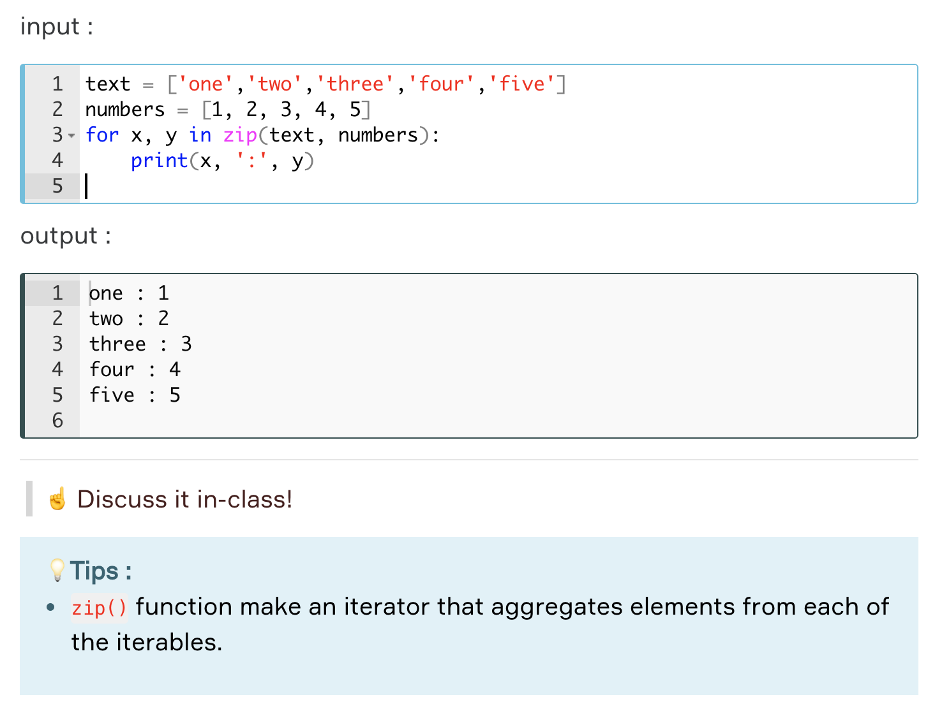

#### Nested 'for' Loop

As a programmer, you may sometimes need to interact with a single element of an iterable data and all other elements simultaneously, that is, your code block in a loop can also contain a loop. Yes, we're talking about nested loops.

In Python, you can easily place one loop inside another one. First outer loop then inner one runs. You'll see it in the following example :

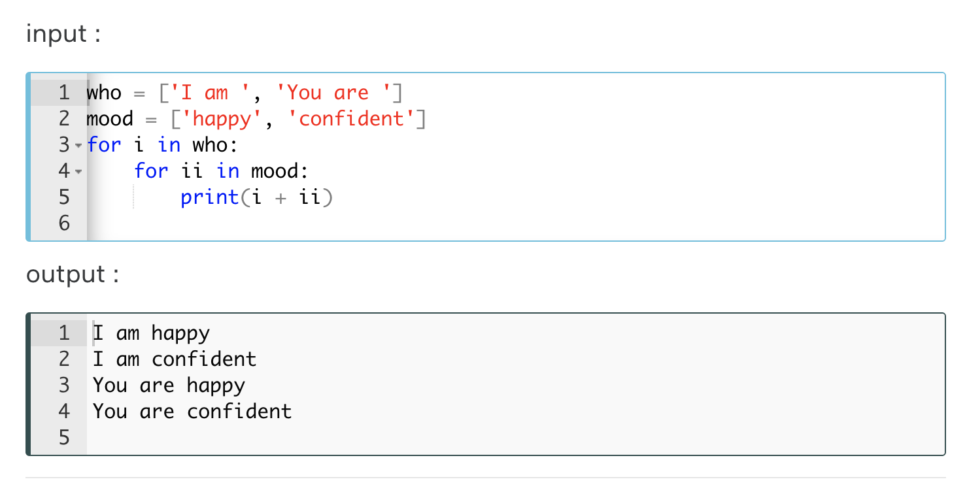

## Functions

Basically, a **function** is a block of code that executes some logic for you, e.g. prints a text, deletes some data or square a number. In other words, a **function**is a piece of code that only runs when it is called.

Functions in Python provide organized, reusable and modular code to perform a set of speciﬁc actions. Functions simplify the coding process, prevent redundant logic, and make the code easier to follow.

You can enter or input data, known as **arguments**, into a function and it returns/outputs something good that you want.

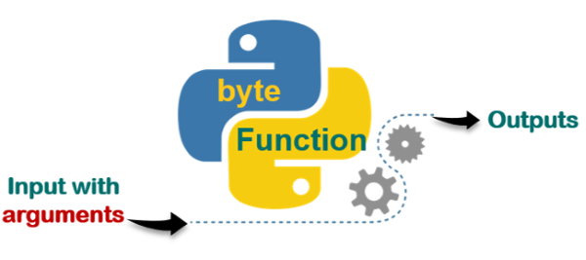

In some cases, you may need to create your own function. So that they help eliminate mess in your code because it saves you from unnecessary repetitions. You can **call**and use your function whenever and wherever you want. Follow a sample of flow diagrams of the functionalization process below. You can see below that we have several nested loops and conditional statements. As you noticed there are many repetitions of codes which look a bit messy and hard to understand.

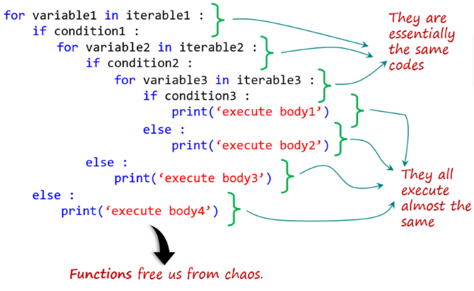

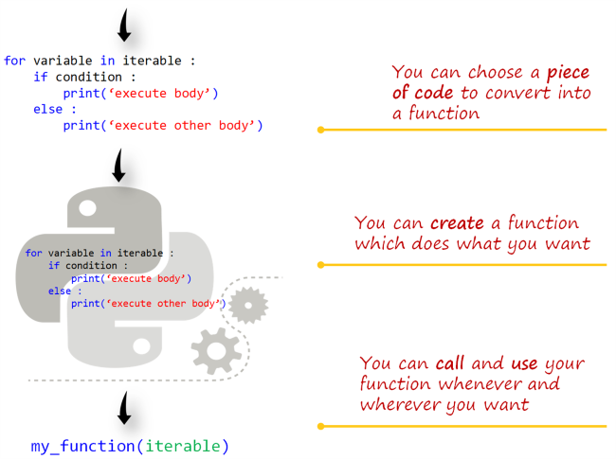

Here we have tried to show you just the logical process of creating a function. As an example, my\_function is the name of the function that we have created. We have chosen a code block which consists of a **for-loop** and an **if-statement** to create a function. You will learn how we create and call a function with full syntaxes in the next lesson. Before **defining** (or creating) a function, let's take a look at how we **call** and use it.

**Q**: What is function in Python?  
**A**: A function is a block of code which is executed only when it is called. To define a Python function, the def keyword is used.

### Calling a Function

Reading a function is very easy in Python. For example; multiply(2, 5) or multiply(no1, no2). In this example, **multiply** is the name of the function, 2 and 5 are its **arguments** that we passed into the **parameters** which are the variables (no1 and no2). You can simply grasp that this function multiplies two numbers.

**💡Tips:**

* In fact, according to relevant [Python documents](https://docs.python.org/3/tutorial/controlflow.html#defining-functions), there is no significant difference between the definition and use of **parameter** and **argument** terms in Python. But, they are slightly different from each other.

Actually, **calling** a function means **using** it. When you need a function in your codes, you can simply use it. For example, if you want to multiply two numbers, you can just write the name of that function and the numbers (arguments) inside the parenthesis. By doing this, you have actually called this function. Look at the examples below :

|  |
| --- |
| a = 3  b = 5  multiply(3, 5) |
| 15 |

#### Calling print() Function

You have already used print() function dozens of times since the beginning of this course. You have also learned the details of print() function in the **Python Basics** course.  You are now very familiar with it. Nevertheless, let's take a look at what is what.  
  
In fact, what we do is solely writing its name and adding parentheses after it to call the print() function in your code. That's it!  
  
For example, let's consider this code : print("Say : I love you!") Here, in the example, you see the name of the function (print) followed by a sentence in parentheses. We can say that the sentence (Say: I love you!) that you passed into the 👉🏻() is an **argument**. We have a wide range of freedom of movement here. We may use the print() function with no argument besides we can also use it even with multiple arguments :

|  |
| --- |
| print('Say: I love you!')  print()  print('me too', 2019) |
| Say: I love you!  me too 2019 |

As you can see the outputs of the example above, we called that function (print()) three times. The first call printed a string, the second call printed an empty line and the third call printed two arguments which consist of one string and one integer data.

### Built-in Functions

If you are considering a function which may do something that you want, it probably exists. You just need to be aware of its existence.

There are a range of functions and types built into the Python interpreter, so they are always usable. By the way, you don't have to worry about the term **interpreter**. We will talk about what it is in the next lessons.

In the latest version Python 3.8 the number of [**built-in functions**](https://docs.python.org/3/library/functions.html#built-in-functions) is 69. So far you have learned and used almost a dozen of these functions for various purposes. Such as : print(), int(), list(), input(), range().

These built-in functions are indeed very useful. They solve most of your needs without having to fall back on elsewhere.

It is a great benefit to have a quick look at the official Python documentation for the built-in functions mentioned below.

* Some of them return bool type according to the conditional algorithm in it. For example; all(iterable), any(iterable), and callable(object).
* Some of them help you convert data types into each other. For example; bool(), float(), int(), and str().
* Some others allow you to create and process the collection types. Such as:    
  dict(),  list(), tuple(), set(), len(), frozenset(), zip(), filter(function, iterable), and enumerate(iterable).
* Some others tackle numbers. Such as : max(), min(), sum(), and round().
* The others are built for special purposes. They do some complicated implementations. For example :  
   map(function, iterable, ...), eval(expression[, globals[, locals]]), sorted(iterable), open(), dir([object]), hash(), and help([object]).

In conclusion, we had a short tour of built-in functions and there is far more to explore, but don't ever give up!

**Q**: Explain Python functions.  
**A**: A function is a section of the program or a block of code that is written once and can be executed whenever required in the program. A function is a block of self-contained statements which has a valid name, parameters list, and body. Functions make programming more functional and modular to perform modular tasks. Python provides several built-in functions to complete tasks and also allows a user to create new functions as well. There are two types of functions: Built-In Functions: copy(), len(), count() are the some built-in functions. User-defined Functions: Functions which are defined by a user known as user-defined functions.

### Defining (Creating) a Function

Sometimes when you writing a program, built-in functions maybe not enough for you. Or sometimes you may need to use a block of code in your program repeatedly. Then you can write your own function. That is called the **user-defined function**in Python.

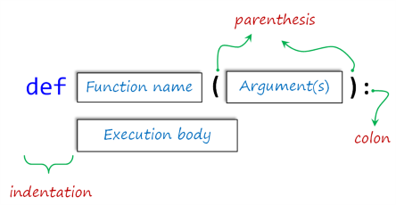

The keyword **def** introduces the name of the function. It must be followed by the function name and the parenthesized list of formal arguments. The statements that form the body of the function start at the next line and must be indented (leave four spaces).

#### Main Principles of 'Defining'

The basic **formula syntax** of user-defined function is :

def function\_name(arguments) :

execution body

We define a Python function using the **def** statement, providing a name (so as to call it later) for our function and specifying either an empty or multiple argument list within parentheses. The rules for naming variables also apply here. So they should be written in **lowercase with underscores between words**. Argument lists are optional, but the parentheses are NOT.

A colon 👉🏻**:** follows the closing parenthesis and indicates the start of our functions execution body. The function’s codes (execution body) MUST be indented under the **def** statement.

**⚠️Avoid:**

* Remember to put colon 👉🏻: just after the parentheses.
* Remember to leave four-space indentation at the beginning of the execution body lines.

|  |
| --- |
| def first\_function(argument\_1, argument\_2) :  print(argument\_1\*\*2 + argument\_2\*\*2) |

|  |
| --- |
| first\_function(2, 3) # here, the values (2 and 3) are allocated to the arguments |
| 13 |

In the example above, the values (2 and 3) are allocated to the arguments provided at the function call in parentheses.

**💡Tips:**

* When there is**no indentation**, it means that the **definition process** of the function must **end**.

And now, let's define the multiplying function (multiply(a, b)) that you have seen as an example in the previous lesson.

|  |
| --- |
| def multiply(a, b) :  print(a \* b)  multiply(3, 5)  multiply(-1, 2.5)  multiply('amazing ', 3) # it's really amazing, right? |
| 15  -2.5  amazing amazing amazing |

As we have already stated, we can define a function without using any arguments. Let's give an example by leaving the parentheses empty.

|  |
| --- |
| def motto() :  print("Don't hesitate to reinvent yourself!")  motto() # it takes no argument |
| Don't hesitate to reinvent yourself! |

**Q**: How do we write a function in Python?  
**A**: We can create a Python function in the following manner.  
Step-1: to begin the function, start writing with the keyword def and then mention the function name.  
Step-2: We can now pass the arguments and enclose them using the parentheses. A colon, in the end, marks the end of the function header.  
Step-3: After pressing an enter, we can add the desired Python statements for execution.

#### Execution of a Function

The functions you have seen so far did not **return**any types or values but executed some actions. In order to use later the output and data types generated by the functions in our program flow, we need to define our function using the keyword return in addition to def. Let's see what happens in the following example :

|  |
| --- |
| def multiply\_1(a, b) :  print(a \* b) # it prints something  def multiply\_2(a, b) :  return a \* b # returns any numeric data type value  multiply\_1(10, 5)  print(multiply\_2(10, 5)) |
| print(type(multiply\_1(10, 2)))  print(type(multiply\_2(10, 5))) |
| 20  <class 'NoneType'>  <class 'int'> |

So, when we need it in our program, we can't use the result of the first function since it is **NoneType** data. But, the second one is **integer data** that we can use it in the future when we need it. Let's take a look at this subject using Python's best-known function.

|  |
| --- |
| shadow\_var = print("It can't be assigned to any variable")  print(shadow\_var) # NoneType value can't be used |
| It can't be assigned to any variable  None |

In the example above, we can't assign the result of print() function to a variable.

**Q**: What is the return keyword used for in Python?  
**A**: The purpose of a function is to receive the inputs and return some output. The return is a Python statement which we can use in a function for sending a value back to its caller.

## The Matter of Arguments

### Arguments vs Parameters

We are aware that it may seem a bit difficult to understand clearly what **arguments**are. Likewise, the term **parameters**used in the same way as the arguments may seem also hard to grasp.

In fact, **arguments**are some kind of variable. So you can think of them as aliases for variables. This is exactly what we call the **parameters**. That is, the values ​​you assign to the parameters defined in a function are arguments.

If you look at the Python [documentation](https://docs.python.org/3/tutorial/controlflow.html?highlight=built%20function" \l "more-on-defining-functions" \t "_blank)on this topic, you will notice that the terms **parameters**and **arguments**are used almost the same way. But they are different things.

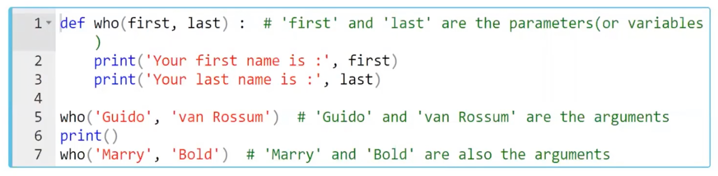

This function can be executed with different arguments. You can pass any two strings into the parameters.

Since the function given in the example above takes two arguments, we need to pass exactly two arguments into it. If you passed only one argument into the parameter of the  who() function, it gives an error. Consider the following example

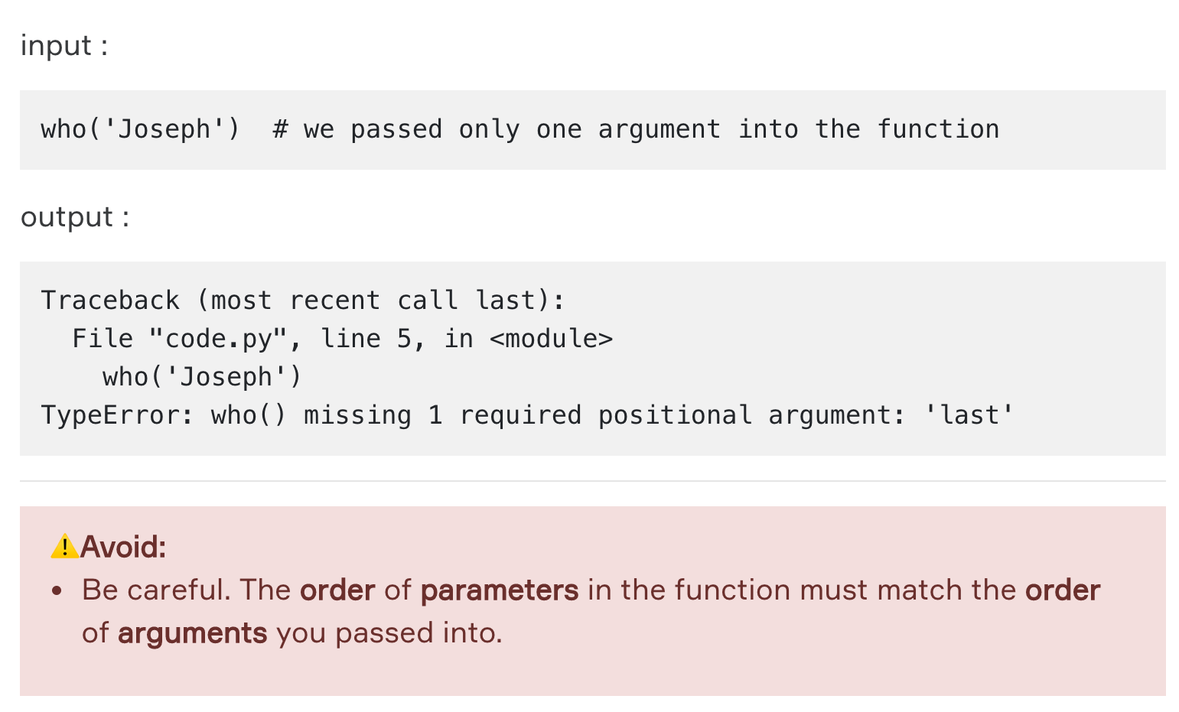

### Correct Use of Arguments

We will stick to relevant [Python documents](https://docs.python.org/3/tutorial/controlflow.html" \l "more-on-defining-functions" \t "_blank) to make you understand this subject clearly. When calling a function, there are several ways to use arguments.

#### Positional Arguments

Actually, the arguments that you learned in the previous lesson is the positional one. Positions (sequence) of the arguments matter. When calling a function with **positional arguments**, they must be passed **in order from left to right**.

|  |
| --- |
| #Make an output "i love you"  def texter(t1, t2, t3):  print(f"{t2} {t3} {t1}")  a = "i"  b = "love"  c = "you"  texter(c,a,b) |
| I love you |

#### Keyword Arguments

If you do not want to allow the sequences/positions of the arguments to restrict you when you call a function, you can also call these arguments by keywords. Commonly and traditionally, **kwargs**is used as an abbreviation of **keyword arguments**.

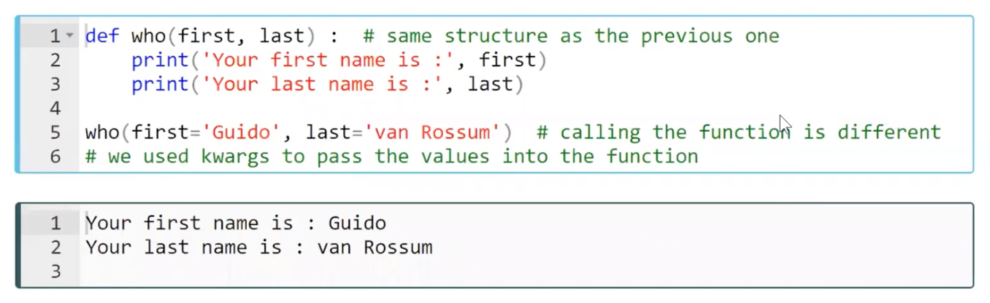

|  |
| --- |
| def texter(t1, t2, t3):  Kwargs saves us from positional restrictions  print(f"{t2} {t3} {t1}")  print(texter(t1="you", t2="i", t3="love"))  print(texter(t2="i", t3="love", t1="you")) |
| i love you  i love you |

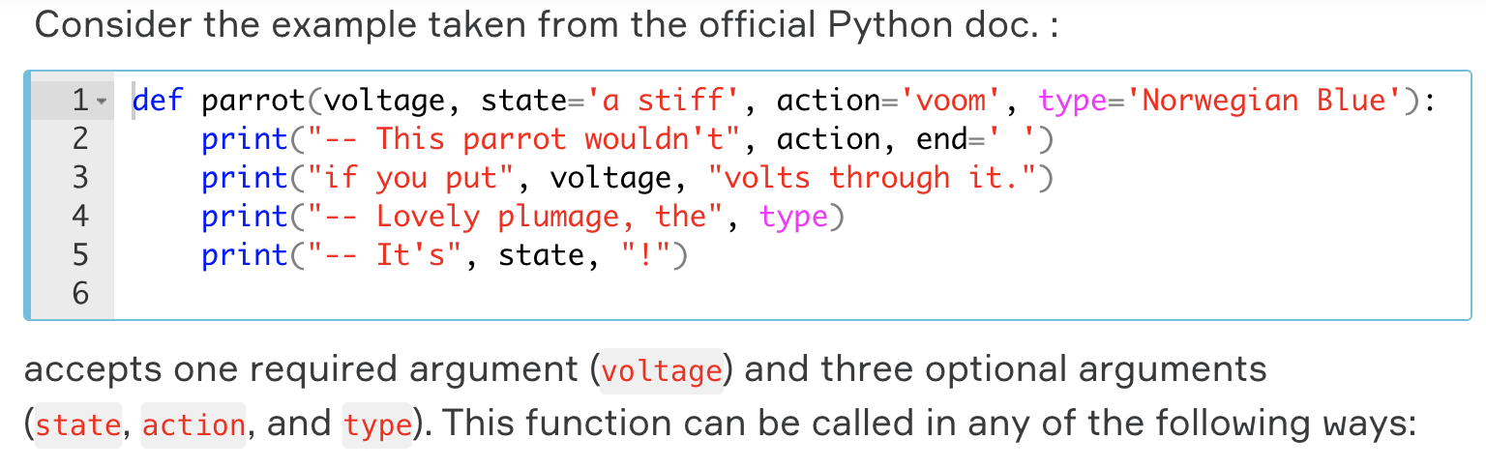

|  |  |
| --- | --- |
| parrot(1000)  #1 positional | -- This parrot wouldn't voom if you put 1000 volts through it.  -- Lovely plumage, the Norwegian Blue  -- It's a stiff ! |
| parrot(voltage = 1000)  #1 keyword | -- This parrot wouldn't voom if you put 1000 volts through it.  -- Lovely plumage, the Norwegian Blue  -- It's a stiff ! |
| parrot(voltage = 1000000, action = "VOOOOM")  # 2 keywords | -- This parrot wouldn't VOOOOM if you put 3333 volts through it.  -- Lovely plumage, the Norwegian Blue  -- It's a stiff ! |
| parrot(action = "VOOOOM", voltage = 1000000)  #2 keywords in reverse order | -- This parrot wouldn't VOOOOM if you put 3333 volts through it.  -- Lovely plumage, the Norwegian Blue  -- It's a stiff ! |
| parrot("a million", "bereft of life", "jump" )  #3 positionals | -- This parrot wouldn't jump if you put a million volts through it.  -- Lovely plumage, the Norwegian Blue  -- It's bereft of life ! |
| parrot("a thousand", state = "pushing up the daisies")  #1 positional, 1 keyword | -- This parrot wouldn't voom if you put a thousand volts through it.  -- Lovely plumage, the Norwegian Blue  -- It's pushing up the daisies ! |
| parrot() | Error |
| parrot(voltage = 5, ‘dead’) | Error  (positional followed by a keyword,  should be opposite) |
| parrot(‘dead’, voltage = 5) | Error  (We assign 2 values to voltage parameter) |

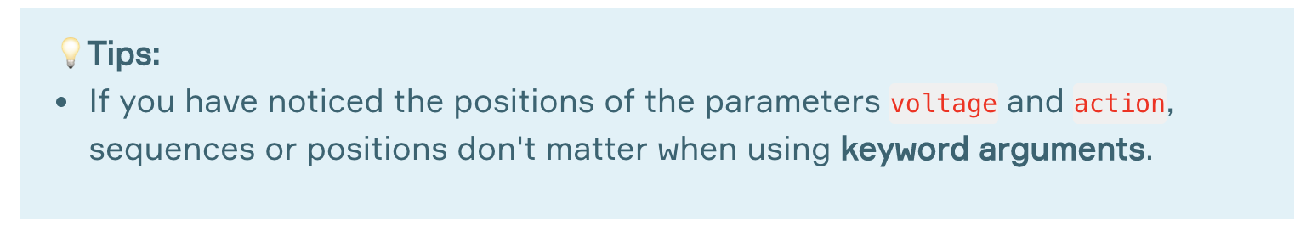

If we use positional arguments together with the kwargs, kwargs must come after positional arguments.

### Special Arguments (Optional)

According to the official related Python documents: By default, arguments may be passed to a Python function either by **position** or explicitly by **keyword**. For readability and performance, it makes sense to restrict the way arguments can be passed so that a developer need only look at the function definition to determine if items are passed by position, by position or keyword, or by keyword.

A function definition may look like:

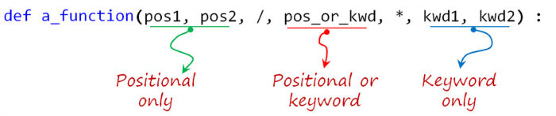

where 👉🏻/ and 👉🏻\* are optional. If used, these symbols indicate the kind of parameter by how the arguments may be passed to the function: *positional-only*, *positional-or-keyword*, and *keyword-only*. Keyword arguments are also referred to as *named arguments* or *named parameters.*

#### Positional-or-Keyword Arguments

If 👉🏻/ and 👉🏻\* are not present in the function definition, arguments may be passed to a function by position or by keyword. These are the arguments that we have already mentioned in the previous lesson.

#### Positional-Only Arguments

Looking at this in a bit more detail, it is possible to mark certain parameters as positional-only. If positional-only, the parameters’ order matters and the parameters cannot be passed by keyword. Positional-only parameters are placed before a 👉🏻/ (forward-slash). The 👉🏻/ is used to logically separate the positional-only parameters from the rest of the parameters. If there is no 👉🏻/ in the function definition, there are no positional-only parameters.

Parameters following the 👉🏻/ may be positional-or-keyword or keyword-only.

#### Keyword-Only Arguments

To mark parameters as keyword-only, indicating the parameters must be passed by keyword argument, place an 👉🏻\* in the arguments list just before the first keyword-only parameter.

**⚠️Avoid:**

* Do not confuse. When you use all kinds of arguments in a function definition, you have to pay attention the order of them.

### Arbitrary Number of Arguments

#### Default Arguments

Before moving on to the subject of the **arbitrary number of arguments**, it is better to briefly mention the **default arguments**, which are one of the kinds of arguments.

The most useful form is to specify a default value for one or more arguments. This creates a function that can be called with fewer arguments than it is defined to allow.

When calling a function defined by **parameters with default values**, there is no obligation to pass any arguments into the function. Let's see how it works in an example :  
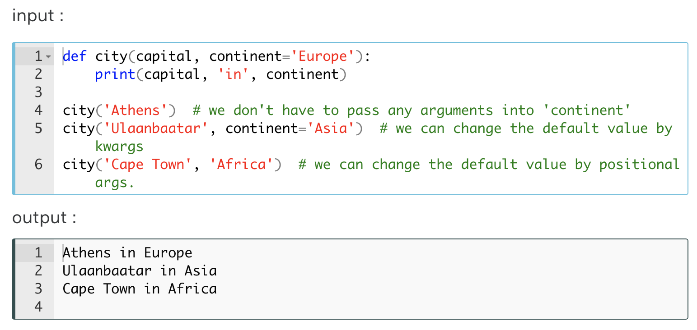

As you see in the example, new values can be assigned to parameters either by name or by position. This kind of usage simplify the calling of a function, otherwise defining the function with default values of parameters makes no sense.

#### \*args and \*\*kwargs

The arguments we have used in the functions so far limit us to a certain extent. If we don't define the default values for the arguments, we will always need to pass the exact numbers of the arguments to match the number of the parameters defined in the function. But, there will be some situations when you might want to pass an arbitrary number of arguments.  
  
Finally, the least frequently used option is to specify that a function can be called with an arbitrary number of arguments. These arguments will be wrapped up in a tuple. Before the variable number of arguments, zero or more normal arguments may occur.

The formula syntax is : \*args.

Normally, these variadic arguments will be last in the list of formal parameters because they scoop up all remaining input arguments that are passed into the function. Any formal parameters which occur after the \*args parameter are ‘keyword-only’ arguments, meaning that they can only be used as keywords rather than positional arguments.

For example, let's define a function which takes two kinds of fruit and prints them.

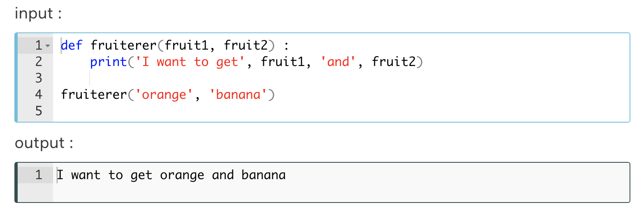

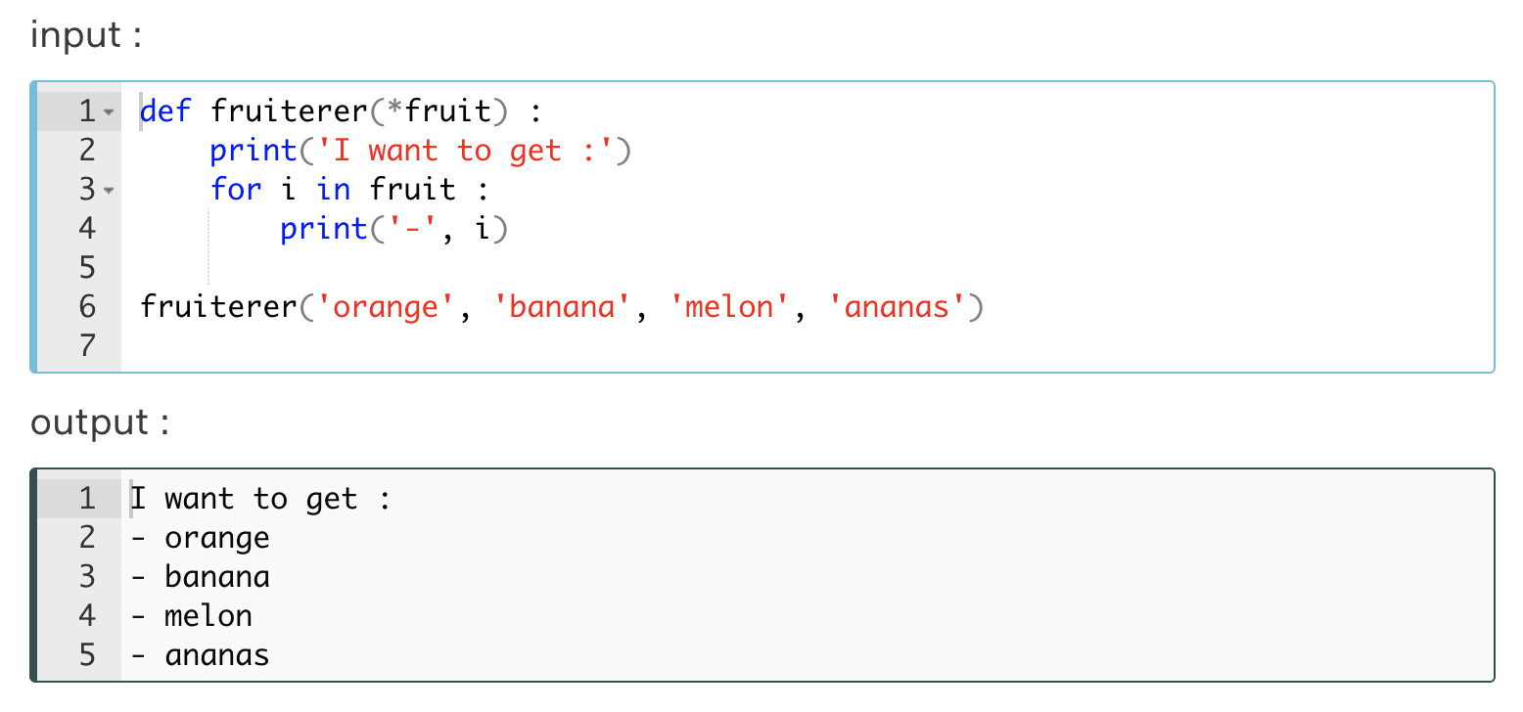

As you can see above, we passed a list of fruits (arguments) into one parameter (fruit). Isn't it very useful?

If you need to prefer to use arbitrary keyword arguments (\*\*kwargs), you can use it in the same way.

The formula syntax is : \*\*kwargs.

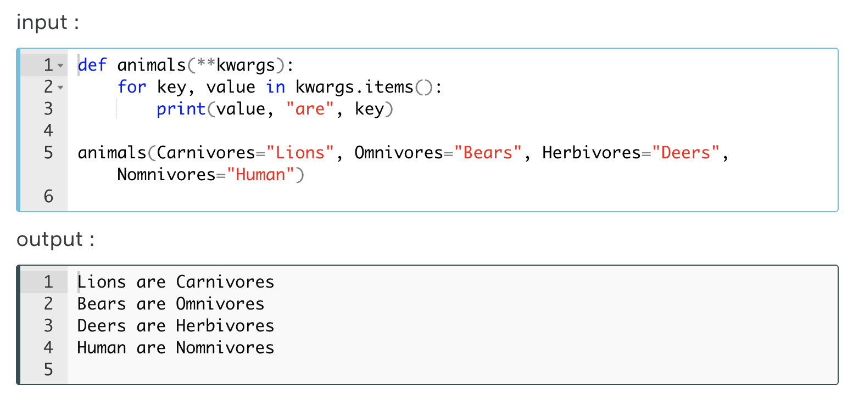

As you can see in the example, in this type of argument (\*\*kwargs), we can determine the number of the arguments and their assigned value pairs by ourselves. In the next call of this function, we can use different arguments both in number and value from the above argument pairs.

**💡Tips:**

* Traditionally, people in the world of computer programming use \*args for the arbitrary number of positional arguments and \*\*kwargs for the arbitrary number of keyword arguments.

When calling a function defined by multiple positional parameters, using \*arg syntax in parentheses, we can pass all arguments into the function with a single variable. Likewise; When calling a function defined by multiple keyword arguments, using \*\*kwargs syntax in parentheses, we can pass all arguments which are in a dictionary form into the function with a single variable. Carefully examine the following examples:

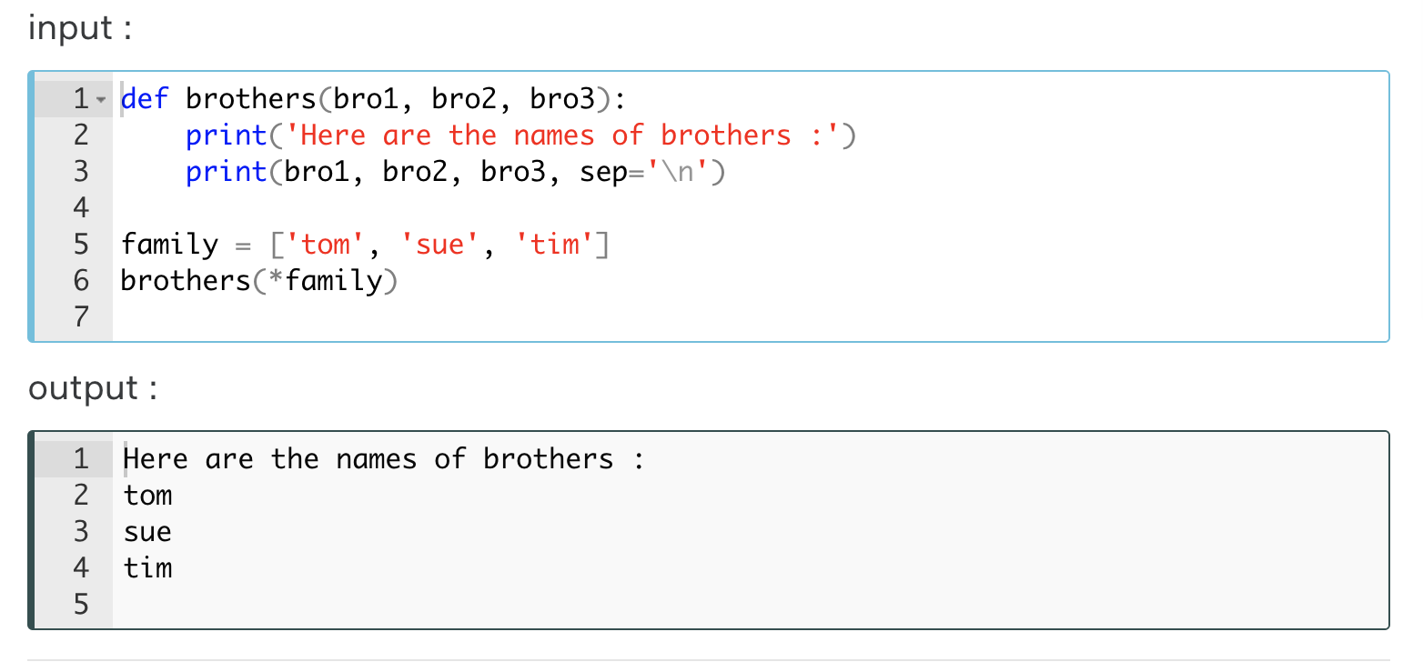

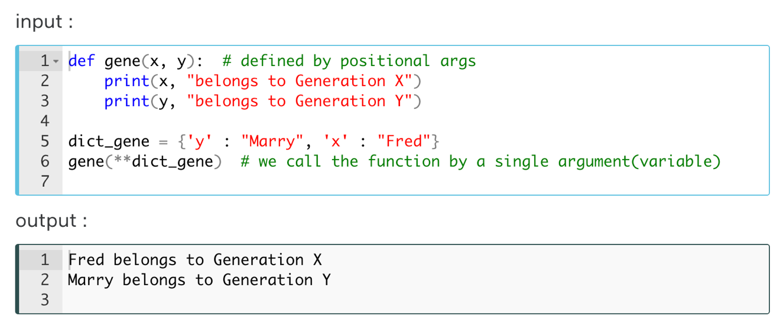

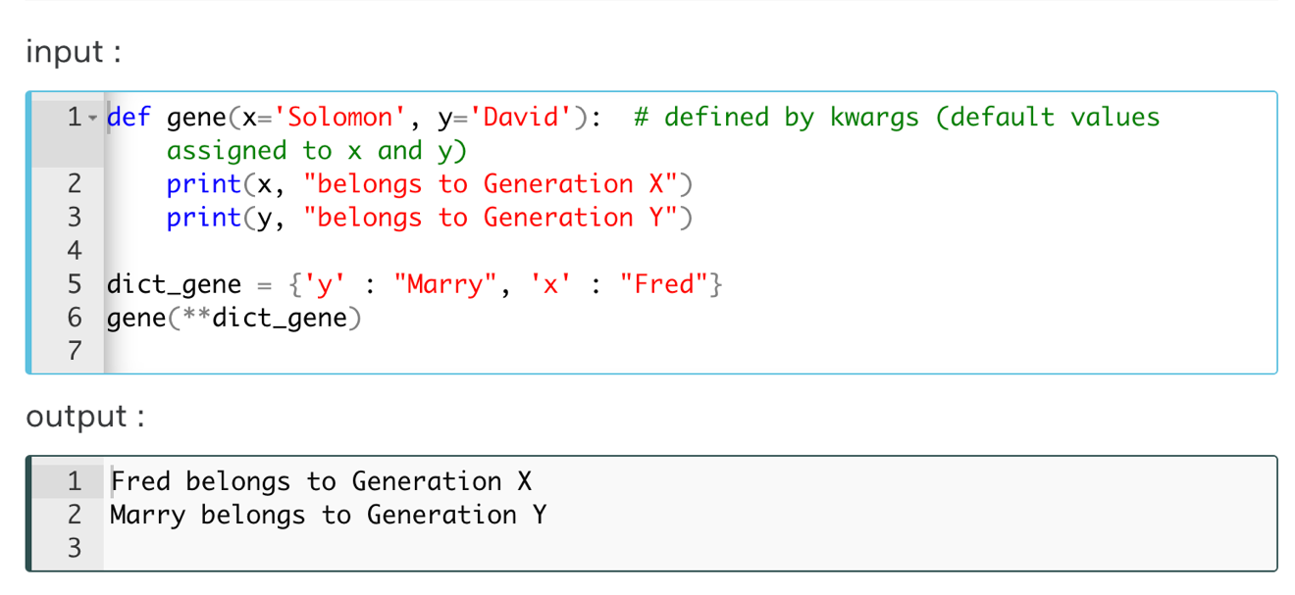

**Q**: What does this mean: \*args, \*\*kwargs? And why would we use it?  
**A**: We use \*args when we aren’t sure how many arguments are going to be passed to a function, or if we want to pass a stored list or tuple of arguments to a function. \*\*kwargs is used when we don’t know how many keyword arguments will be passed to a function, or it can be used to pass the values of a dictionary as keyword arguments. The identifiers args and kwargs are a convention, you could also use \*bob and \*\*billy but that would not be wise.

### Recapitulation (Optional)

The use case will determine which parameters to use in the function definition:

|  |
| --- |
| def a\_function(pos1, pos2, /, pos\_or\_kwarg, \*, kwarg1, kwarg2, \*\*kwargs) : |

As guidance:

* Use **positional-only** if you want the name of the parameters to not be available to the user. This is useful when parameter names have no real meaning, if you want to enforce the order of the arguments when the function is called or if you need to take some positional parameters and arbitrary keywords.
* Use **keyword-only** when names have meaning and the function definition is more understandable by being explicit with names or you want to prevent users relying on the position of the argument being passed.
* Use **arbitrary numbers of arguments** (\*args) when you can't determine how many arguments your function needs. **\*args**enables you to have interoperability with a list of positional arguments in your function.
* You can use **\*\*kwargs**, when you don't know the exact number of keyword arguments in your function. **\*\*kwargs** enables you to have interoperability with a dictionary of key-value pairs.
* The order of the **parameters** you use when defining the function is as important as the order of the **arguments** you pass into when you call the function.

## Scope of the Variables

Let us give you some theoretical explanations about the term **namespace** and **scope** in Python. We will again stick to relevant [Python documents](https://docs.python.org/3/tutorial/classes.html?python-scopes-and-namespaces#python-scopes-and-namespaces) to make you understand this subject clearly. Besides, we think that examining these Python documents will be of great benefit to you.

#### What is Namespace?

A **namespace** is a system in which each **object** in Python has a *separate name*. An object could be a *method* or a *variable*. In other words, a **namespace** is a mapping from names to objects. Most namespaces are currently implemented as Python **dictionaries**, but that’s normally not noticeable in any way (except for performance), and it may change in the future.

*For example*: imagine that you have two files named 'my\_python' on your computer both on **drive-C** and **drive-D**. You can easily access which file you want, by the file-path system. It can be easily understood which file is on which drive by looking at their file path.

In the program stream, the Python interpreter understands what specific method or variable one is trying to access in the code, depending on the namespaces.

Namespaces are created at different moments and have different lifetimes. The namespace containing the built-in names is created when the Python interpreter starts up and is never deleted.

In the following figure, you can see some variables which have the same names are in the different *modules* (**namespaces**) at the same time. You can work with the variable that you want using this syntax : module.variable.

Considering this figure, we can call var1 in Module2 like : module2.var1

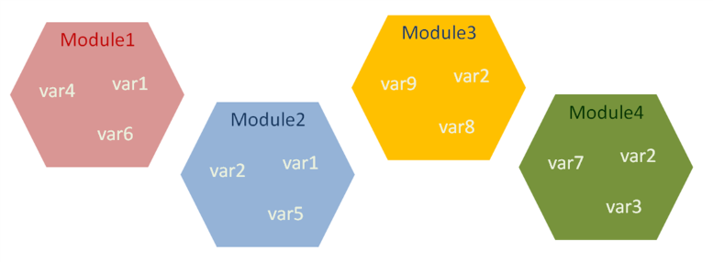

#### What is Scope?

A **scope** is a concept describes where or in which **space** the **variables** are defined in the program stream. This concept has a significant place in programming. In other words, a **scope** is a *textual region*of a Python program where a *namespace* is directly accessible. “Directly accessible” here means that an unqualified reference to a name attempts to find the name in the namespace.

The term **scope** is mostly related to nested functions, modules, and the main program flow in accordance with the use of variables. It describes the accessibility and the existence of a variable.

A **scope** defines the **hierarchical order** in which the names of the variables have to exist in order to match **names** with the **objects** (variables).

Now, let's put all these definitions into practice with a simple example :

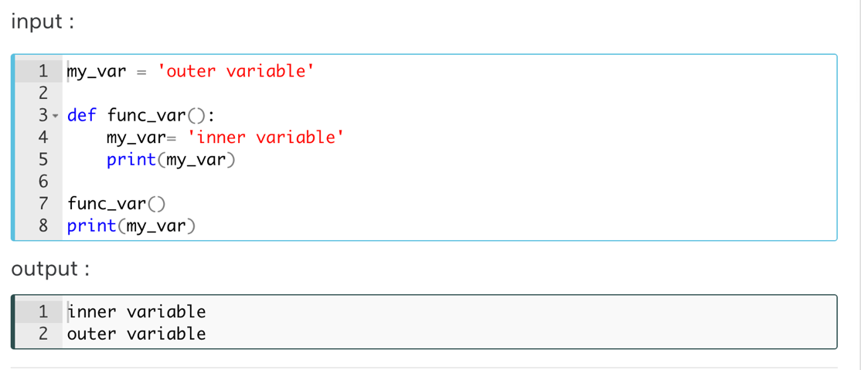

As you can see in the example, the name of the variable (my\_var) has been used both in the function (func\_var) and at the top of the main program stream. When you call the function (func\_var) or print directly the variable (my\_var), you were probably noticed that the same variable produces different outputs. This is because of the location (space) of that variable, that is, where or in which space it is defined in the program flow.

After learning what the concept of scope theoretically is, let's examine the **global** and **local** variables.

**Q**: What is the namespace in Python?  
**A**: The namespace is a fundamental idea to structure and organize the code that is more useful in large projects. A namespace is defined as a simple system to control the names in a program. It ensures that names are unique and won't lead to any conflict. Also, Python implements namespaces in the form of dictionaries and maintains name-to-object mapping where names act as keys and the objects as values.

### Global and Local Variables

When you define a variable in the Python program stream it is global or local, depending on in which space it is defined.

#### Global Variable

If the variable you define is at the highest level of a module, that variable becomes **global**. So you have the freedom to use this global **variable** in a block of code anywhere in your program.

Global variables allow us to make some interactions between functions. **For example,** suppose we store the credentials of a student who has applied for Clarusway in a **global variable**. Let's assume that we use this global variable many times in 3 **different functions** that we have defined regarding course activities. The **global variable** provides us with convenience when the credentials of the person change. Only when we rearrange the information in this global variable will our variables in all functions be rearranged.

#### Local Variable

The variables you have defined **in a function** body are **local**. The name of this variable is therefore **only valid** in the function body to which it is located.**Local variables** eliminate some of the confusion risks that global variables can cause.

Let's take a look at this example to grasp the difference between global and local variables:

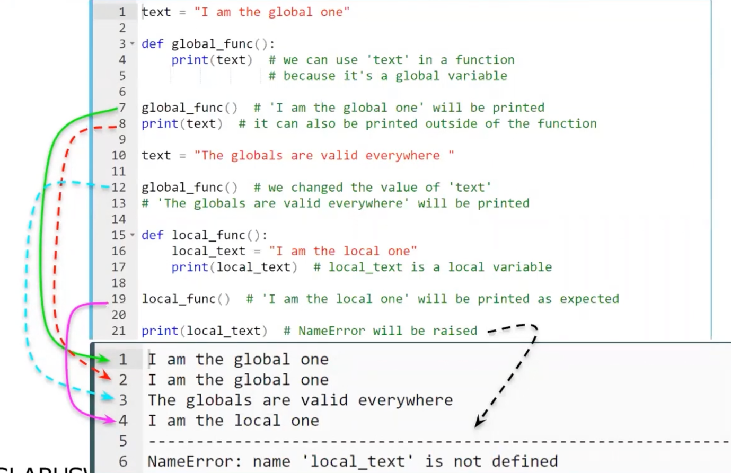

Because we can’t use local variable outside of its functiion

In the above example, we have seen that a *global variable* can be accessed not only from the top-level of the module but also from the body of the function. On the other hand, a *local variable* is valid only in the function's body it is defined. So, it is accessible from inside the nearest scope level and can not be accessed from the outside.

**💡Tips:**

* You might have a question about where you will need to use these issues. But, if you are writing a relatively long algorithm, you will eventually need to work with the nested functions and modules.

**Q**: What are local variables and global variables in Python?  
**A**: Variables declared outside a function or in global space are called global variables. These variables can be accessed by any function in the program. Any variable declared inside a function is known as a local variable. This variable is present in the local space and not in the global space. When you try to access the local variable outside the function, it will give an error.

### LEGB Ranking Rule

When you call an **object** (*method or variable*), the *interpreter*looks for its name in the following order:

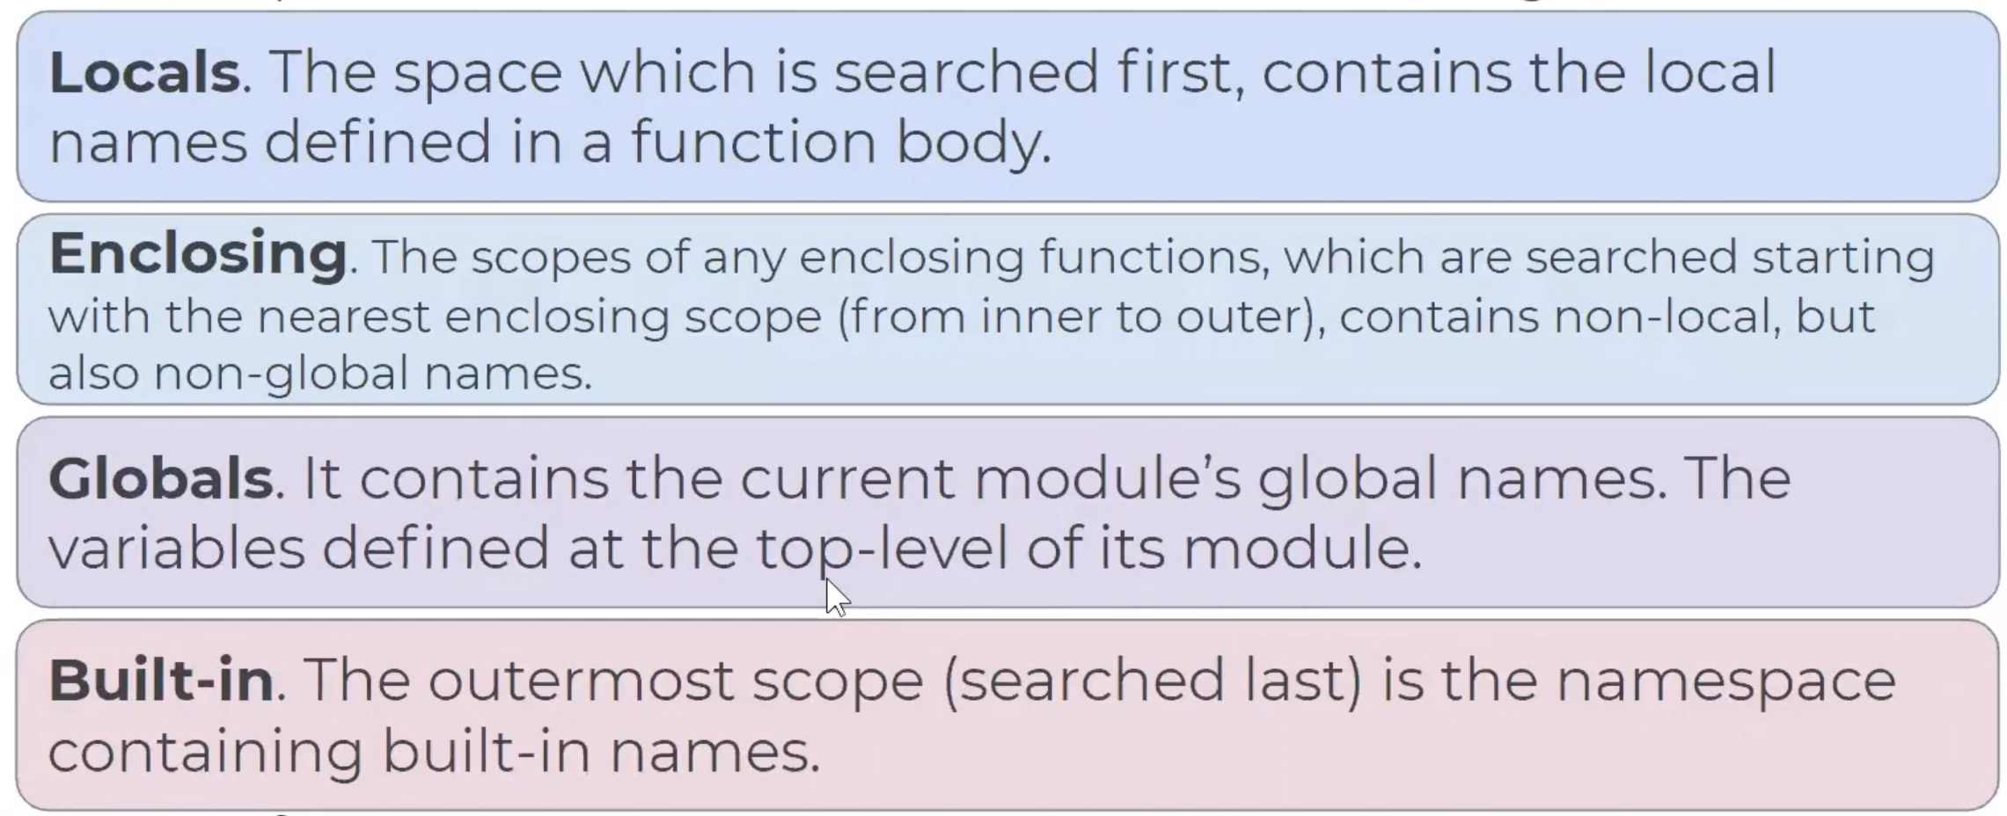

The order given above is known as **LEGB** Ranking Rule. Let's see how it works in an example :

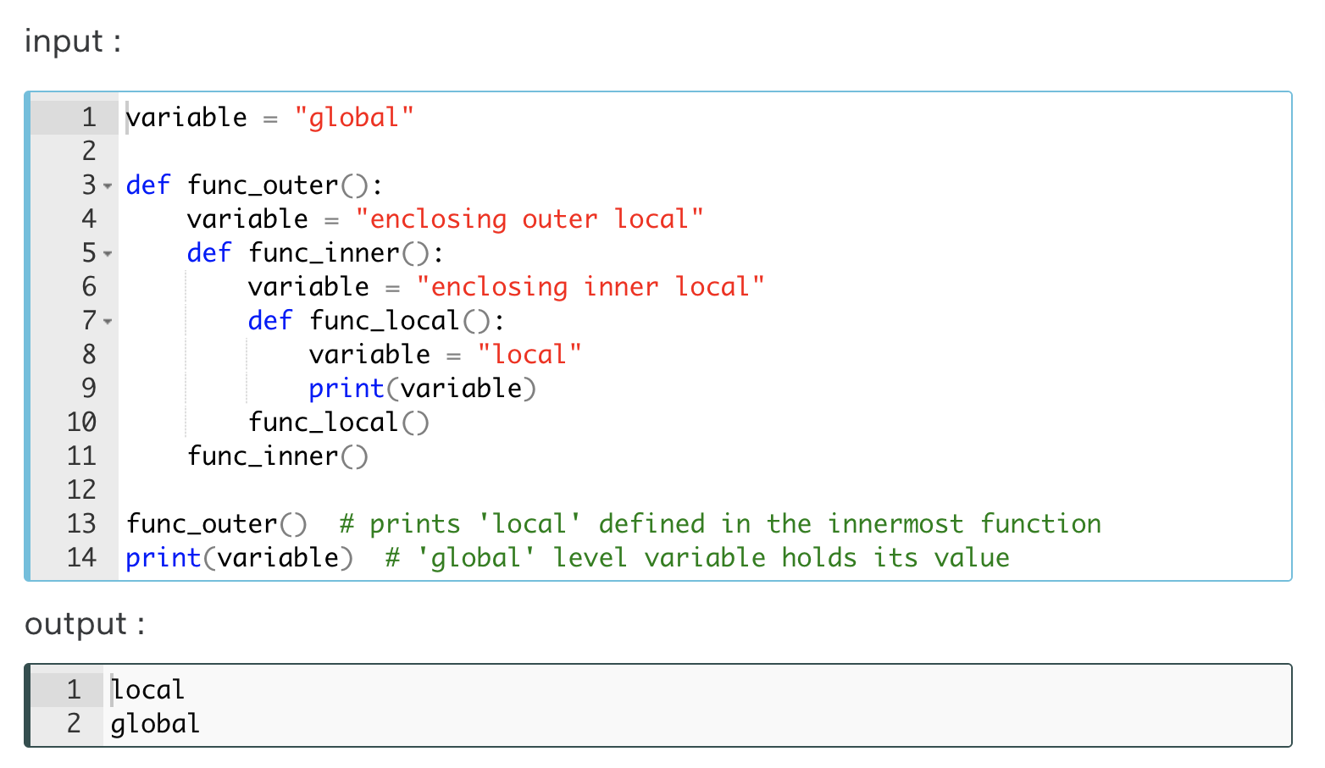

In this example, during the execution of the code lines, the interpreter has to resolve the name '*variable*'.  The searching order of the variable names will be as follows : 'local' in func\_local, 'enclosing inner local' in func\_inner, 'enclosing outer local' in func\_outer, globals and built-in names. You can examine LEGB Rule in the following figure. 

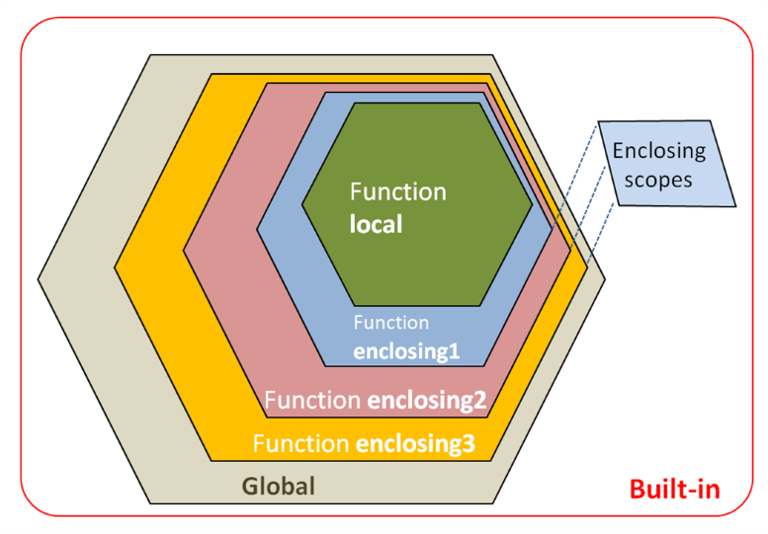

### 'global' and 'nonlocal'

You know from the previous lesson that a variable defined in a function body becomes local. In some cases, we want to work with the variables defined as a global scope in the function body. Normally they are perceived *globally* and processed accordingly.

Or we may need to work with the nonlocal variables in the function body. The keywords global and nonlocal save us from these restrictions.

#### Keyword 'global'

You can not change the value assigned to a globally defined variable within a function. To do this we use the keyword global. If you examine the example below you will understand better.

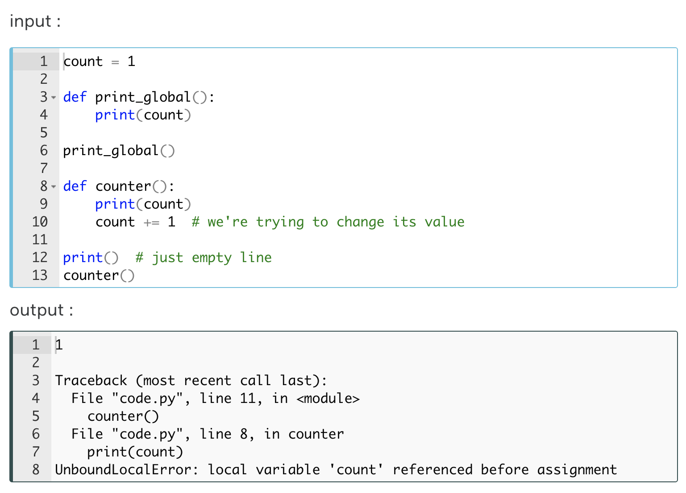

The reason for the error in the previous program is that the variable (count) we tried to modify could not be found by the interpreter in the local scope. It's because we used *global variable* in the *local scope*.

#### Keyword 'nonlocal'

On the other hand, you can use the keyword nonlocal to extend the scope of the *local variable* to an upper scope. Consider the examples of nonlocalization :

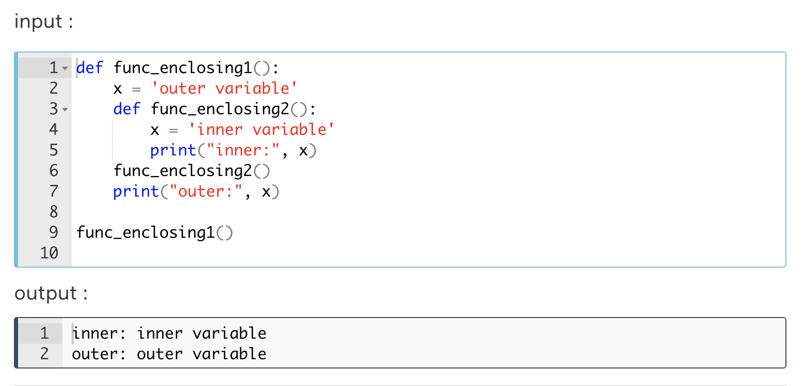

We will make the variable x nonlocal so we can use its inner-value in the outer function (scope). Let's see.

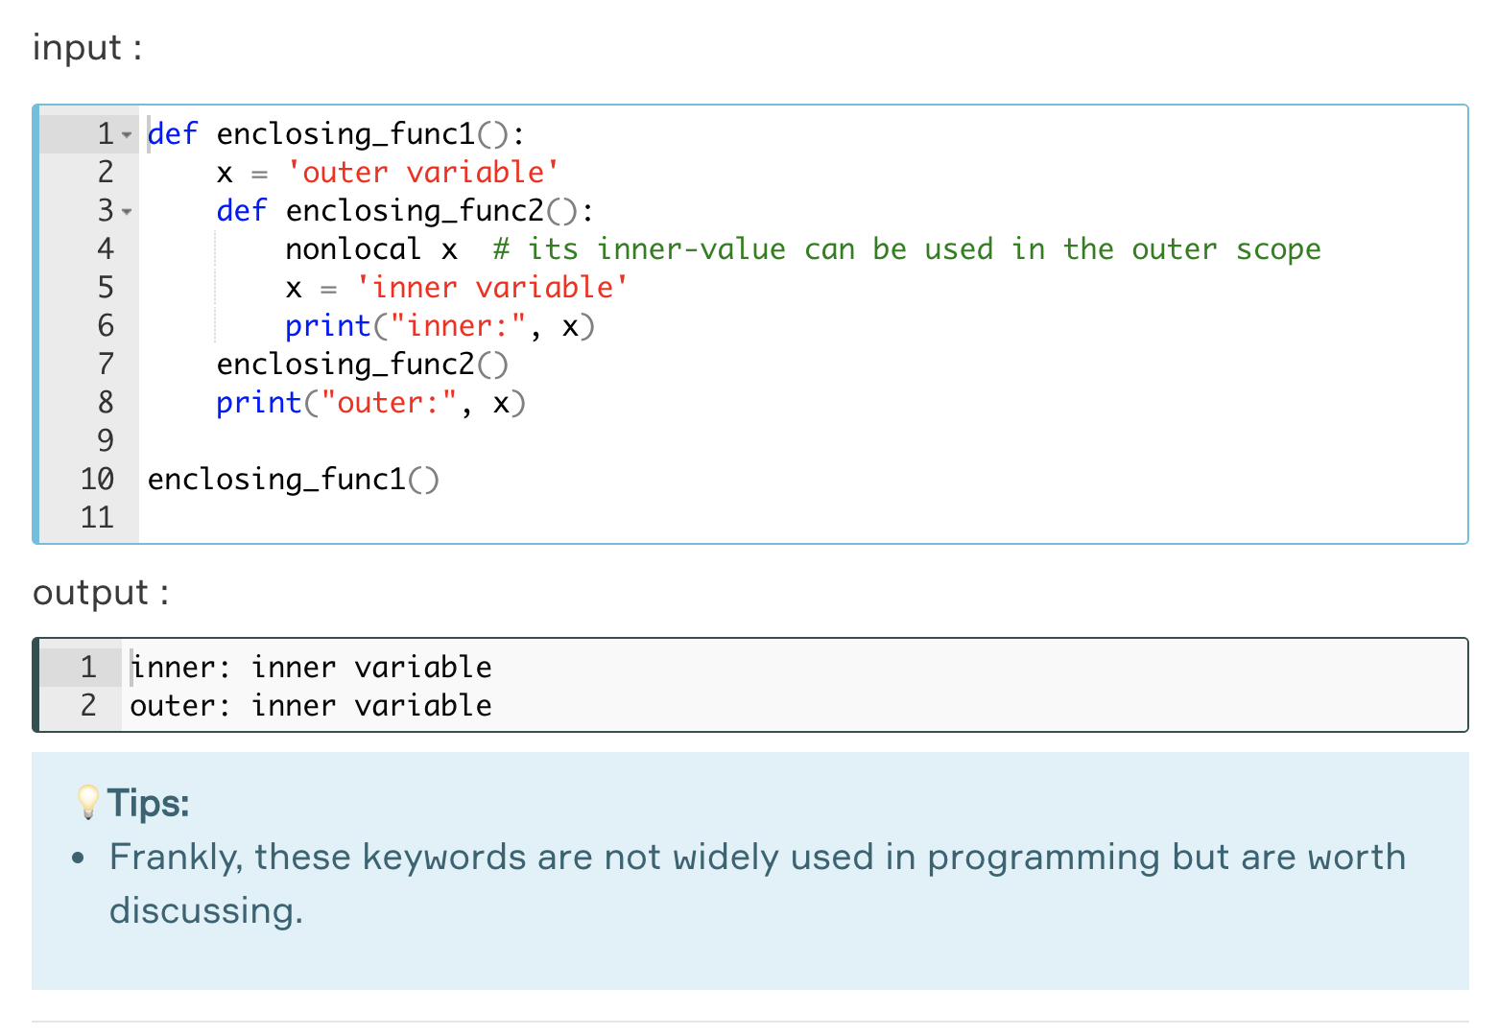

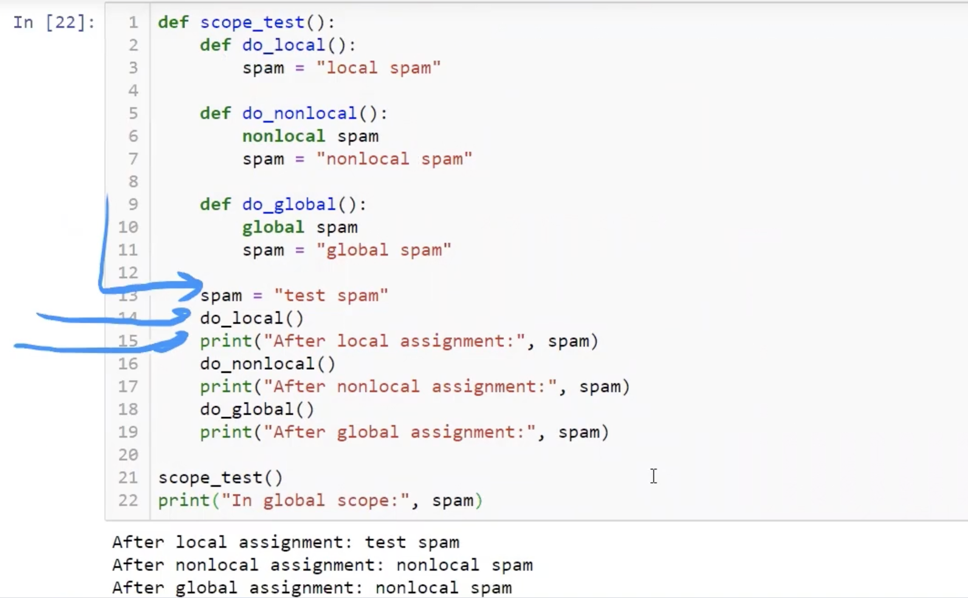

This is important

In global scope: global spam

## Lambda Functions

Another way to define functions in Python is lambda functions. Lambda functions are also called **anonymous**functions since they have no name. We use keyword lambda to define a function.

**The formula syntax is**: lambda parameters : expression

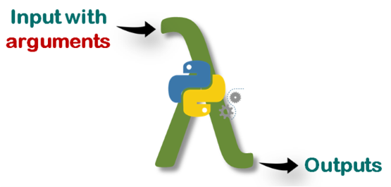

**Why we need lambda functions?**

If you need to use a one-time function, defining a lambda function is the best option. In some cases, you may need to define a function only once without having to use it later. For instance; let's square given numbers with a function. First, we're going to use def :

|  |
| --- |
| def square()  return x\*\*2 |

And now we'll define lambda function to do the same.

|  |
| --- |
| lambda x: x\*\*2 |

As you see, lambda is very simple and has a single line with a single expression. On the other hand, these two functions do exactly the same thing.

A lambda function can take multiple arguments separated by commas, but it **must** be defined with a *single expression*. This expression is evaluated and the result is returned

**⚠️Avoid:**

* Note that you do not need to use return statement in lambda functions.

Consider the following example of multiple arguments. Let's calculate the arithmetic mean of two numbers :

|  |
| --- |
| lambda x, y: (x+y)/2 # takes two numbers, returns the result |

What if we need to use conditional statements within the lambda definition? Here how we do it :

|  |
| --- |
| lambda x: 'odd' if x%2!=0 else 'even' |

**The formula syntax of conditional lambda statement is**:

lambda parameters : **first\_result** if conditional statement else **second\_result**

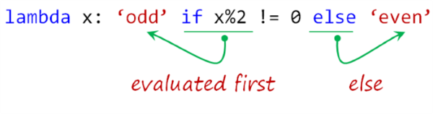

**⚠️Avoid:**

* Note that you can't use the [usual conditional statement](https://lms.clarusway.com/mod/lesson/view.php?id=18&pageid=57" \t "_blank) with lambda definition.

If lambda is doing the same things with def then you might think of why and where do we use **lambda**? In the next lesson, we will try to find the answer to this question.

**Q**: What is a lambda function?  
**A**: A lambda function is an anonymous function (a function that does not have a name) in Python. To define anonymous functions, we use the ‘lambda’ keyword instead of the ‘def’ keyword, hence the name ‘lambda function’. Lambda functions can have any number of arguments but only one statement.

### Uses of the Lambda Functions

So far you have seen the definition of lambda function and some of its features. Well, unlike def, where do we use lambda? If we need, how do we use the **lambda functions** in our code stream? Moreover, they don't even have names, so how can we call them? In this and the next lesson, we're going to try to find out the answer to these questions.

Lambda's most important advantages and uses are:

1. You can use it with its own syntax using ***parentheses***,
2. You can also *assign* it to a ***variable***,
3. You can use it in several ***built-in*** functions,
4. It can be useful inside **user-defined** functions (def).

Let's see how these work:

* **By enclosing the function in parentheses** :

|  |
| --- |
| (lambda x: x\*\*2)(2) # squares '2' |
| 4 |

**The formula syntax is**: (lambda parameters : expression)(arguments)

|  |
| --- |
| print((lambda x, y: (x+y)/2)(3, 5))  # takes two int, returns mean of them |
| 4.0 |

You can also assign the lambda statement in parentheses to a variable :

|  |
| --- |
| average = (lambda x, y: (x+y)/2)(3, 5)    print(average) |
| 4.0 |

**Q**: What Are The Principal Differences Between The Lambda And Def?  
**A**:  
- Def can hold multiple expressions while lambda is a uni-expression function.  
- Def generates a function and designates a name to call it later. Lambda forms a function object and returns it.  
- Def can have a return statement. Lambda can’t have return statements.   
- Lambda supports to get used inside a list and dictionary.

### Lambda within Built-in (map()) Functions-1

When using some built-in functions we may need additional functions inside them. This can be done by using def, but when we do the same thing with lambda we save both time and additional lines of code and we make it clear to read.

**Lambda within map() function :**

map() returns a list of the outputs after applying the given function to each element of a given iterable object such as list, tuple, etc.

**The basic formula syntax is**: map(function, iterable)

Let's square all the numbers in the list using map() and lambda. Consider this example :

|  |
| --- |
| iterable = [1, 2, 3, 4, 5]  map(lambda x:x\*\*2, iterable)  result = map(lambda x:x\*\*2, iterable)  print(type(result)) # it's a map type  print(list(result)) # we've converted it to list type to print  print(list(map(lambda x:x\*\*2, iterable)))  # you can print directly |
| <class 'map'>  [1, 4, 9, 16, 25]  [1, 4, 9, 16, 25] |

If you try to do the same thing using def, it is likely that the lines of code similar to the following occur. As you can see below, there are at least two additional lines of code. Moreover, we will not use the square function again because we only need to use it inside the map() function.

|  |
| --- |
| def square(n): # at least two additional lines of code  return n\*\*2    iterable = [1, 2, 3, 4, 5]  result = map(square, iterable)  print(list(result)) |

Now, let's try to give an example with multiple arguments in **lambda function** using map() :

|  |
| --- |
| letter1 = ['o', 's', 't', 't']  letter2 = ['n', 'i', 'e', 'w']  letter3 = ['e', 'x', 'n', 'o']  numbers = map(lambda x, y, z: x+y+z, letter1, letter2, letter3)  print(list(numbers)) |
| ['one', 'six', 'ten', 'two'] |

In the above example, we have combined three strings using 👉🏻**+** operator in the lambda definition.

**💡Tips :**

* Note that map() takes each element from iterable objects one by one and in order.

**Q**: What is map function in Python?  
**A**: map function executes the function given as the first argument on all the elements of the iterable given as the second argument. If the function given takes in more than 1 arguments, then many iterables are given.

### Lambda within Built-in (filter()) Functions-2

**Lambda within filter() function :**

filter() filters the given sequence (iterable objects) with the help of a function (lambda) that tests each element in the sequence to be true or not.

**The basic formula syntax is**: filter(function, sequence)

Let's grasp the subject with an example in which we'll filter the even numbers in a list.

|  |
| --- |
| first\_ten = [0, 1, 2, 3, 4, 5, 6, 7, 8, 9]    even = filter(lambda x:x%2==0, first\_ten)  print(type(even)) # it's 'filter' type,  # in order to print the result,  # we'd better convert it into the list type  print('Even numbers are :', list(even)) |
| <class 'filter'>  Even numbers are : [0, 2, 4, 6, 8] |

**💡Tips :**

* Note that filter() filters each element in the iterable object, depending on whether the function's result is True or False.

This time, we'll filter the vowels from the first ten letters in the list.

|  |
| --- |
| vowel\_list = ['a', 'e', 'i', 'o', 'u']  first\_ten = ['a', 'b', 'c', 'd', 'e', 'f', 'g', 'h', 'i', 'j']    vowels = filter(lambda x: True if x in vowel\_list else False, first\_ten)  print('Vowels are :', list(vowels)) |
| Vowels are : ['a', 'e', 'i'] |

We draw your attention to this issue that *lambda definition* we use in this example gives only True or False as a result.

### Lambda within User-Defined Functions

**Lambda within def :**

Using a lambda statement in a user-defined function provides us useful opportunities. We can define a group of functions that we may use later in our program flow. Take a look at the following example :

|  |
| --- |
| def modular\_function(n):  return lambda x: x \*\* n    power\_of\_2 = modular\_function(2) # first sub-function derived from def  power\_of\_3 = modular\_function(3) # second sub-function derived from def  power\_of\_4 = modular\_function(4) # third sub-function derived from def  print(power\_of\_2(2)) # 2 to the power of 2  print(power\_of\_3(2)) # 2 to the power of 3  print(power\_of\_4(2)) # 2 to the power of 4 |
| 4  8  16 |

The modular\_function takes one argument, number ***n***, and returns a function that takes the power of any given number ***x*** by that ***n***.

This usage enabled us to use a function as flexible. Thanks to lambda, we could use a single def in different ways with the arguments we wanted. We've created three sub-functions derived from a single def. This is flexibility!

We can define a function with the same logic as the previous example that repeats the string passed into it.

|  |
| --- |
| def repeater(n):  return lambda x: x \* n    repeat\_2\_times = repeater(2) # repeats 2 times  repeat\_3\_times = repeater(3) # repeats 3 times  repeat\_4\_times = repeater(4) # repeats 4 times  print(repeat\_2\_times('alex '))  print(repeat\_3\_times('lara '))  print(repeat\_4\_times('linda ')) |
| alex alex  lara lara lara  linda linda linda linda |

### Some Examples:

#### Example-1

Define a lambda function to reverse the elements of any iterables. Use parantheses for arguments and print the result:

|  |
| --- |
| iterable = ‘clarusway’  reverser = (lambda x : x[::-1])(iterable)  print(reverser) |
| yawsuralc |

#### Example-2

Write a program that types ‘even’ or ‘odd’ iaw the numbers in a list.

Use lambda function and loop.

Your code should contain no more than 2 lines.

Sample output:

Input:

[1, 2, 3, 4]

Output:

1 : odd

2 : even

3 : odd

4 : even

|  |
| --- |
| numbers = [-12, 21, 10, 2, 4, 3]  for x in numbers:  print(x, ‘ : ’, (lambda a: ‘odd’ if a % 2 != 0 else ‘even’)(x)) |
| -12 : even  21 : odd  10 : even  2 : even  4 : even  3 : odd |

|  |
| --- |
| (lambda a : ‘odd’ if a % 2 != 0 else ‘even’)(40) |
| even |

#### Example-3

Define a simple function(def) named functioner using lambda to create your own print function with emoji faces. Such as:

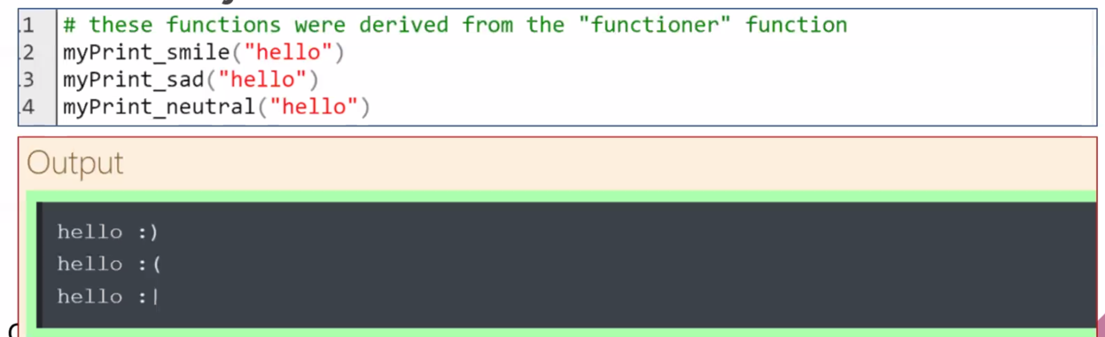

|  |
| --- |
| def functioner(emoji):  return lambda message : print(message, emoji)  myprint\_smile = functioner(' :)')  myprint\_sad = functioner(' :(')  myprint\_neutral = functioner(' :|')  myprint\_smile("hello")  myprint\_sad("hello")  myprint\_neutral("hello") |
| hello :)  hello :(  hello :| |

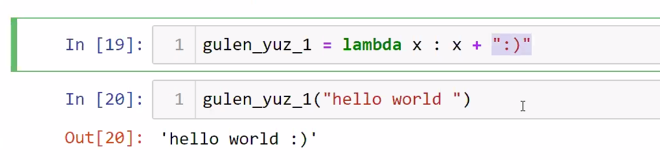

## Modules

*Scripts* and *modules* have essentially identical structures in terms of creation and are the files with a **.py** extension, containing some Python codes, statements, operations, and functions.

**💡Tips :**  
The difference between these two terms :

* In fact, the difference between them depends on **how** and **for what purpose** you use this file with **.py** extension.

|  |  |
| --- | --- |
| SCRIPT | MODULE |
| While working on your simple and short projects, you normally type and run Python codes directly into the interpreter. It would be a good option to save them in a file. And later when you need to run or work with them within a text editor you can easily access them using this file you created. So that every time you quit from the Python interpreter and enter again you won't lose your codes (functions and variables) typed before. This option will be vital to you, especially when working with programs with long blocks of code. The file you created consisting of codes, definitions and a list of operations that can be read, edited and interpreted in the future is known as **script**. | As your program gets longer, you may want to split it into several files for easier maintenance. You may also want to use a handy function that you’ve written in several programs without copying its definition into each program. To support this, Python has a way to put definitions in a file and use them in a **script** or in an interactive instance of the interpreter. Such a file is called a **module**. |

You may need to use a function that you type in a program at another time and in another program stream. Or you may even need to reuse some code someone else wrote before. You can solve this issue by copying the code you have already written and pasting it into another program stream. But this does not bring a fundamental solution. Because as the functions and code blocks you want to work with increase, the structure and readability of your program will seriously deteriorate. As we said before, Python is a user-friendly programming language and you can be sure that there is a solution to handle this issue as well. And the solution is **modules**.

These simple files, usually with a **.py** extension and containing Python statements and definitions, are called **modules**. The ability to load or import one module from another in Python is a unique feature that significantly reduces our programming processes, and that is what makes the Module system really powerful.

**💡Tips :**

* If you open and use this file (with a **.py** extension) *directly*, that is **script**, and
* If you *load* (import)this file (with a **.py** extension) and call any function from it, that's a **module**this time.

### How to Load a Module?

For loading a module, we use keyword import and the **name** of the module.

**The formula syntax is**: import module\_name

For instance, suppose we have a module called my\_module. Let's take a look at how we load it :

|  |
| --- |
| import my\_module # we've loaded my\_module  my\_module.my\_function()  # we've called a function defined in my\_module  print(my\_module.my\_variable)  # we've accessed a variable defined in my\_module |

my\_module is the name of the module we imported. When loading a **module**you can also use an **abbreviated nickname** for modules by using a keyword as. Let's give a nickname to my\_module to load it :

|  |
| --- |
| import my\_module as mym  # gives a nickname to my\_module  mym.my\_function()  print(mym.my\_variable) |

In the example above, mym stands for the module my\_module. For instance, imagine that there is a file called my\_module.py named my\_module.

And for being importable, this file should be placed in the same directory as the file you are working on.

**Initially**, the Python importing mechanism **searches for** a module in the **current directory**, **then** the **built-in modules**are inspected and an error will be raised if nothing is found. The module becomes available under **its name or alias** after importing and you can use the **dot notation** to access the functions and variables defined in it.

Use pwd to see the directory:

|  |
| --- |
| pwd |
| '/Users/s/Drive\_2020/1\_CLARUSWAY/9\_PYTHON/Jupiter Files' |

Importing a function or variable defined in a module is a very common and useful method. We use the keyword from to use this option. Let's see how it works :

|  |
| --- |
| from my\_module import my\_function  # we have loaded only my\_function from my\_module  my\_function()  # now my\_function can be used directly at the current module |

**💡Tips:**

* Note that in the example above, we imported only my\_function. So if we try to use this syntax : my\_module.my\_function an error will be raise.

You can also use keyword as here the same way as well. Consider this example :

|  |
| --- |
| from my\_module import my\_function as mfcn  mfcn()  # we use the my\_function’s alias directly |

It is traditionally best to type each import syntax in separate lines and put them all at the beginning of the current module. Let's see it in an example :

import module\_1

import module\_2

import module\_3

**Q**: How to import modules in Python?  
**A**: Modules can be imported using the import keyword. You can import modules in three ways. Example:

import array # importing using the original module name

import array as arr # importing using an alias name

from array import \* # imports everything present in the array module

### Built-in Modules

Python comes with a huge library of standard modules many of which are built into the interpreter. These modules make our code more effective by providing useful functions and data structures. Another advantage of built-in modules which is invaluable to the user is that you can access these standard libraries from all operating systems in which Python is installed. Officially published standard library list (Python Module Index) can be found [here](https://docs.python.org/3/py-modindex.html" \t "_blank).

Let's have a look at some of them if you want :

#### math

**math** is one of the most known and used modules. This module allows us to work with mathematical functions.

|  |
| --- |
| import math  print(dir(math)) # you can find out all names defined in this module |
| ['\_\_doc\_\_', '\_\_loader\_\_', '\_\_name\_\_', '\_\_package\_\_', '\_\_spec\_\_', 'acos', 'acosh', 'asin', 'asinh', 'atan', 'atan2', 'atanh', 'ceil', 'copysign', 'cos', 'cosh', 'degrees', 'e', 'erf', 'erfc', 'exp', 'expm1', 'fabs', 'factorial', 'floor', 'fmod', 'frexp', 'fsum', 'gamma', 'gcd', 'hypot', 'inf', 'isclose', 'isfinite', 'isinf', 'isnan', 'ldexp', 'lgamma', 'log', 'log10', 'log1p', 'log2', 'modf', 'nan', 'pi', 'pow', 'radians', 'sin', 'sinh', 'sqrt', 'tan', 'tanh', 'tau', 'trunc'] |

**💡Tips:**

* The built-in function dir() is used to find out which names a module defines. It returns a sorted list of strings.

|  |
| --- |
| from math import pi, factorial, log10  # we will use the functions directly  print(pi)  print(factorial(5))  print(log10(1000)) |
| 3.141592653589793  24  3.0 |

As you can see in the example above, we can import several functions by writing function names separated by commas at the same time.

|  |
| --- |
| Define your own factorial function named factor using def. |
| def factor(x):  result = 1  for i in range(x):  result \*= (i+1)  return print(result) |

#### string

**string** is used for common string operations.

|  |
| --- |
| import string as stg  print(stg.punctuation)  print(stg.digits) |
| !"#$%&'()\*+,-./:;<=>?@[\]^\_`{|}~  0123456789 |

#### datetime

**datetime** is commonly used when working with date and time types.

|  |
| --- |
| import datetime  print(dir(datetime))  print(datetime.date.today()) #yyy-mm-dd  print(datetime.datetime.now ()) #in microseconds |
| ['MAXYEAR', 'MINYEAR', '\_\_builtins\_\_', '\_\_cached\_\_', '\_\_doc\_\_', '\_\_file\_\_', '\_\_loader\_\_', '\_\_name\_\_', '\_\_package\_\_', '\_\_spec\_\_', 'date',  'datetime', 'datetime\_CAPI', 'sys', 'time', 'timedelta', 'timezone', 'tzinfo']  2019-12-31  2019-12-31 15:03:31.303994 |

**Tips:**

* In the example above, we used the functions (now() and today()) defined under the date and datetime objects from the datetime module according to the **dot notation**.

|  |
| --- |
| from datetime import date  birth = date(571, 4, 22)  death = date(632, 6, 8)  date.toordinal(death) - date.toordinal(birth)  print(death-birth) |
| 22327 days, 0:00:00 |

#### random

**random**is a module that contains functions that allow us to select randomly from various data types.

|  |
| --- |
| import random  print(dir(random)) |
| ['BPF', 'LOG4', 'NV\_MAGICCONST', 'RECIP\_BPF', 'Random', 'SG\_MAGICCONST', 'SystemRandom', 'TWOPI', '\_BuiltinMethodType', '\_MethodType', '\_Sequence', '\_Set', '\_\_all\_\_', '\_\_builtins\_\_', '\_\_cached\_\_', '\_\_doc\_\_', '\_\_file\_\_', '\_\_loader\_\_', '\_\_name\_\_', '\_\_package\_\_', '\_\_spec\_\_', '\_acos', '\_bisect', '\_ceil', '\_cos', '\_e', '\_exp', '\_inst', '\_itertools', '\_log', '\_os', '\_pi', '\_random', '\_sha512', '\_sin', '\_sqrt', '\_test', '\_test\_generator', '\_urandom', '\_warn', 'betavariate', 'choice', 'choices', 'expovariate', 'gammavariate', 'gauss', 'getrandbits', 'getstate', 'lognormvariate', 'normalvariate', 'paretovariate', 'randint', 'random', 'randrange', 'sample', 'seed', 'setstate', 'shuffle', 'triangular', 'uniform', 'vonmisesvariate', 'weibullvariate'] |

|  |
| --- |
| from random import choice  city = [‘Stockholm’, ‘istanbul’, ‘Seul’, ‘Cape Town’]  print(choice(city)) |
| Istanbul |

**Q**: What are python modules? Name some commonly used built-in modules in Python.  
**A**: Python modules are files containing Python code. This code can either be functions classes or variables. A Python module is a .py file containing executable code. Some of the commonly used built-in modules are: os, sys, math, random, datetime.

**Q**: How can you generate random numbers in Python?  
**A**: Random module is the standard module that is used to generate a random number. The method is defined as:

import random  
print(random.random())

The statement "random.random()" method return the floating point number that is in the range of (0, 1).  
The function generates random float numbers.

The file you created consisting of codes, definitions and a list of operations that can be read, edited and interpreted in the future is known as [script].If you open and use this file (with a **.py** extension) *directly*, that is [script], an if you *load* (import)this file (with a **.py** extension) and call any function from it, that's a [module]this time.

### Creating and Working with Modules

#### Scripts & Modules Initialization

*Scripts* and *modules* have essentially identical structures in terms of creation and are the files with a **.py** extension, containing some Python codes, statements, operations, and functions.

As we stated before, the file with the **.py** extension, which contains all the codes, expressions, definitions and functions in a program you saved for later work, is actually the **script**. Then what is the difference between the *scripts* and the *modules*?

In fact, if you're using an advanced IDLE, such as **Jupyter Notebook**/**Lab** (which we are), all these issues about the *scripts* and the *modules* don't make much sense. So, these applications have a user-friendly menu on such issues.

**Tips:**

* When using Jupyter Lab / Notebook, you will almost always work with files with a **.ipynb** extension.

#### Acting of a Module as a Script

In accordance with the previous lesson, during working with modules and scripts you should have noticed that when you load (Only when you first import) the module with the keyword import, the outputs of all the operations typed in it is displayed collectively. Take a look at this image again :

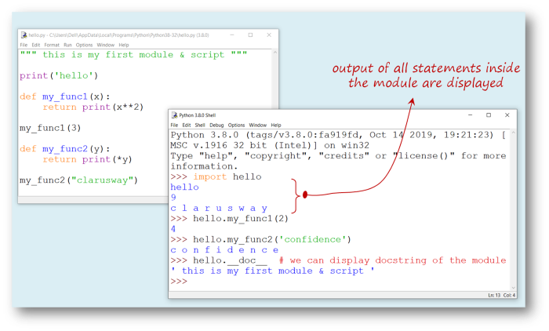

As you see, when you want to import this file as a *module*, it acts as a *script* for the **first** importing, which is undesirable. It is not normal for a module to generate output when imported. Then why it happens?

Well... As a Pythonic rule, when the file you created with **.py** extension is imported as a *module*, Python sets the specific variable **\_\_name\_\_** to the name of the *module*. But, if the file is run as a *script*, variable **\_\_name\_\_** is set to the string value of **"\_\_main\_\_"**. So, using this Pythonic rule, we can fix this issue.

#### \_\_name\_\_, "\_\_main\_\_" Method

If we collect the output-generating statements which are in our module under if \_\_name\_\_ == "\_\_main\_\_" : statement we will solve the problem. Let's do it and see what will happen :

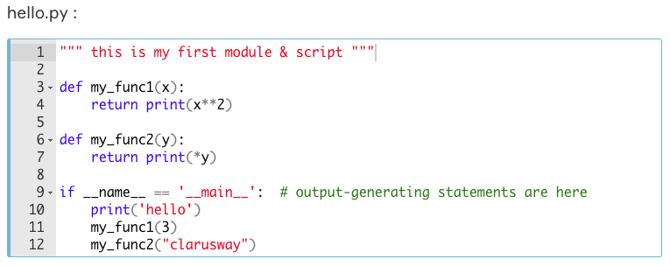

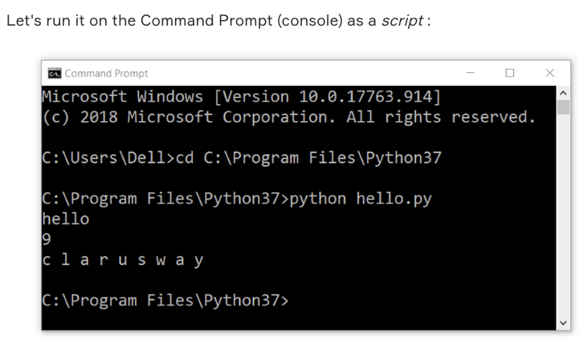

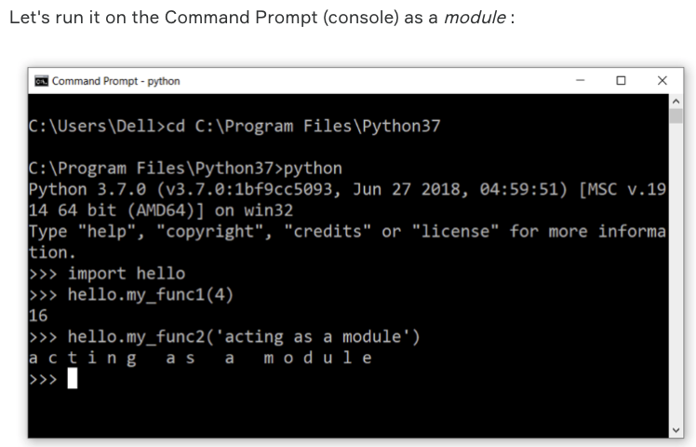

We've solved this issue that when we import the module to use it, there is no undesired output anymore.

## Packages

According to the [official document](https://docs.python.org/3/tutorial/modules.html?#packages) of Python, packages are basically a way of structuring Python’s module namespace by using “**dotted module names**”.

Imagine designing a very large project with many modules. As the number of modules you work on and create in the project increases, it becomes more and more difficult to follow them systematically and use them regularly and eventually becomes inextricable. This is especially so if they have similar *names* or *functions*. In order to make the modules more systematically organized, we can use **packages**.

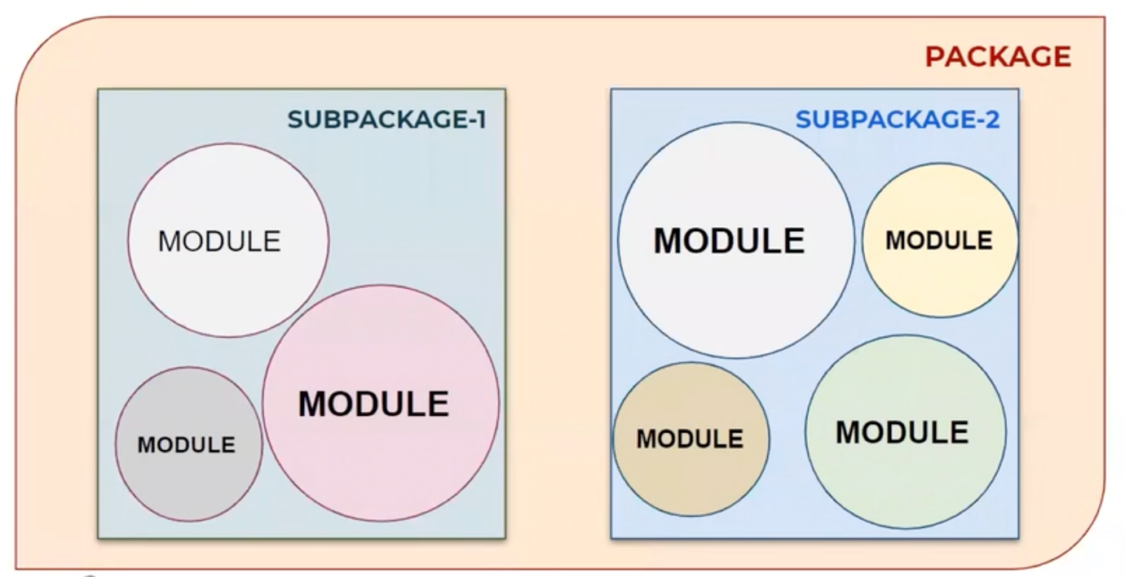

Examine the basic structure of the package system:

|  |
| --- |
| earth/ # Top-level package  \_\_init\_\_.py # Initialize the earth package  asia/ # Subpackage for file asia  \_\_init\_\_.py  japan.py  mongolia.py # A module under a subpackage  pakistan.py  taiwan.py  ...  europe/ # Subpackage for file europe  \_\_init\_\_.py  germany.py # A module under a subpackage  england.py  turkey.py  kosovo.py  ...  america/ # Subpackage for file america  \_\_init\_\_.py  canada.py  ustates.py  mexico.py  peru.py # A module under a subpackage  ... |

The *hierarchical model*of **dot notation** used to access and work with a module works as follows. The importing syntax which shows the entire hierarchy is so-called **absolute** importing. It's look like :

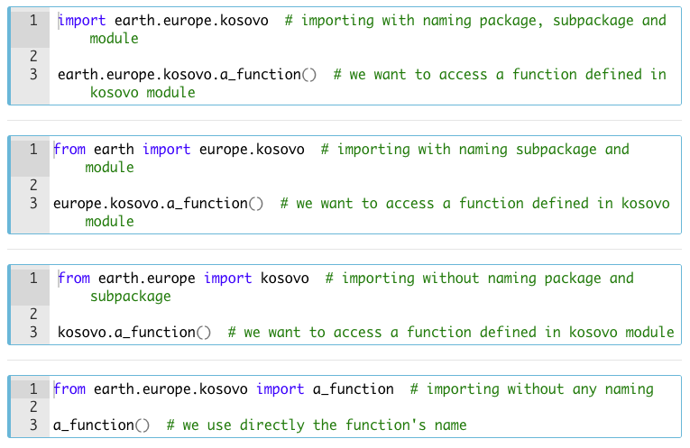

**💡Tips:**

Which style you should use depends on your needs. But the key point is readability!

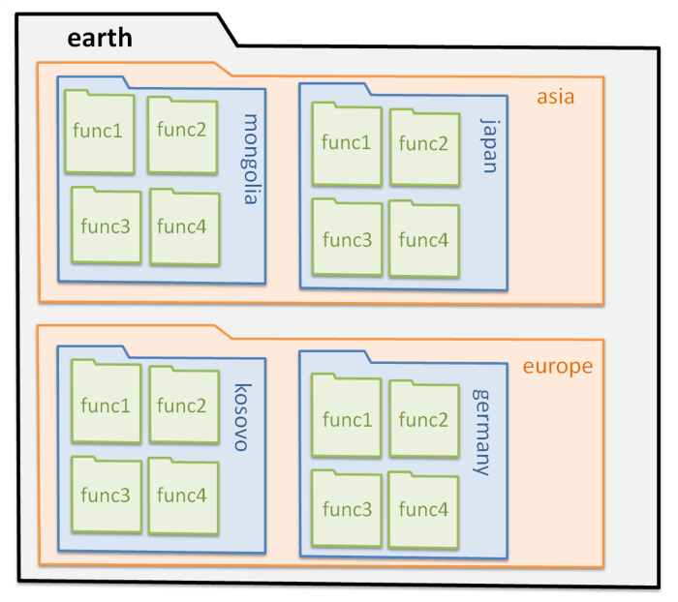

**⚠️Don't forget:**

* For Python to recognize the folders you created as packages / subpackages, you need to create an empty file named \_\_init\_\_.py in both the package and subpackage folders.
* They are usually empty, but may contain some initialization code of the package.

When you need to reorganize your *modules* with the packaging system, you need to create package/subpackage folders in the directory where Python is installed. Of course, keep in mind that you have to put a file named **\_\_init\_\_.py** in the folders you will create.

**💡Tips:**

* **Note that** when using from package import item, the item can be either a *submodule (or subpackage)* of the *package*, or some other name defined in the package, like a function, class or variable.
* The import statement **first** tests whether the item is defined in the package; if not, it assumes it is a **module** and attempts to load it. If it fails to find it, an *ImportError* exception is raised.

**Q**: What is module and package in Python?  
**A**: In Python, module is the way to structure the program. Each Python program file is a module, which imports other modules like objects and attributes. The folder of Python program is a package of modules. A package can have modules or subfolders.

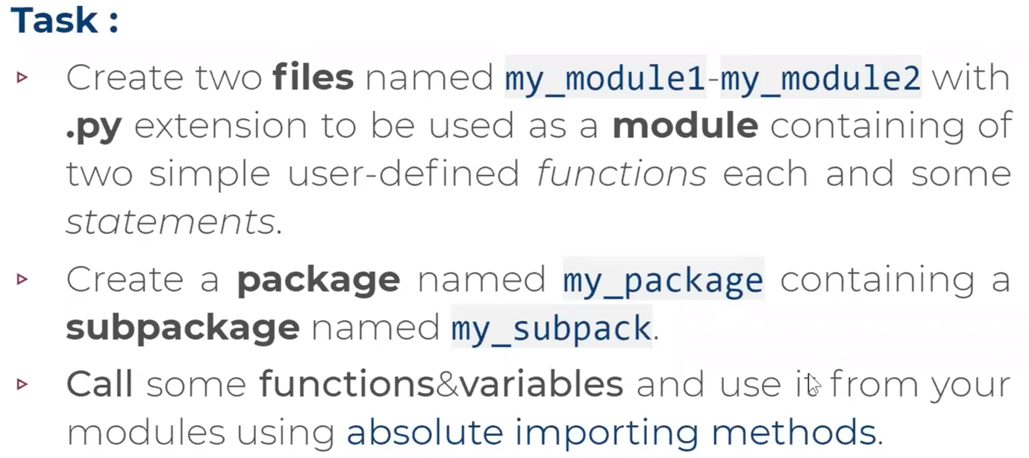

### Importing \* From a Package (Optional)

In connection with this subject, we can say that there is another and practical way to import packages / subpackages / modules. Consider this method : from package.subpackage import \* . This syntax allows us to import all modules that the subpackage has.

Although this way of importing all content is not a highly preferred method, when you add \_\_all\_\_ = [list of content] statement into the \_\_init\_\_.py file, you can display the subpackages/modules under package / subpackage in a list without any mess.

Well, how we do that? Take a look at the following images and explanations :

In order to display the list of *subpackages/modules* inside the *package*, we must add the following syntax into the **\_\_init\_\_.py** files:

For the **package**: \_\_all\_\_ = ['subpackage1', 'subpackage2']

For the **subpackage**: \_\_all\_\_ = ['module1', 'module2']

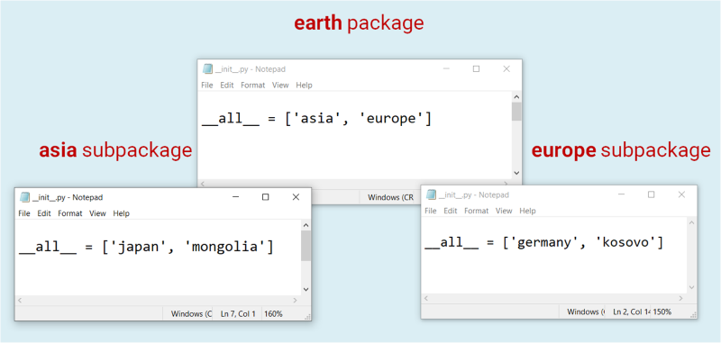

This image shows that when you type a **dot** immediately after the package name, the list of subpackages appears on the IDLE.

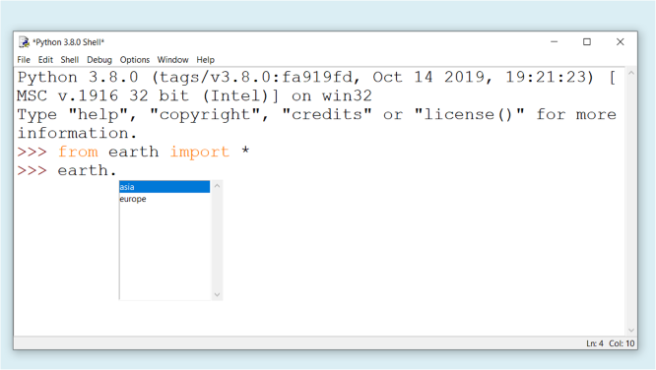

And the next image shows that when you type a **dot** immediately after the subpackage name, the list of modules appears on the IDLE.

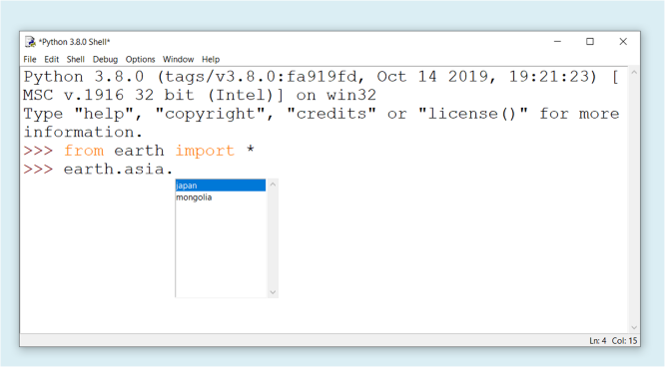

### Working with Inter & Intra-Packages/Subpackages

You can feel the power of Python and its user-friendliness in working with intra&inter-packages/subpackages. If you need to work with a module defined in another subpackage, you can simply import it into the current module file. And of course, you can either import and use another *module*from the current *subpackage* you're working on.

For example: while you're working on earth.europe.germany in **germany.py** file, you can import and use *module* '**japan**' from *subpackage* **asia** by using a similar syntax: **from** earth.asia **import** japan. We've stated before that this kind of syntax is **so-called absolute** importing. But there is another simple way to do the same thing. This style of syntax is so-called **relative imports**.

You can write **relative imports**, with the from module import name form of the *import statement*. These imports use leading **dots** to indicate the *current* and *parent packages* involved in the relative import. Let's see how it works for the *module***japan**:

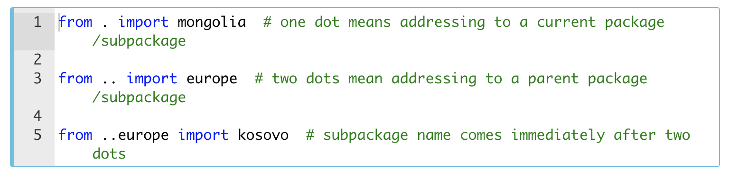

The modified **germany.py** file is below. We're importing and using module **japan**inside the **germany.py** file :

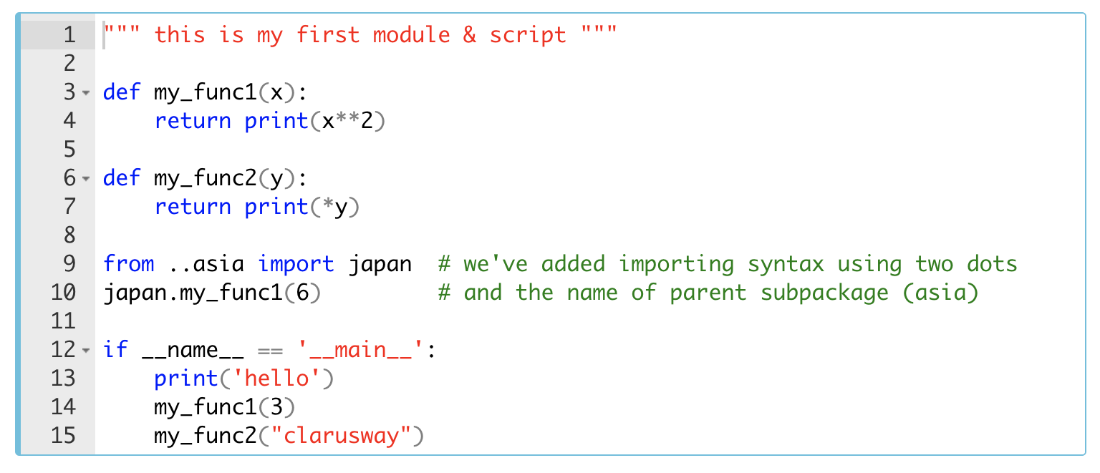

**⚠️Avoid:**

* Using the syntax from name import **\*** is usually considered bad practice.
* While working on Python codes, keep this in your mind : **Readability counts**!

When we import the module **germany,**we can see the result like:

|  |
| --- |
| import earth.europe.germany |
| 36 |

**💡Tips:**

* **Absolute imports** syntax are preferred, as they are usually more readable.
* When dealing with very complex and sophisticated packages, it is preferable to use **relative imports**syntax, since using absolute imports will result in unnecessary redundancy.

### pip - The Package Manager for Python

After you develop yourself in the Python programming, you will start to take part in more professional projects. Over time you will see that you will have to benefit from the packages in almost all of your programs. This rich package library is one of the factors that make Python programming language powerful.

In fact, the package library we're talking about here isn't built-in and you need to install it externally. That's where the **pip** comes in. pip which is also a preinstalled program in Python is the standard package manager for Python. It allows you to install/uninstall, and manage additional packages that are not part of the [Python standard modules](https://docs.python.org/3/py-modindex.html" \t "_blank). The acronym of **Pip Installs Packages** is mostly known as pip.

You can use pip not only to give additional functionality to the standard library by installing additional packages on your computer, but you can also use it to help you contribute to Python's development by sharing your own projects.

Now open your *command prompt* and run the following syntax to make sure that you have pip installed.

pip –version

This code should display your valid **pip** version which is **19.3.1** currently. The output will be :

pip 19.3.1

**💡Tips:**

* When you install the **Anaconda-3** package program, you will also automatically install hundreds of packages in addition to Python's standard library.
* Therefore, if you installed the Anaconda-3 package program, you will not actually have much work with pip.

#### Working with pip

**The formula syntax is** : pip command options

* **install**

The most common and essential command of **pip** is of course install. The most common syntax is :

pip install my\_package

If you want, you can use this command by adding the version number to the end of the syntax as follows :

pip install my\_package==3.2.1

For the Python's current version you can use the following command. Although Python is not actually a *package*, you can also install it as follows. You do not need to try it because it will be faster if you [download](https://www.python.org/downloads/release/python-381/" \t "_blank)and install it from its website.

pip install python==3.8.1

* **list**

Another important command you should learn is list. It lists all the packages you have installed on your computer in alphabetical order and in two columns. 1

pip list

* **show**

The other useful command we can mention is show. 1

pip show my\_package

It's used to view some information about the packages. These information about a package will be : Name, Version, Summary, Home-page, Author, Author-email, License, Location on PC.

* **uninstall**

And the last command we want to show you is uninstall. It uninstalls the installed packages from your computer. 1

pip uninstall my\_package

If you want to examine pip in detail visit [here](https://pip.pypa.io/en/stable/reference/pip/" \l "pip" \t "_blank).

## Files

On most operating systems, **files** are spaces on your computer where data is stored. The many items you use on your computer in everyday life are actually just files. *Texts*that you type and store your Python codes, *pictures*and *videos*you encounter during the course or **python-3.8.1.exe** that you should have downloaded to your computer for installation are the files.

Think about it : Just as words can be written to paper, so can information be written to a computer file. You can open these files and modify their contents at any time, store them on various media, (such as hard drives, removable disks, or the cloud), or transfer them from one media to another.

In an operating system's graphical user interface, files are often represented by **icons**: thumbnails showing the content. Although it differs in all OS, files have their own icons. Let's take a look at the Windows OS's some file icons. For example, here are MS Word, Python and PDF files.

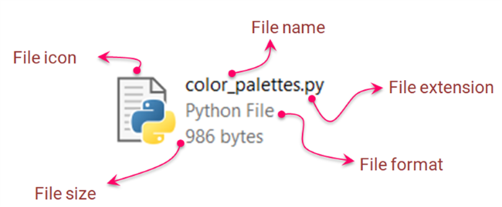

### File Components

#### Metadata

All the detailed information about a *file*stored on the computer is called the **metadata** of that file. As an example, take a look at the following image. For instance, in Windows10, you can right-click on a *file*and then click *properties* then choose *details* to display the **metadata** :

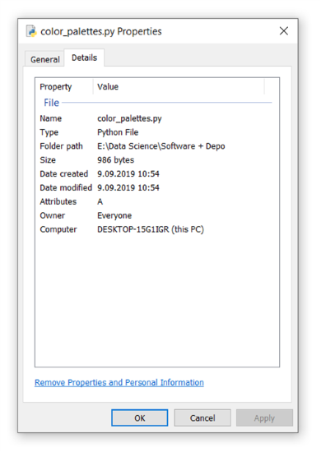

In general, almost all modern OSes have this (shown on the picture) descriptive information as **metadata**. Every time you modify anything about the file, the metadata will be updated accordingly.

#### File Attributes

The other point that we think it would be useful to know about the files is the **file attributes**. It's the special kind of metadata. Each file has several *attributes*, but these *attributes* vary greatly from one **OS**to another.

In other words, **File attributes** are metadata associated with computer files that define file system behavior. Each attribute can have one of two states: **set** and **cleared**.

For example, let’s look at the following *attributes*: these basic file attributes are contained in every Windows file.

* **Read-Only**(R) : When set, it makes the file read-only and indicates that a file can not be altered.
* **System** (S) : When set, it indicates that the hosting file is a critical system file that is necessary for the computer to operate properly.
* **Hidden** (H) : When set, it makes the file hidden and indicates that the hosting file is unseen by default.

### Directories & Folders

There is a structure for storing the files in an orderly manner, just like the modules, packages, and subpackages and making them easily accessible on demand. This organized structure where files are stored is called a **folder** or **directory**.

What we call a *directory* or a *folder* is actually managed in the same logic as a folder for storing documents and files in a real office environment. If you look at the folder icons used by the operating systems shown below (Windows, Linux, Mac, respectively), you can see this clearly.

A folder/directory can contain files or other folders/directories. A directory inside the other directory is generally known as a **subdirectory**.

In all operating systems, directories/folders are structured in a hierarchical order. There is usually one (or multiple if it is partitioned) directory called the **root directory**, and there are as many subdirectories as needed inside the root directory.

Naming the root directory may vary from one operating system to another. The following diagram shows us a sample of the hierarchical structure of the directories of the Windows OS.

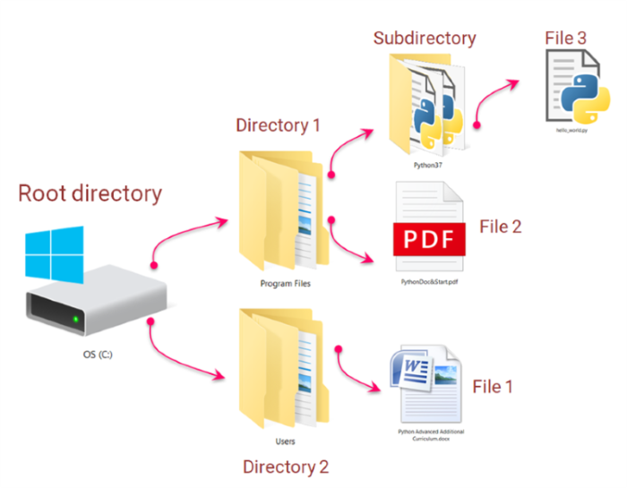

### Reading Files

#### 'open()' Function

Usually, when you work on a project, the data you need for your Program that you plan to write comes from outside in a file format. In this section, you will learn how to work with external files that you will often use.

To start working with files, we need to open it first by using a built-in function open(). According to the official related [Python documents](https://docs.python.org/3/library/functions.html" \l "open" \t "_blank), it has the following parameters :

**open (***file,****mode****=****'r'****, buffering=-1, encoding=None, errors=None, newline=None, closefd=True, opener=None***)**

***file***is the only required parameter of the open() function. This parameter is a [path-like object](https://docs.python.org/3/glossary.html" \l "term-path-like-object" \t "_blank) which is a str or bytes that represents a path in the file directory. In other words, *path-like object* giving the pathname (absolute or relative to the current working directory) of the file to be opened or an integer file descriptor of the file to be wrapped.

This parameter takes the name of the file that you want to open which is stored in the directory where the Anaconda3 or the Python installed. In other words, the file should be stored in the **current working directory**. Throughout this section, we assume that all example files we covered lie in the current working directory.

**⚠️Attention ! :**

* Since the interpreter of the Playground is installed on the server, you cannot open, read or write a file on it.

In the following example, you see that we open a **.txt** file object. We passed the required parameter (***file***) into the open() function.

|  |
| --- |
| my\_file = open("first\_file.txt")  # this syntax opens a 'txt' file  print(type(my\_file)) |
| <class '\_io.TextIOWrapper'> |

It opens the file and returns a corresponding *file-like object*. If the file cannot be opened, an OSError is raised. Pay attention to the type of my\_file. We have created a **file-like object**. So we can apply different kinds of **methods** to my\_file.

Well, let's examine the function step by step. We will only focus on the most commonly used parameters : ***mode*** and ***encoding***. Since we need to examine **mode** in detail, we'll leave it to the next lesson. Let's take a look at **[encoding](https://docs.python.org/3/howto/unicode.html" \l "encodings" \t "_blank)**for the time being.

The encoding parameter indicates the encoding that needs to be used to *decode* or *encode* a file. The default value depends on the platform you use and its language. **UTF-8** is one of the most preferred used encodings, and Python generally defaults to using it. *UTF* stands for “Unicode Transformation Format”, and the *‘8’* means that 8-bit values are used in the *encoding*. We can open a file in the same way by using the following syntax :

|  |
| --- |
| my\_file = open("first\_file.txt", encoding="utf-8")  # we've used 'utf8' encoding format just the same as the previous one |

Sometimes it may take time to know if you are using the correct *encoding* in your file. Therefore, if the file you're trying to open looks unusual or wrong, or gives an error, you might need to deal with this parameter a bit.

If you want to know the encoding in detail you may take a look at the following references :

* The [Unicode Consortium](https://home.unicode.org/" \t "_blank) Web-Page,
* Wikipedia entries about *[character encoding](https://en.wikipedia.org/wiki/Character_encoding" \t "_blank)* and *[UTF-8](https://en.wikipedia.org/wiki/UTF-8" \t "_blank),*
* The following video of Tom Scott about the history of Unicode and UTF-8.

#### 'mode' Parameter

Let's start by examining the most important parameters of the open() function, **mode**. This parameter has several options that regulate how or for what purpose we open the file. These options are as follows :

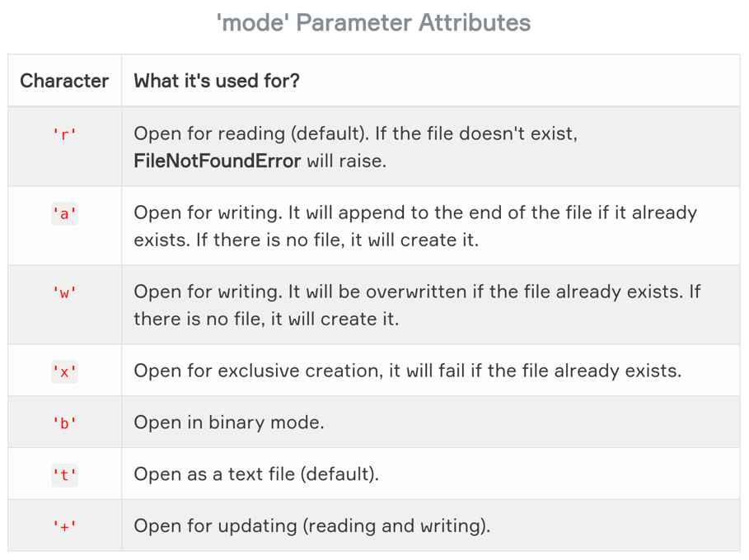

By default, open() function executes opening the file for *reading* ('r') as a *text* ('t'). In other words, it defaults to 'r' or 'rt' which means open for reading in text mode.

**💡Tips:**

* Note that, as you can see above, depending on what you are going to do with the file, you can combine the modes according to your needs.
* If you want to *open* and be able to *read*, modify, and *update* the existing file you should set the mode as 'r+'.

Another **important point** we should cover about **mode**is that you can choose the format in which you want to open the file as text ('t') or binary ('b'). According to the [official related Python documentation](https://docs.python.org/3/library/functions.html#open), files opened in 'binary' mode return contents as bytes objects without any decoding. In 'text' mode, the contents of the file are returned as str, the bytes having been first decoded using a platform-dependent encoding or using the specified encoding if given.

In this case, if you want to open a *binary file* for writing you should set the mode as 'wb'. On the other hand, if you want to work with a *text file* you don't need to specify 't' since the default value of **mode** is already set as 't'. So, when opening and writing a text file it's enough to set the mode as 'w'.

Finally, let us examine the differences between the use of 'w' and 'a'. Both options are used to modify the file or to write new data to the file. However, when you use 'a', the data you want to write will be added at the bottom of the file and combined with existing content, whereas using 'w' will delete the existing content and add new content each time.

#### '.read()' Method

Yes, so far we have learned many things for reading the files. Let's move on to the reading chapter which is our main topic now.

First of all, we need to create a text file and save it in the folder where Anaconda3 / Python is installed. Suppose we have a file named "**fishes.txt**" with the following content.

Orca is a kind of Dolphin.  
Blue Whale is the largest animal known on earth.  
Sharks are the sister group to the Rays (batoids).  
The Tuna Fish can weigh up to 260 kg.  
Squid and Octopus are in the same class.

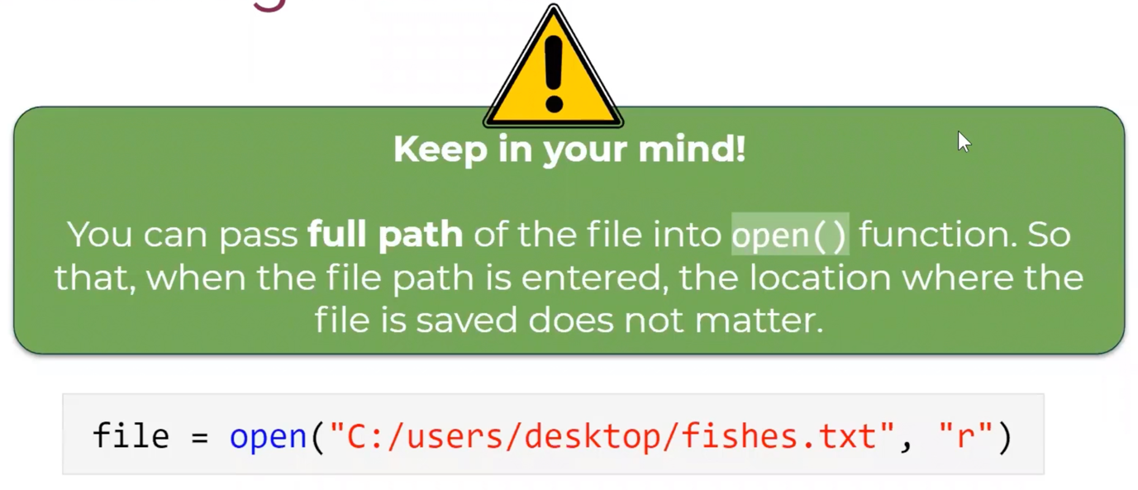

You can use the following methods for reading this file :

* **.read(**size**)**
* **.readline(**size**)**
* **.readlines()**
* using **loops**

##### **1.** .read(size) :

This method is generally the most preferred method for reading files, although it depends on the need. This method reads the size bytes (characters) of the file. If this parameter is not specified, the entire file is read at once. Let's take an example of how this method works :

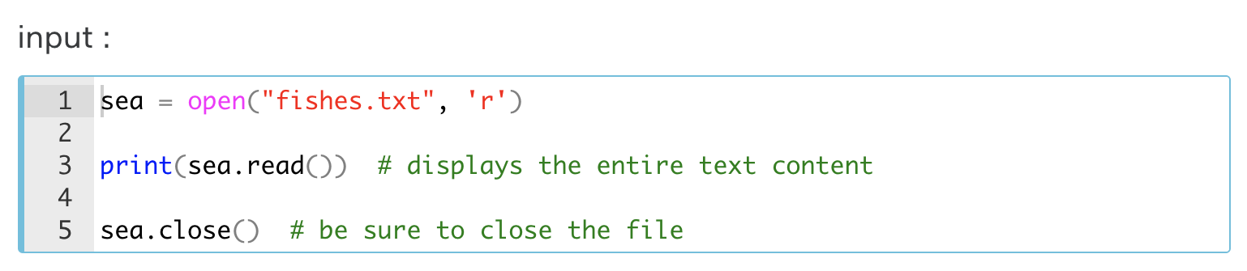

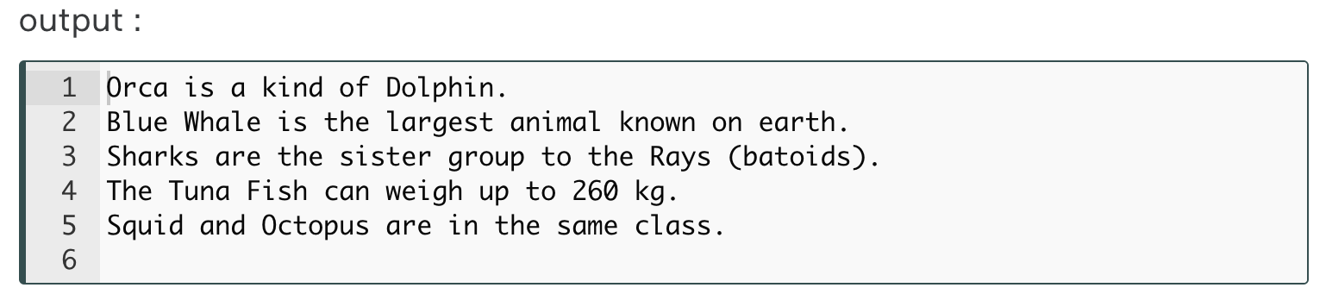

**💡Tips :**

* Be sure to close the file you opened using the .close() method.

Now let's do some readings using the size parameter. It specifies the sequence number of the characters starting at number 1.

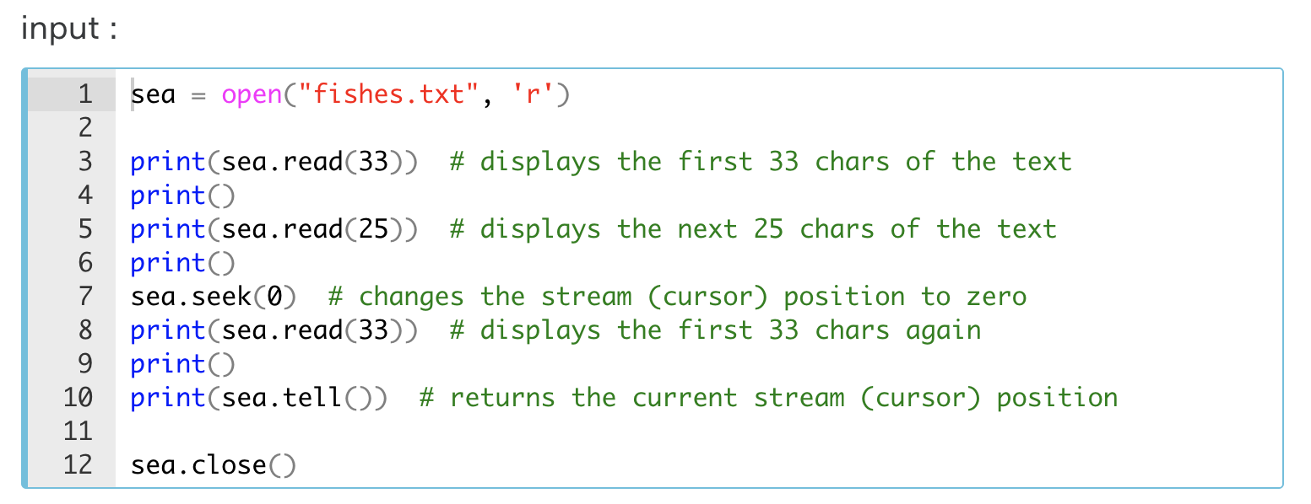

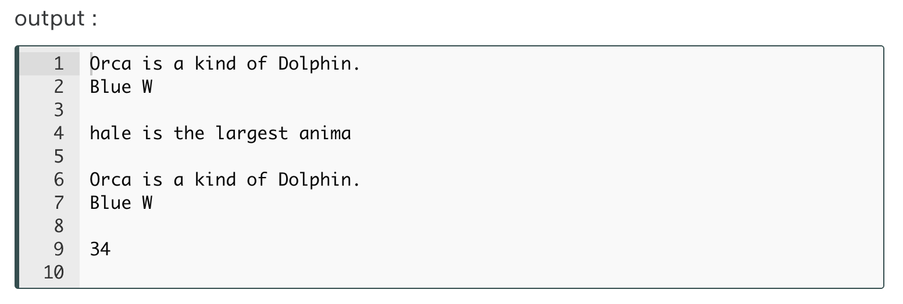

**💡Tips:**

* Note that; while .read(33) counting the first 33 bytes, it covers newline **\n** and **space**character of the file text.
* The *offset=* 0 indicating the *first* character of the text, '**.seek(***offset***) method**' changes the stream (cursor) position to a given *offset*.

##### **2.** .readline(size) :

Now let's take a look at the second method that we use to read files in the Python. This method reads only size bytes from a single line of the text. Now let's start to examine this method through an example :

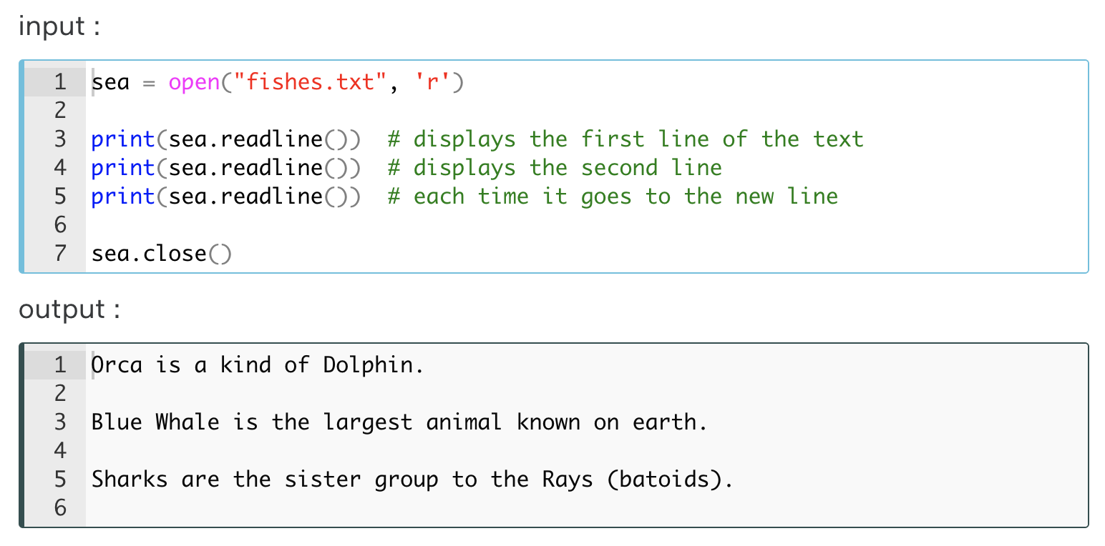

**💡Tips:**

* Note that; .readline() reads the entire line.
* Pay attention to the output that there are empty lines between each line.

Now, let's take a look at an example using the size parameter. The first line of the text contains 26 bytes (characters) except the **newline** char (\n). But, note that the newline character (\n) is considered as a part of each line. Then the first line of text consists of 27 characters. Let's choose 13 as the size parameter and see what happens :

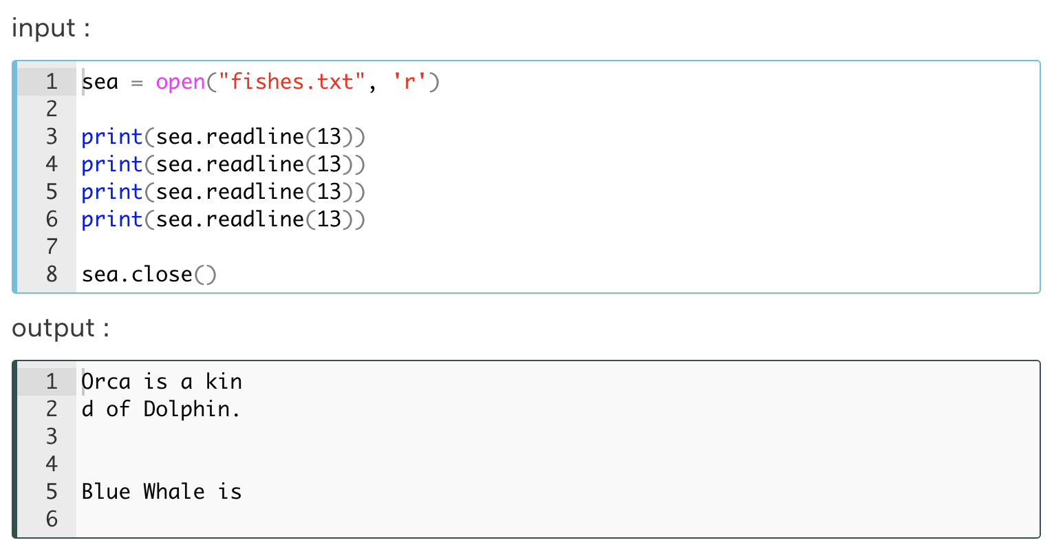

This is for the \n character at the end of the first line

This is for the default newline of the readline method

As you can see, the .readline(13) reads 13 chars through the line and it continues to read 13 chars each until the line ends, and only then passes to the next line. In this example, considering the first line consists of 27 characters, the print(sea.readline(13)) syntax can read the entire line in a total of three repetitions. The output has two empty lines. One of them is caused by the last character (\n) of the first line and the other is because of the default empty line that the .readline() method puts between each line.

**⚠️Attention:**

* Remember that you can not run these codes on Playground.
* Note that, you should use Python Shell (IDLE) or Jupyter Lab/Notebook on your PC.

##### **3.** .readlines() :

And the third method in reading the files in Python is .readlines(). It reads the entire file line by line in the list form.

Using our same text file, let's look at the following example on how the output looks like :

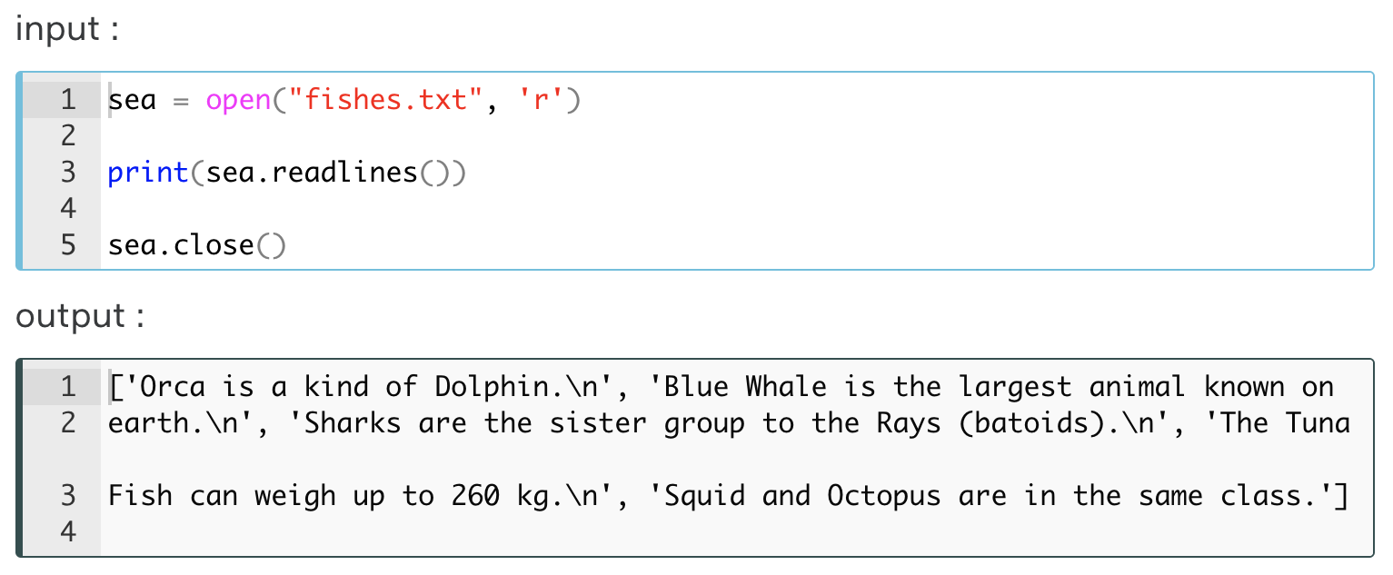

As you can see in the output, all lines are displayed as separate elements of a list. You can easily see the fact that the newline character (\n) is a part of the line we've mentioned before.

The position of the stream (cursor) makes sense when using these methods. If we make the file read using one of these methods, each time we use the **print**(*method*) syntax it continues reading from where the cursor is. Let's take a look at the following example where .readline() and .readlines() are used together.

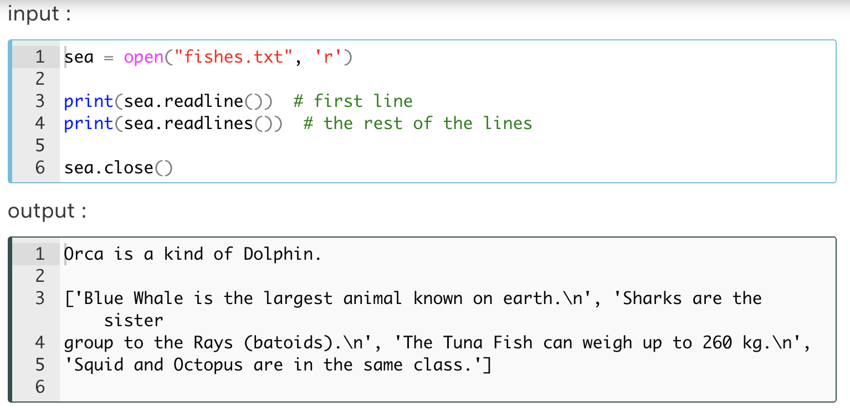

You may have noticed that the type of the sea.readlines() object is the list. Let's see it :

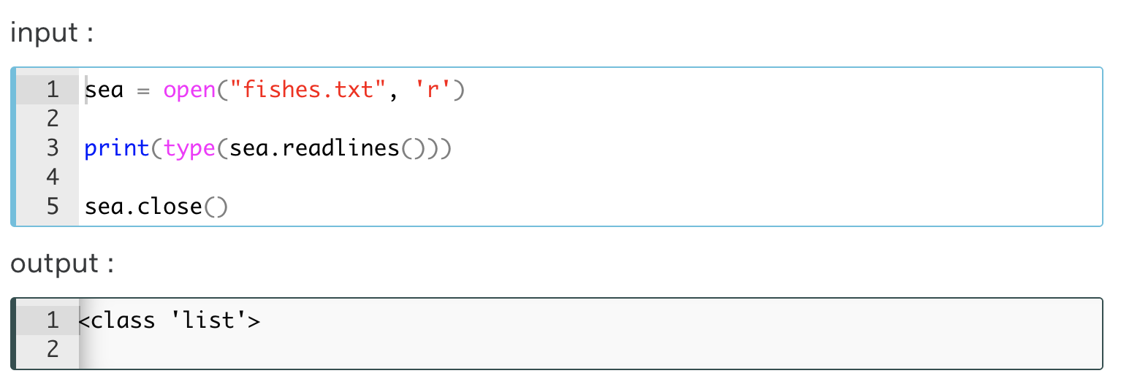

**⚠️Attention ! :**

* Although it is very good to read relatively small files with this method, but when large files are involved, this method can be inefficient.

As we stated before that we can apply different kinds of methods to the **file-like object**. Accordingly, the last method for reading a file is using the lines of the **file-like object** as an iterator. So the most efficient way to read the contents of a file is using the **for loop**. Let's take a look at an example of how we do this.

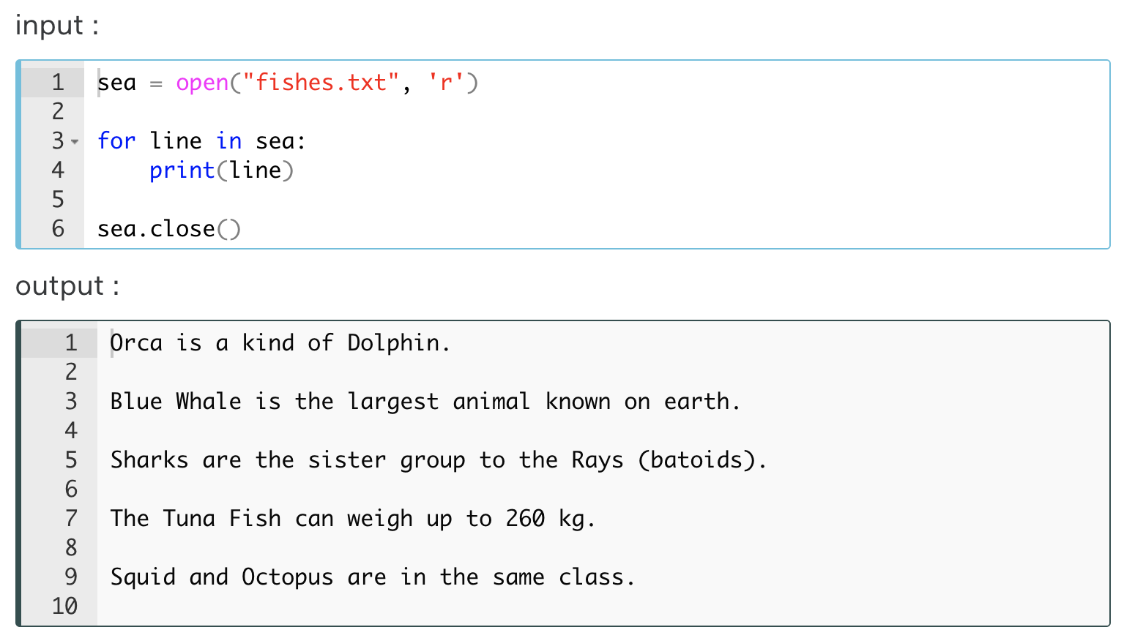

In this way, especially large text files can be read easily and practically. This method gives us the opportunity to read the line we want, as well as freeing us from syntax repetition.

Since the type of sea.readlines() object is a list, we can use it as an iterator and read the whole file in the same way.

### Closing the Files

You should have noticed that in the examples we have given so far regarding file operations, whenever we open a file to work with that file using one of the reading methods, after finishing our working we close the file we opened with the close() method.

**⚠️Attention ! :**

* Do not leave the file open.
* Keep in mind that closing the file is paramount.

Normally, when the program finishes running, that file is closed. But this does not happen at times and people forget to close these files that have been opened while working with them. If we do not want to lose the data we are working with, we should keep in mind that the file should be closed as soon as our work is finished.

As we mentioned above, we can do the closing process with the close() method, but there is a slightly easier way to do this. Using the **with**.... **as** ... block. In fact, the actual use of the with ... as ... block is to make sure that all the necessary functions are called. Take a look at the way we use it :

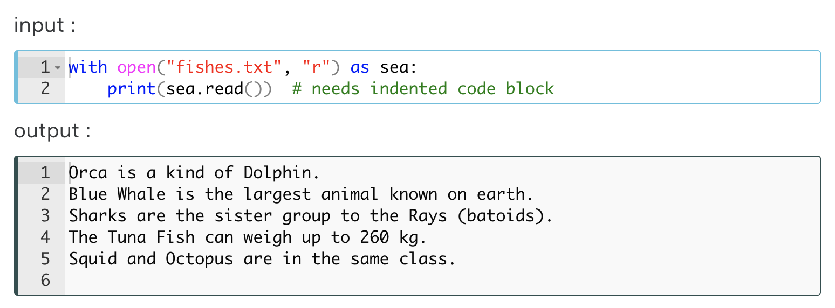

As you can see, in this case, we don't need to use the close() method to close the file. It does this on its own.

### Writing Files

#### '.write()' Method

We have completed the first part of **working with files**. There is another basic file operation. Now it's time to learn how to **write** to the files. As you can remember that we have two most commonly used **modes** ('w' and 'a') that allow us to modify the files. Let's examine them one by one :

**⚠️Attention:**

* You can use the **Playground**for file writing operations.
* You can also use your own IDE such as **Jupyter Lab/Notebook** or **Python Shell (IDLE)** on your PC.

As we mentioned earlier, we can overwrite a text to a file using 'w' mode, which means that every time we use 'w', the content of the file is deleted and new content is written. If there isn't any file then it will be created automatically.

**💡Tips:**Note that;

* Data in the other type that we intend to write to the file must be converted to **string type** before the writing process,
* **Playground**creates a virtual file, not a real file.

Let's create and write string data to a file. We're going to use .write() method for writing :

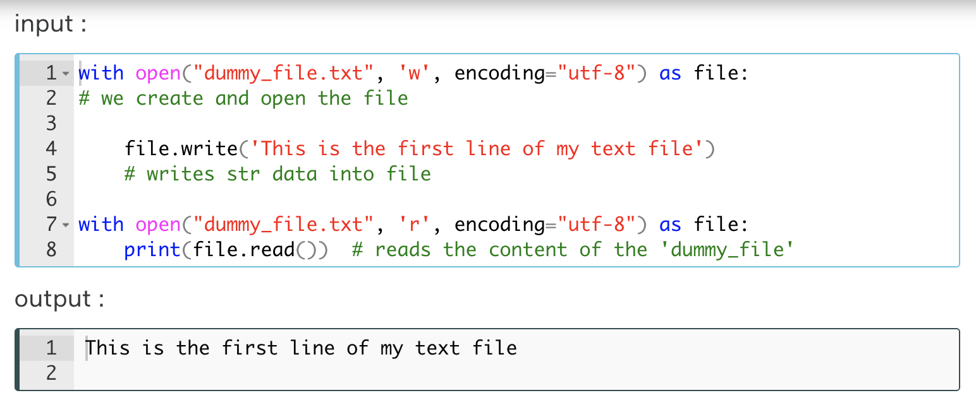

Now let's repeat the process and see what happens. This time the file (**dummy\_file**) exists :

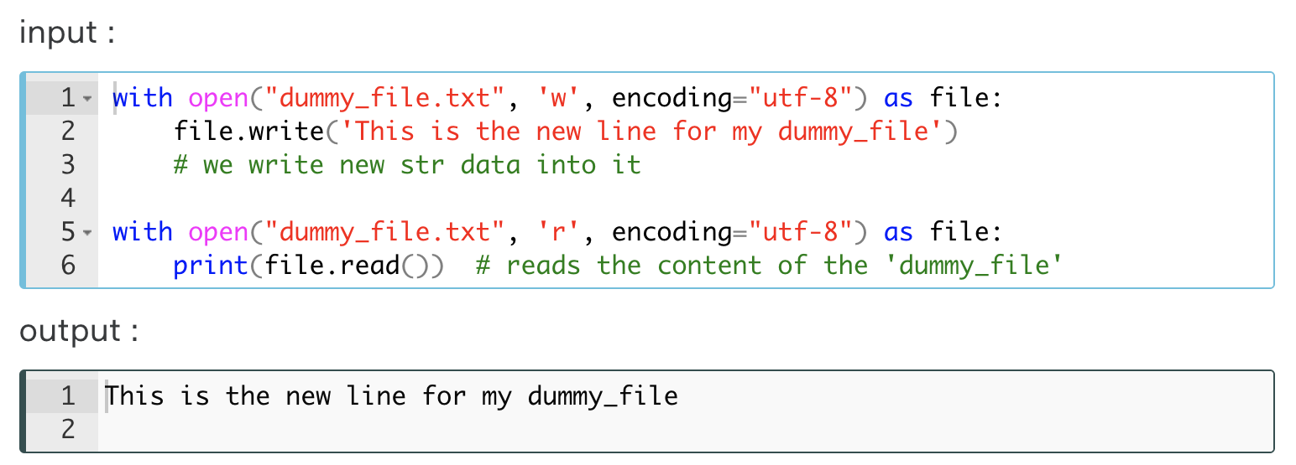

As you can see in the output, the previous content has been deleted and replaced with new content.

When you write strings to a file using the .write() method, the string data is written exactly as it is. Whenever you use .write() method, each string joined together into one. Therefore you have to put newline characters (\n), separators or spaces, etc. manually if you want. Consider the following example :

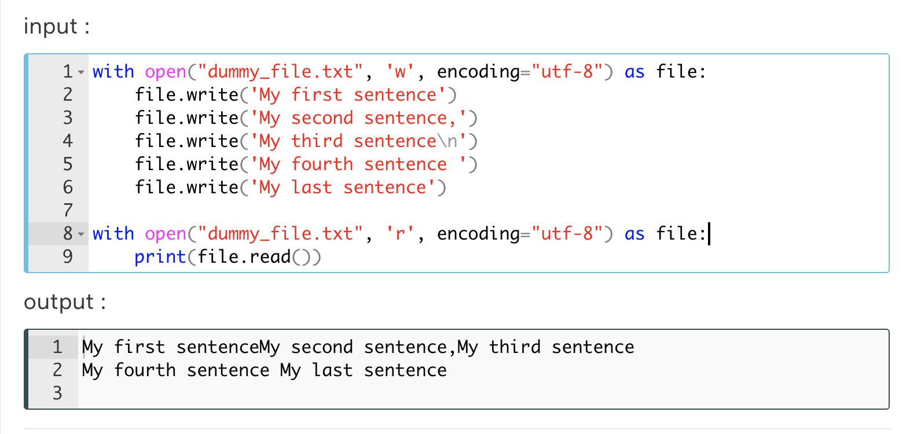

Now, think of that we have a list of fruit names. Let's write them to a file each on separate lines one after another.

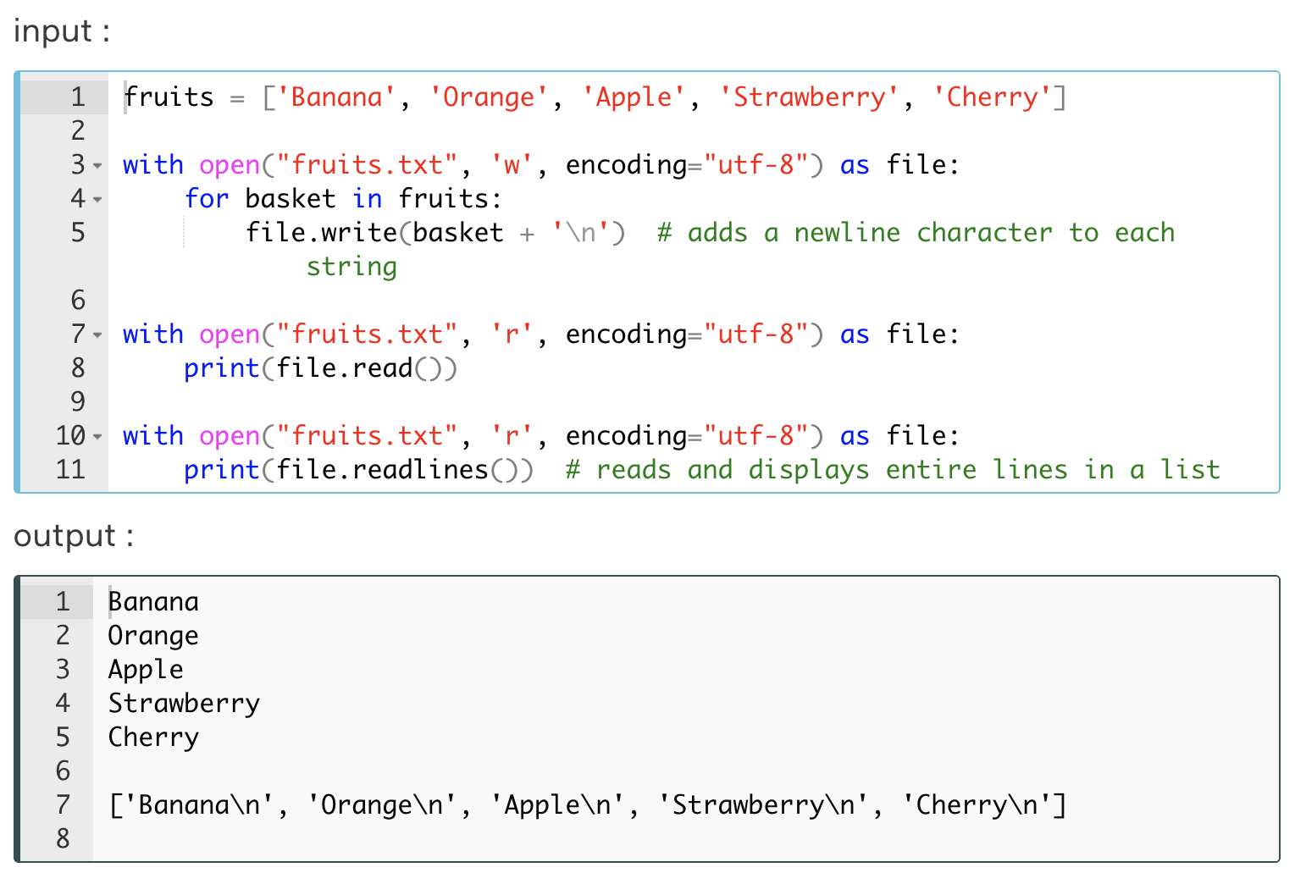

Likewise, you can write your text to the file by using any character you want instead of the **newline**character. For example, if you want to separate the strings by a **tab**character, you should use '\t'.

#### '.writelines()' Method

There is another method for writing data to the files. It is .writelines() method. Unlike .write() method, .writelines() takes the iterable sequence of strings and writes them to the file. The difference between these two methods is just similar to the logic of difference between .read() and .readlines().

Let's use the same list of the *fruits* again but this time in a little bit different way. We should choose the *line separators* ourselves without using for loop. Let's see how we do it :

As you see, the same output was displayed as the previous one. In this writing method, which we do without using the for loop, the strings in the list must also include the *separator chars*such as\n, \t, *space.*

Write a code that inserts a **newline char** \n to between lines of the text of the '**fishes.txt**' file and reads the new content of that file.

with open('fishes.txt', 'r', encoding = "utf-8") as sea:

fish\_lines = sea.readlines()

with open('fishes.txt', 'w', encoding = "utf-8") as sea:

for reef in fish\_lines:

sea.write(reef + '\n')

with open('fishes.txt', 'r', encoding = "utf-8") as sea:

print(sea.read())

#### Appending to File using 'a' Mode

Unlike the previous writing mode ('w'), in most cases when we want to add new content to a file, deleting the existing content is undesirable. Therefore, there is a need for another mode that both keeps the existing content of the file and saves the new content to the continuation of the file. In Python, we meet this need with 'a' mode which stands for **append**.

Well then, how we do that appending process. Let's add *melon* to our **fruits.txt** file as the last line. Let's remember our fruits :

['Banana\n', 'Orange\n', 'Apple\n', 'Strawberry\n', 'Cherry\n']

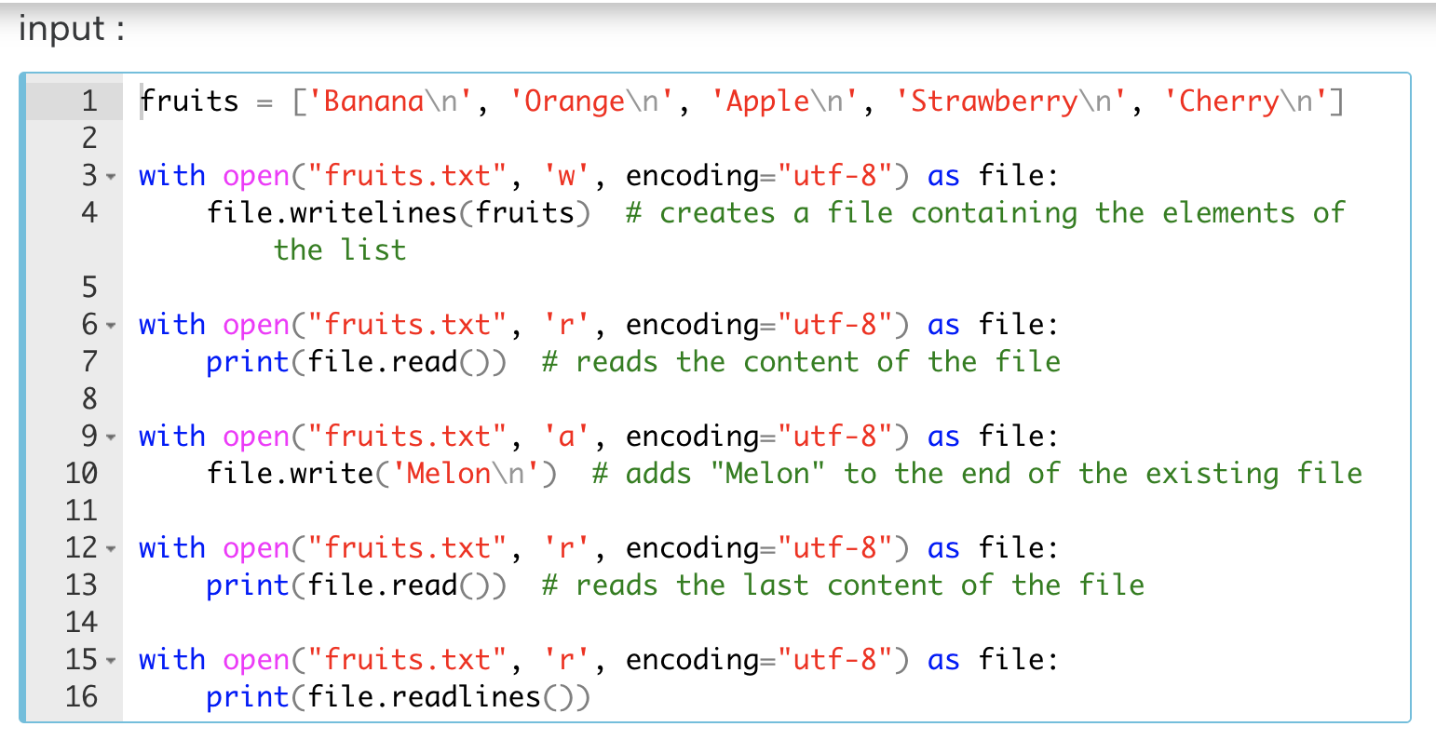

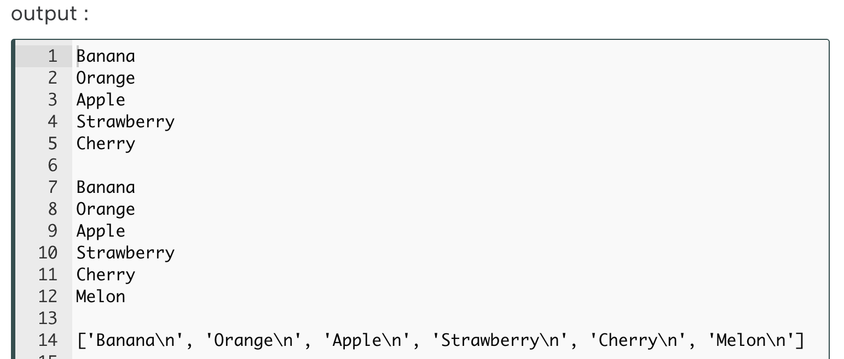

## CSV Files

### What is a CSV File?

Another widely used file type in all programming languages is CSV files. **CSV** stands for **Comma Separated Values**. Due to its simple structure and easy creation, data with various contents are usually stored in this format.

Actually, it's a plain text like **.txt** files. Normally, CSV files use a **comma** to *separate*each specific data value. When you **save** the*plain text file*that you create by using a simple text editor (such as *Notepad*in Windows OS) **as** a **.csv** extension, then you create a CSV file.

A CSV file is basically a table made up of rows and columns. The structure of a simple CSV file is as follows :

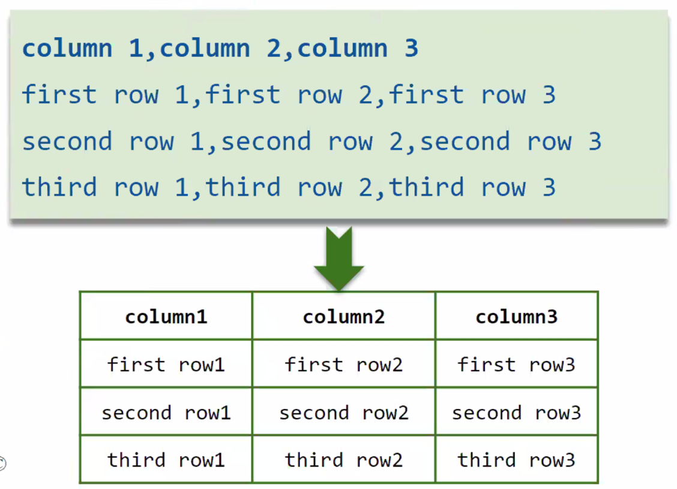

Now, let's create our first CSV file. We can use the previous **txt** file named **fruits.txt**. As usual, save this file with a **.csv** extension into directory where **Anconda3/Python** installed.

no,fruit,amount  
1,Banana,4 lb  
2,Orange,5 lb  
3,Apple,2 lb  
4,Strawberry,6 lb  
5,Cherry,3 lb

Yes, our first CSV file consists of 3 columns and 5 rows. It's time to read this file.

### Reading Methods of the CSV Files

There are several ways to read CSV files in Python.

1. You can use the ordinary way of reading using open() function and .read() method just you learned in the previous lesson.
2. You can use [csv](https://docs.python.org/3/library/csv.html" \l "module-csv" \t "_blank)**[Module](https://docs.python.org/3/library/csv.html" \l "module-csv" \t "_blank)**.
3. You can use the **Pandas** library for which created data analysis purposes. It is highly recommended if you have a lot of data to analyze. We will not examine this scientific library in this topic. You can learn it if you attend the Data Science course.

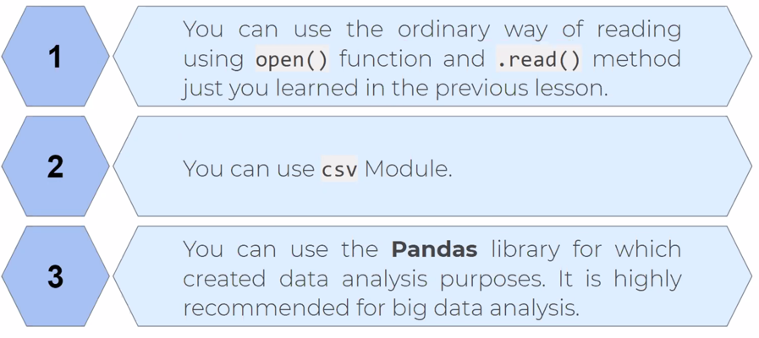

Well, let's examine the first two reading methods of CSV files.

#### Ordinary Reading Method of CSV Files

This method is quite simple and does not differ from reading the text files.

Let's read the **fruits.csv** file we created in the previous lesson.

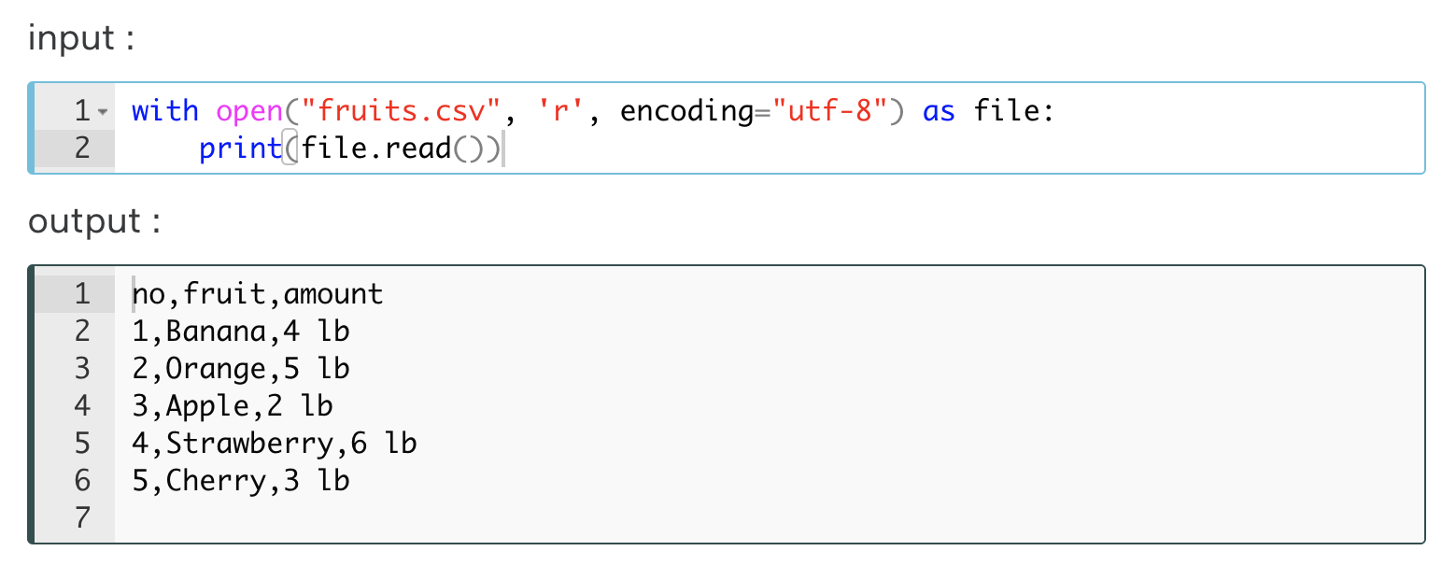

As you can see, the content of the CSV file is displayed in plain text. In cases where the file content is very long and the number of rows and columns is high, this method is quite useless.

#### Reading the CSV Files with 'csv' Module

Since the content of the CSV files is displayed in a more readable and regular format with this method, this method is more preferred than the previous one.

First of all, of course, we should load csv module. Secondly, we will use csv.reader() function in a for loop to read the CSV file. Examine the following example carefully :

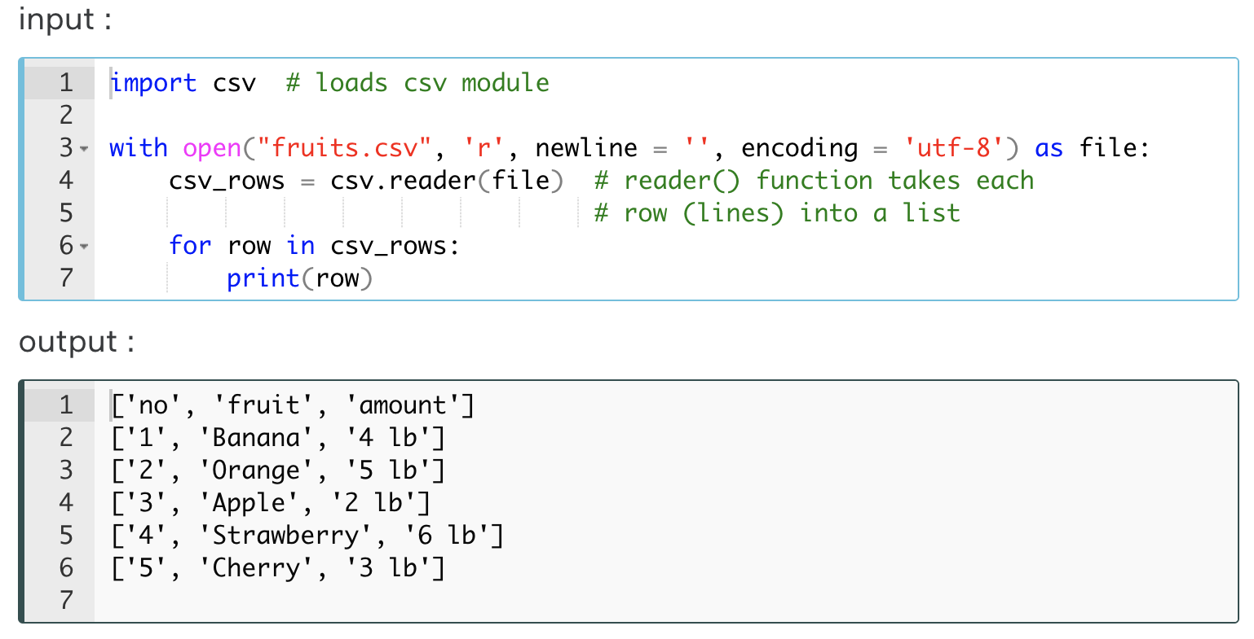

Top of Form

Bottom of Form

As you can see, the rows are displayed in the list type. Each element of the rows is located as separate strings in the list. There are three strings in each list.

**💡Tips:**

* If newline='' is not specified, newlines embedded inside quoted fields will not be interpreted correctly, and on platforms that use \r\n linendings on write an extra \r will be added.
* It is best practice and always safe to specify newline='', since the csv module does its own newline handling.

The default value of the delimiter parameter is ",". Thus, we can display each comma-separated element as separate strings. At this time let's use the delimiter="," parameter and see the same result as the previous one.

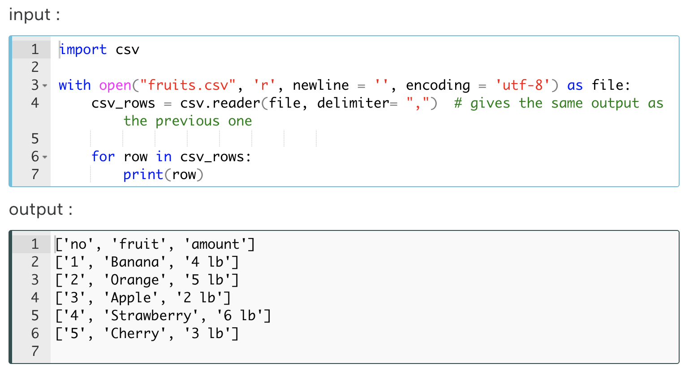

We can also display each row in the list as a single string. If we determine a character that **is not included** in the **CSV** file and allocate this character as the value of delimiter, we can print all lines of the CSV file as lists as a single string element. Consider this one :

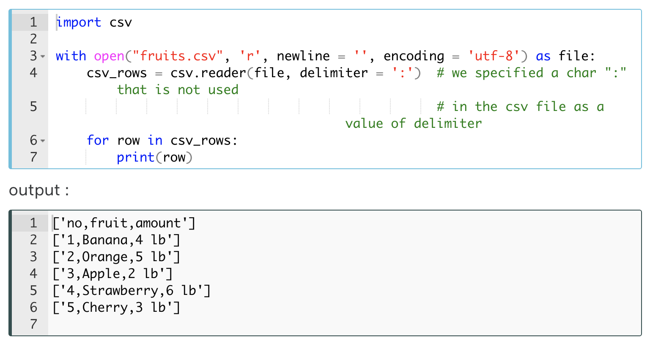

Yes, we got another list type output. Unlike the previous one, each row (list) contains a single string.

If you want to learn the details of the reading and even writing **.csv** files, you should take a look at the [official Python documentation](https://docs.python.org/3/library/csv.html" \l "module-contents" \t "_blank).

## Program Flow, Error & Exception Handling

### Program Execution

In this section, we will try to understand how Python codes work, in other words, we will take a look at what's happening when you run the codes.

Have you ever thought, after writing lines of Python code, how they do amazing things? We just write codes and do not care about the rest, but after we press the run button, we can say that very complex things are performed very quickly.

Even if we run the simple conventional Python syntax : print('Hello World!'), the same complex things are performed in the same way. The Python scripts (a file with **.py** extension) contains Python codes and we can run this file via several **interpreter**tools such as Python Shell, OS Console or IDEs. We don't care what's happening when we run our set of Python statements. This is normal but it's worth learning how it works.

Since the very beginning of this course, you have probably heard terms such as **interpreted** or **compiled**languages. And most likely, you learned that Python was an interpreted type of programming language. What does all this mean? Let's dive into the Pythonic world.

The process of program execution (the program flow) basically looks like this :

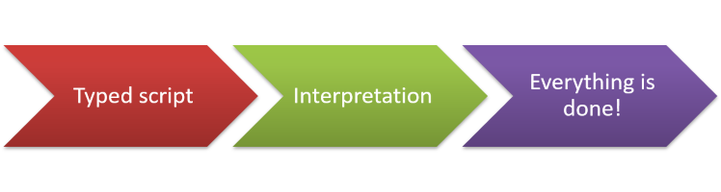

The step we are interested in is the middle one : **Interpretation**. Yes, Python is an interpreted programming language. We know that but superficially. Let's take a closer look at what this means.

#### The Interpretation

What is the interpretation process? Simply, we can say that this is like reading your codes. In other words, you can think that a specific-purpose software reads your codes line by line and executes what you typed.

This magical software is known as Interpreter and is a part of the standard Python installation package. And of course, the other default installation part of Python is built-in libraries.

The compiler translates Python codes to byte-codes that come into it by reading line by line from **top to bottom** and from **left to right**.

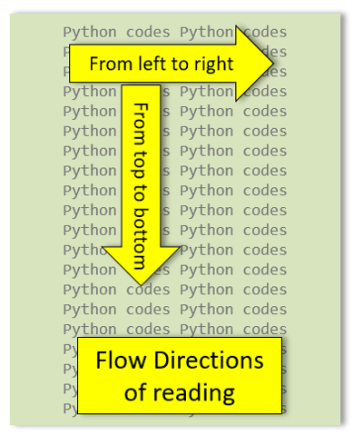

The interesting thing is that the interpreter we mentioned here can be written in any programming language. Python's default interpreter is a software written in the **C** programming language known as **CPython**. There are several other interpreters available such as :

* **Jython** is an interpreter that works with a Java-based algorithm and converts Python codes into Java-compatible byte code, which will be executed later by the **Java Virtual Machine**.
* **PyPy** is a replacement for CPython. It is built using the RPython language that was co-developed with it. The main reason to use it instead of CPython is speed: **RPython**(Restricted Python) provides some restrictions to the usual Python code.
* **IronPython** is an open-source implementation of the Python programming language which is tightly integrated with the **.NET Framework**.

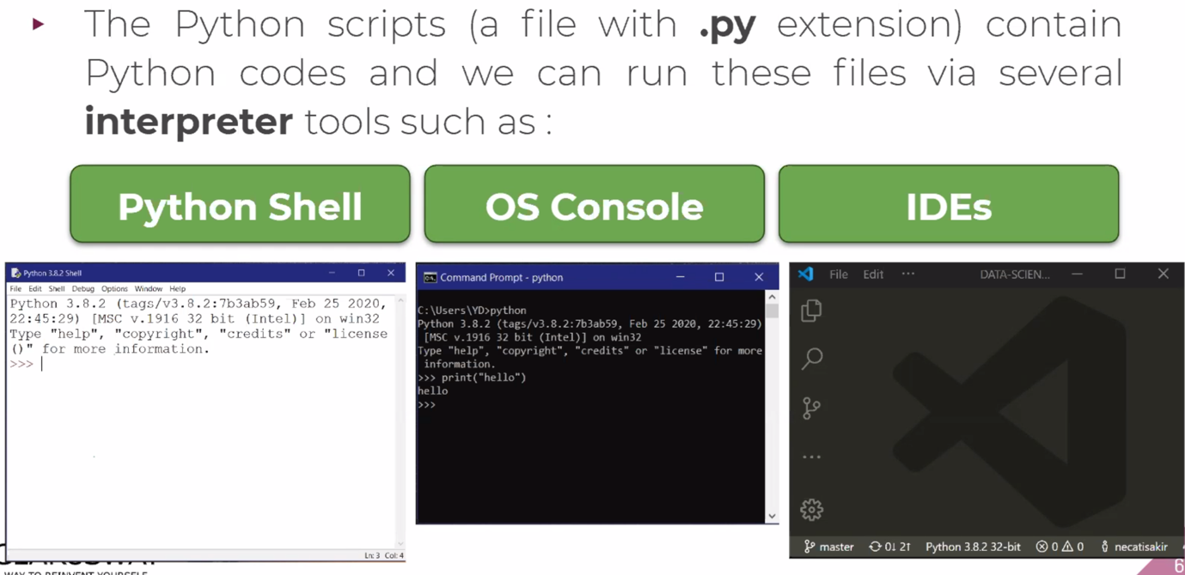

Now let's try to figure out the interpretation process in detail. The interpretation step consists of basically three sub-steps which are :

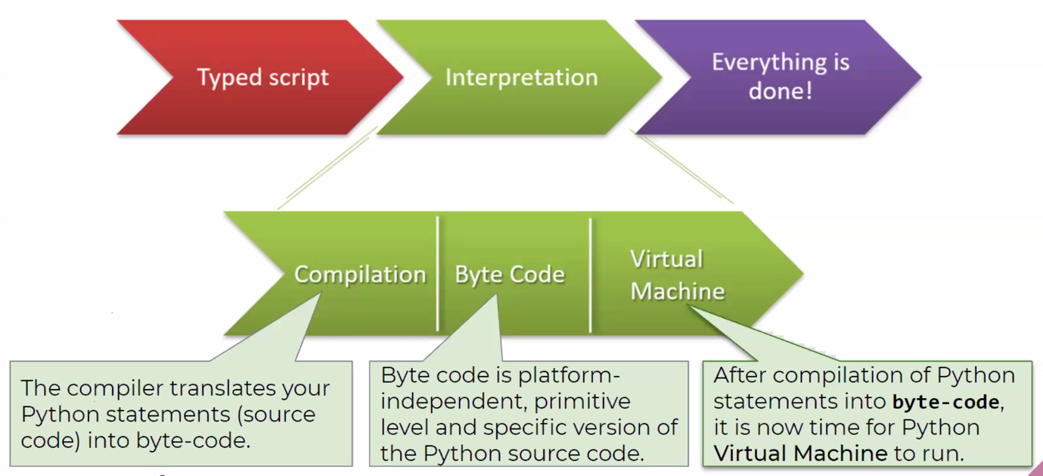

The **compiler**translates your Python statements (source code) into byte-code. Different from the binary machine code, the **byte code** is platform-independent, primitive level and **specific**version of the Python source code. That's why some Python programs are executed not as fast as in   
**C-based** conventional compiled languages.

After **compilation**of Python statements into **byte-code**, it is now time for **Python Virtual Machine** to run.

#### Virtual Machine

When you say Python Virtual Machine, you should not think of a mechanical machine or hardware. It is actually nothing but software made up of a large piece of code.

Just like in compiler, Virtual Machine executes byte-codes that come into it by reading line by line from **top to bottom** and from **left to right**.

As we mentioned before, all this is done automatically by itself. It does not require a separate library or program installation. You do not need to know how the codes that go from the Python statements to the byte-code and from the byte-code to the Virtual Machine are created and executed. Just grasping the order of flow and the logic of these processes will be sufficient at this stage.

Lastly, we can say that the actual execution of the Python codes we typed is done by Python Virtual Machine as the last step. In fact, other previous steps are the process of converting Python statements into a format that Python Virtual Machine can understand and execute.

### Errors

Keep in mind, writing code in Python is easy but requires high attention. Even the slightest punctuation, a comma or a space character will cause you to receive an error warning and your program not to run.

Sometimes you can see that the codes with the simplest syntax can give an error when you never expected. Consider the following example :

|  |
| --- |
| print("Don't say 'I never make a mistake'" |
| Traceback (most recent call last):  File "code.py", line 1  print("Don't say 'I never make a mistake'"  ^  SyntaxError: unexpected EOF while parsing |

In the error message appeared on the screen, there is the term **Traceback.** It is actually a [module](https://docs.python.org/3/library/traceback.html" \l "module-traceback" \t "_blank) of [614 lines of Python code](https://github.com/python/cpython/blob/3.8/Lib/traceback.py" \t "_blank). This module provides a standard interface to extract, format and print stack traces of Python programs. It exactly mimics the behavior of the Python interpreter when it prints a stack trace. In this way, it allows you to follow the line and character of the error and trace it.

**💡Tips:**

* Concentrate on the **last lines** of the error messages.

The name of module - *Traceback* - appears when your code causes an error and it reports detailed information on that specific error, demonstrating the particular files in which the error occurred. In these error messages, the most important thing that a programmer should be interested in is the last lines in the most cases. In this example, the last two lines indicate that this error type is a Syntax error and it also indicates in which line and in which character (with the **^** sign) the error raised.

**⚠️Attention:**

* Do not panic when you see those error lines. Do not hesitate to read carefully what they are saying to you.

#### Syntax Errors

In the previous example (shown below), you must have seen the mysterious word **SyntaxError**, which you will likely encounter frequently during your time in Python.

|  |
| --- |
| Traceback (most recent call last):  File "code.py", line 1  print("Don't say 'I never make a mistake'"  ^  SyntaxError: unexpected EOF while parsing |

A wide variety of errors in Python are called SyntaxError. Typically, they indicate a problem that Python encountered when trying to compile your program, or that your code could not be run.

Every syntax error has a text value (known as **associated value**) that describes the error in detail.

In this example, the message "**SyntaxError: unexpected EOF while parsing**" means that something else had been expected by the interpreter after your statement, but you didn't pass it to the interpreter. In our mistaken code, there should have been a closing parenthesis mark "**)**" which is missing.

**💡Tips:**

* Focusing on the **associated value** of the SyntaxError often helps solve your problem.

Error messages may not always be very clear. To find the source of your error, it is sufficient to know that the error you received is in the syntax.

#### Common Errors

The most common syntax errors made by programmers can be listed as follows.

##### Quotes

In the [Matter of Quotes](https://lms.clarusway.com/mod/lesson/view.php?id=3&pageid=6" \t "_blank) lesson, we have elaborated on how sensitive programming language Python is to quotation marks. So it's critical not to forget to enclose a string in quotes of the same type.

**💡Tips:**

* Keep this simple advice in your mind; triple quotes for multi-line strings, double or single quotes for ordinary strings.

##### Wrong Parentheses

One of the most common syntax errors is the wrong number of parentheses in function calls. e.g. print(len(my\_list[2:]).

##### Wrong Spelling & Typo

Yes, it may sound strange to you, but the most common mistake made by programmers is the wrong spelling keywords, function names, and variable names. e.g. True and true, print and prit or pirnt.

**⚠️Avoid ! :**

* Do not confuse uppercase and lowercase letter of the keywords. Keep in your mind that Python is a case-sensitive programing language.

##### Indents

Indents are also very common errors for programmers.

**⚠️Avoid ! :**

* Do not forget to put the appropriate indent where necessary. Keep in your mind that Python is a indent-sensitive programing language.

Modern IDEs tend to check everything you might be able to make mistakes and to gently highlight the places you made mistakes or typos with various cursors and indicators while typing. This will make your job significantly easier, but don't rely too much on it and be prepared to read your traceback yourself.

### Exceptions

So far, your code has been syntactically error-free and should be executed smoothly. However, in some cases, you will find that even if you have not made a syntax error, your program will be executed to a certain line and then give some warning messages. This means that your program is *partially executed*. Well, let's figure out what is going on.

If your program is running but you still get some error messages for several reasons, you probably get an error warning called an **exception**. This is because of defective line of codes in your program.

What is the difference between Syntax errors and Exception errors?

| **Syntax Error** | **Exception Error** |
| --- | --- |
| These types of errors are detected during **compiling** the program into byte-code. | These types of errors are detected during the program execution (**interpretation**) process. |

Now, let's examine the following example :

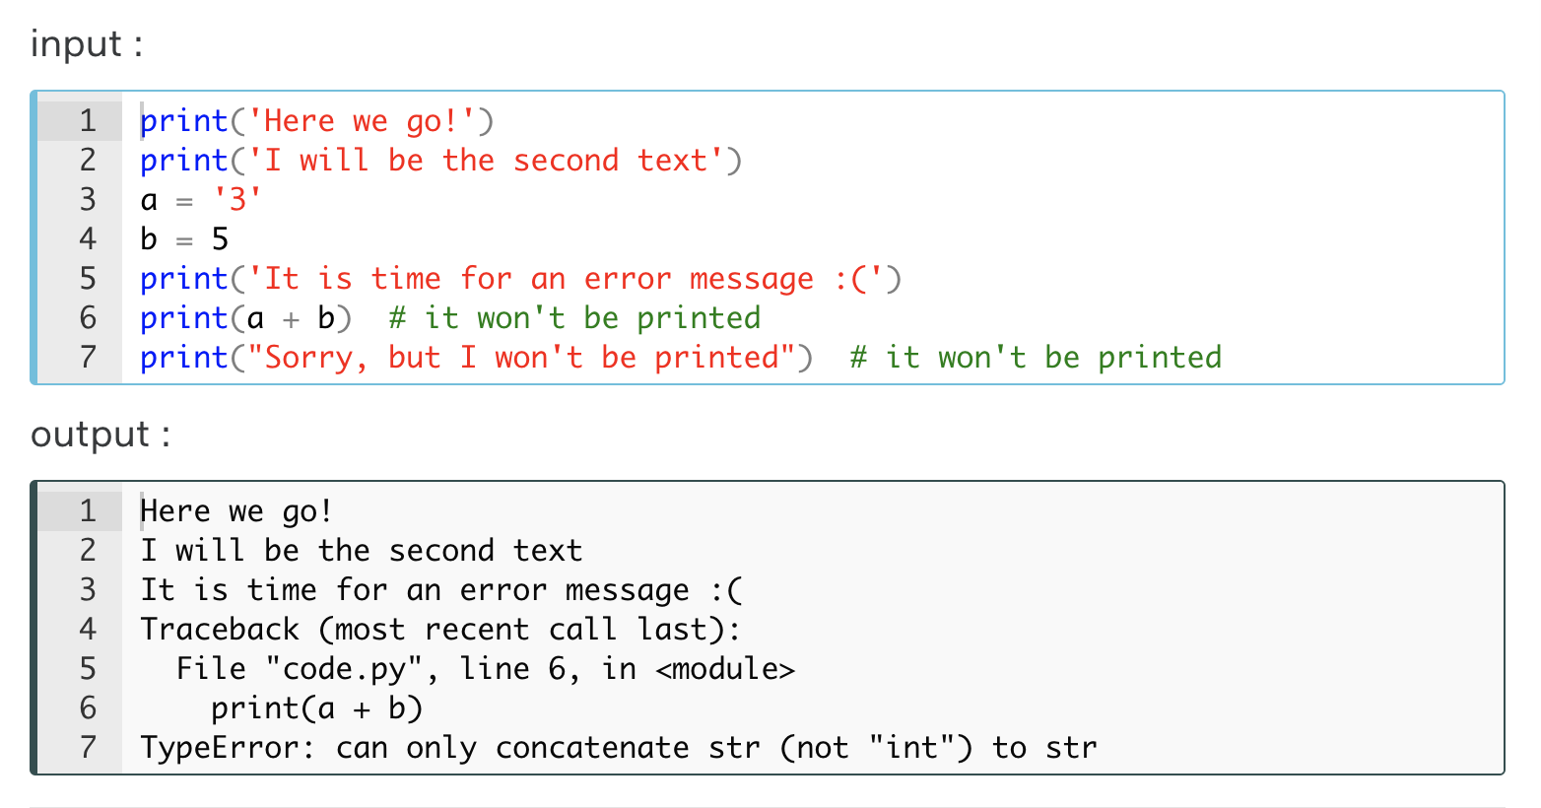

Yes, as you can see, the first three print() functions printed their own content, but the last two print() functions did not work and we received an exception error message (that is our program was partially executed). As we stated before, you should look at the last line of the error message which says that this is the **TypeError**. It's obvious, right? There is a wrong use of types of variables (a is a str type and b is an int).

**💡Tips:**

* The exceptions are not the end of the world: you will learn how to deal with them later.

Similar to the syntax errors, almost all exception error messages also have a text value following the error message explaining what the error is related to.

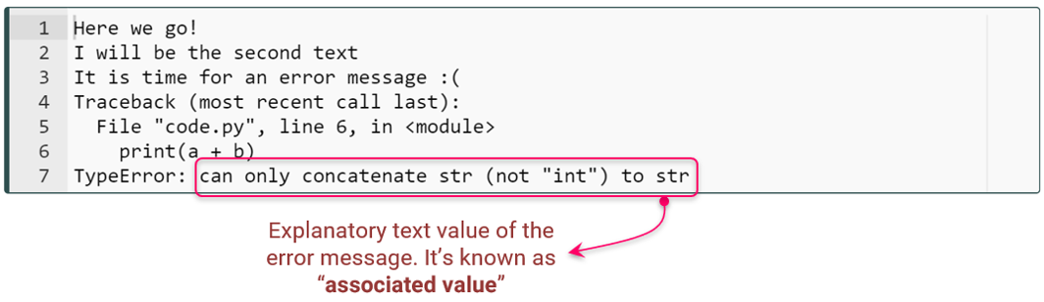

**Q**: What are the Errors and Exeptions in Python?   
**A**:

In Python, there are two types of errors: syntax error and exceptions.

**Syntax Error:**It is also known as parsing errors. Errors are issues in a program which may cause it to exit abnormally. When an error is detected, the parser repeats the offending line and then displays an arrow which points at the earliest point in the line.

**Exceptions:**Exceptions take place in a program when the normal flow of the program is interrupted due to the occurrence of an external event. Even if the syntax of the program is correct, there are chances of detecting an error during execution, this error is nothing but an exception. Some of the examples of exceptions are - ZeroDivisionError, TypeError and NameError.

#### Common Exceptions

In this lesson, we will take a look at the most common [exception errors](https://docs.python.org/3/library/exceptions.html" \l "built-in-exceptions" \t "_blank) a programmer can encounter.

##### ValueError

Raised when an operation or function receives an argument that has the right type but an inappropriate value, and the situation is not described by a more precise exception such as IndexError. In other words; to encounter a ValueError in Python means that it is a problem with the content of the object you tried to assign the value to. This should not be confused with types in Python.



Imagine, this is like forcing a fish to live in a chicken coop. Consider the following example :

|  |
| --- |
| print(int('ten')) |
| Traceback (most recent call last):  File "code.py", line 1, in <module>  print(int('ten'))  ValueError: invalid literal for int() with base 10: 'ten' |

As you can see in the output; when you are trying to make an integer of a string which has no integer value, the **ValueError** raises.

##### NameError

This error is usually raised if a variable you use in the code stream is not pre-defined or not properly defined. In other words, it is raised when a local or global name is not found. This applies only to unqualified names. The associated value is an error message that includes the name that could not be found. For better understanding, let's take a look at this example :

|  |
| --- |
| print(variable)  variable = "Don't ever give up!" |
| Traceback (most recent call last):  File "code.py", line 1, in <module>  print(variable)  NameError: name 'variable' is not defined |

**⚠️Attention :**

* Note that the NameError often raises due to the lack of attention to these two things: **case-sensitivity** of Python and **pre-defines** of the variables.

##### TypeError

Raised when an operation or function is applied to an object of inappropriate type. The associated value is a string giving details about the type mismatch. Let's examine this example :

|  |
| --- |
| for i in range('x'):  print(i) |
| Traceback (most recent call last):  File "code.py", line 1, in <module>  for i in range('x'):  TypeError: 'str' object cannot be interpreted as an integer |

As in the example; although it requires int, we have tried to iterate the wrong type - str - object in the range() function.

**💡Tips:**

* The most useful way you can do about all the errors you can't deal with yourself is to search for the error message on the internet search engine.
* You can make sure that the errors that you will encounter and their solutions have been experienced by someone previously.

**Q**: Give some examples of standard errors that occour in Python.  
**A**:

* **TypeError-** It occurs when the expected type does not match with the given type of a variable.
* **ValueError-**It occurs when an expected value is not given, suppose you are expecting 6 elements in a list and you gave 2.
* **NameError-** It occurs when you are trying to access an undefined variable or a function.
* **IOError-** It occurs when you are trying to access a file that does not exist.
* **IndexError-** It occurs when you are trying to access an invalid index of a sequence.
* **KeyError-** It occurs when you use an invalid key to access a value in the dictionary.

### Exception Handling

In this lesson, you will learn the strategies we need to prevent exception errors from unnecessarily disrupting our program flow.

In some cases, you may need to anticipate exceptions that might disrupt your program flow and take action in advance. This is where exception handling comes into play.

For example, suppose we have a block of code that takes two numbers from the user, divides the first number by the second number and prints the output of the division. Let's see what happens.

|  |
| --- |
| while True:  no\_one = int(input("The first number please : "))  no\_two = int(input("The second number please : "))  division = no\_one / no\_two  print("The result of the division is : ", division)  break |
| #Let's run it for the first time :  The first number please : 6  The second number please : 3  The result of the division is : 2.0 |
| #Let's run it for the second time :  The first number please : 7  The second number please : 2  The result of the division is : 3.5 |
| #This time, let's make a mistake intentionally and enter 0 as the second number :  First number please : 4  Second number please : 0  -------------------------------------------------------------  Traceback (most recent call last)  <ipython-input-5-537f57020b40> in <module>  2 no\_one = int(input("First number please : "))  3 no\_two = int(input("Second number please : "))  ----> 4 division = no\_one / no\_two  5 print("The result of the divison is : ", division)  ZeroDivisionError: division by zero |

Yes, we received an exception error message in our last attempt. So it's time to show you the way to solve it. We can ensure that our program continues without hesitation by using the **try-except** **statement**. The basic structure of **try-except** **statement** looks like :

|  |
| --- |
| try:  code block to be normally executed  except:  code block to be exceptionally executed |

Let's fix this exception problem using **try-except** **statement** as follows :

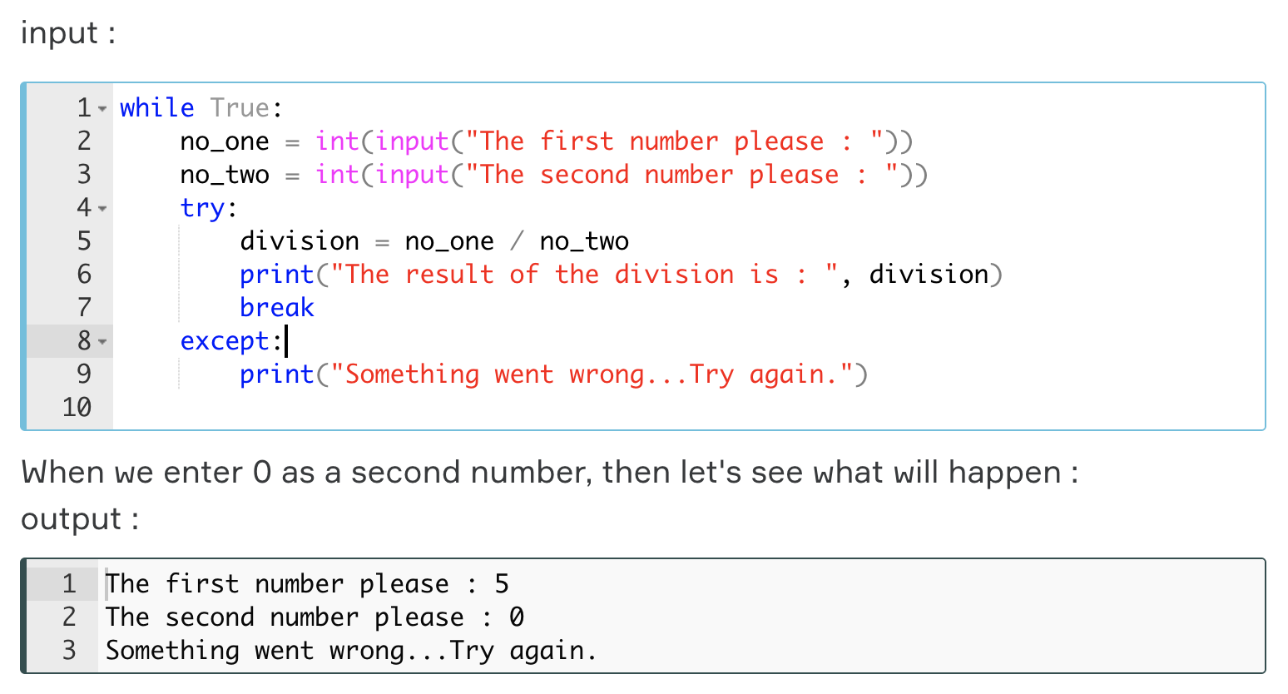

As you can see the output, there is no exception error message or breaking of the program. We can specify the exception error message in our **try-except** **statement**.

**💡Tips:**

* Of course, when do this, we anticipate which exception error we will encounter.

Consider this block of code :

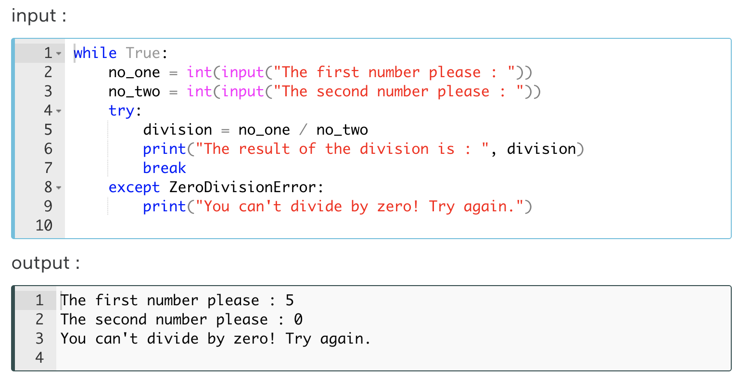

#### Full 'Exception Handling Block'

There are a few more keywords used with **try-except** **statement**. By using them, we increase our useful options in our program and create more effective and quality programs.

The full version of **try-except** **statement** is as follows :

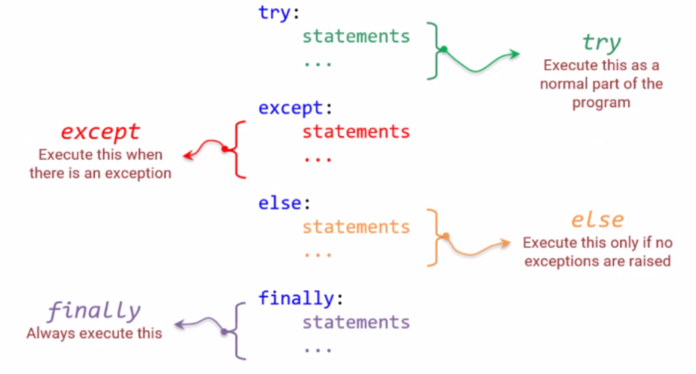

Let's make some **explanations**about the **process** described above :

* First, Python executes all statements between try and except.
* If there is **no exception**, then the try **block** is successfully executed and finished.
* If an **exception raises**, the rest of the try **block** is **ignored**. After that, Python interpreter checks if the type of exception matches the exception specified after the except keyword, it executes the except **block** and resumes executing the program **after** the try-except **block**.
* If an exception doesn’t match the exception named in the except **syntax**, it is known an unhandled exception and execution of your program stops with a **traceback error message**.
* The else**-block** is only executed if there raised no exceptions.
* We can use a finally **syntax** at the end of the block. A finally **syntax** is always executed before leaving the try-except **block**, whether an exception was raised or not.

You can follow the flow of these processes below :

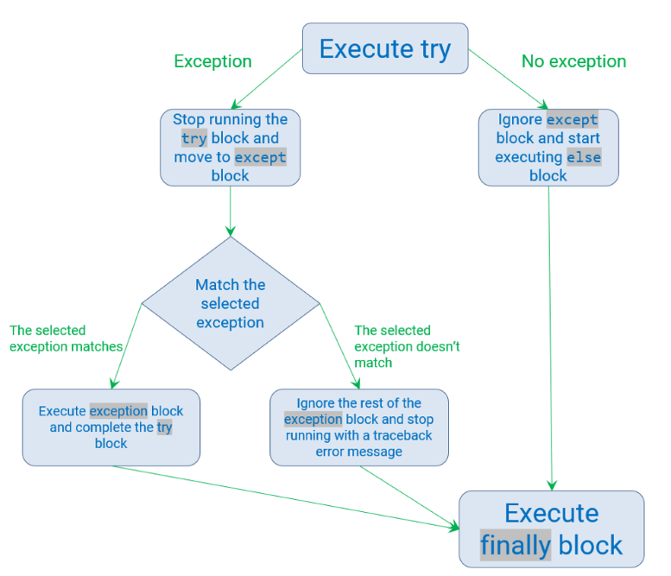

#### Implementation of the Full 'Exception Handling Block'-1

Let's reorganize our previous code according to the structure described in the previous lesson. Consider this block of code :

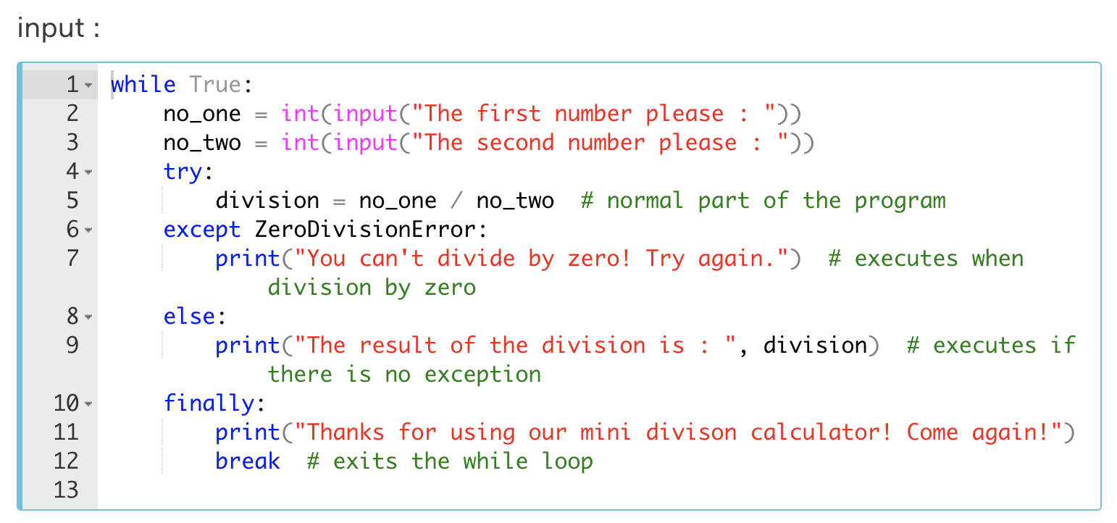

|  |
| --- |
| #Output1  The first number please : 7  The second number please : 2  The result of the division is : 3.5  Thanks for using our mini divison calculator! Come again! |
| #output - 2 : #Let's enter 0 as a second number.  The first number please : 7  The second number please : 0  You can't divide by zero! Try again.  Thanks for using our mini divison calculator! Come again! |
| #output - 3 : #This time, let's enter str type as a second number.  #The selected exception (ZeroDivisionError) will not match so #traceback error will be raised.  The first number please : 7  The second number please : k  -------------------------------------------------------------  ValueError Traceback (most recent call last)  <ipython-input-2-5fd297d1c219> in <module>  1 while True:  2 no\_one = int(input("The first number please : "))  ----> 3 no\_two = int(input("The second number please : "))  4 try:  5 division = no\_one / no\_two # normal part of the program  ValueError: invalid literal for int() with base 10: 'k' |

No matter what exception we encounter, there is a way to see it. Using the keyword Exception. Let's take a look at the following example

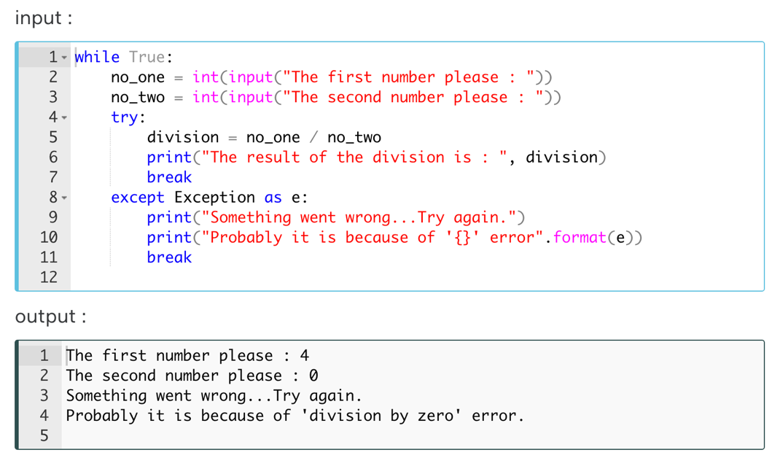

Yes, as you can see the output, by using the keyword Exception, we can display the name of the exception type. Consider the other example :

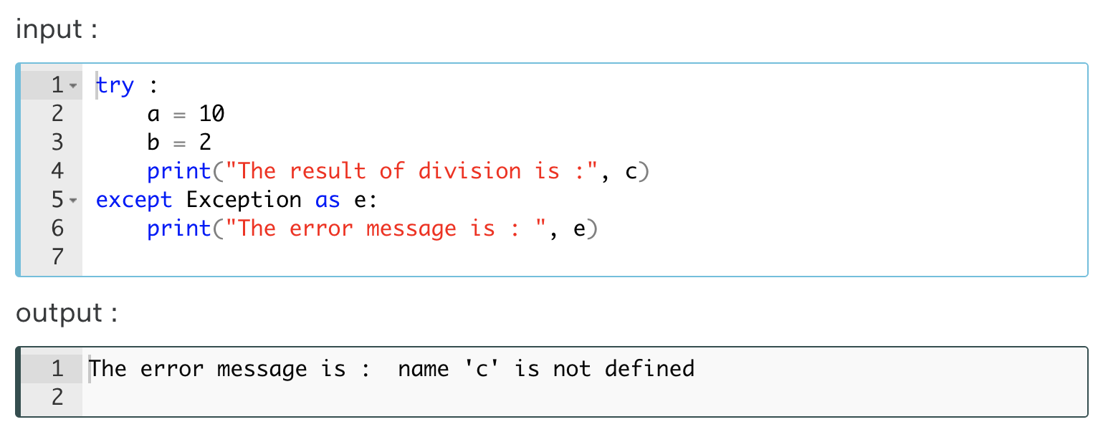

In this case, we used the variable "c" and since we didn't define it previously, it raised a **NameError** of which associated value is displayed in the output cell above : "*name 'c' is not defined*".

**💡Tips:**

* Apart from GeneratorExit, KeyboardInterrupt, SystemExit, the Exception keyword you learned in the previous lesson covers all exceptions.

#### Implementation of the Full 'Exception Handling Block'-2

In this second part of our lesson, we will continue to examine the full exception block through various examples. While examining the samples, try to understand the results by experimenting on the **Playground** yourself.

The **try…except** block has an optional else clause. The else clause is executed only if no exceptions are raised. Consider the following example of the else clause :

|  |
| --- |
| try:  x = 4 / 1  except:  print('Something went wrong')  else:  print('Nothing went wrong') |
| Nothing went wrong |

The **try…except** block has another optional finally clause. The finally clause is always executed, whether an exception has occurred or not. Consider the following example of the finally clause :

|  |
| --- |
| try:  x = 3 / 0  except:  print('Something went wrong')  finally:  print('Always execute this') |
| Something went wrong  Always execute this |

Use finally clause to define **clean-up actions** that must be executed under all circumstances e.g. *closing a file*:

|  |
| --- |
| try:  f = open('myfile.txt')  print(f.read())  except:  print("Something went wrong")  finally:  f. close() |

#### Several Handling Scenarios

In this part of our lesson, we will continue to examine this issue through various examples. While examining the samples, try to understand the results by experimenting on the **Playground** yourself.

Take a look at the first one. In this example you can define as many except blocks as you want, to catch and handle specific exceptions :

|  |
| --- |
| try:  x = 2/0  except ZeroDivisionError:  print('Attempt to divide by zero')  except:  print('Something else went wrong') |
| Attempt to divide by zero |

Since all the built-in exceptions are formed a [**hierarchical structure**](https://docs.python.org/3/library/exceptions.html#exception-hierarchy), you can use the following exception syntaxes. To catch several possibilities, it’d be better to use two or more except blocks for different exceptions.

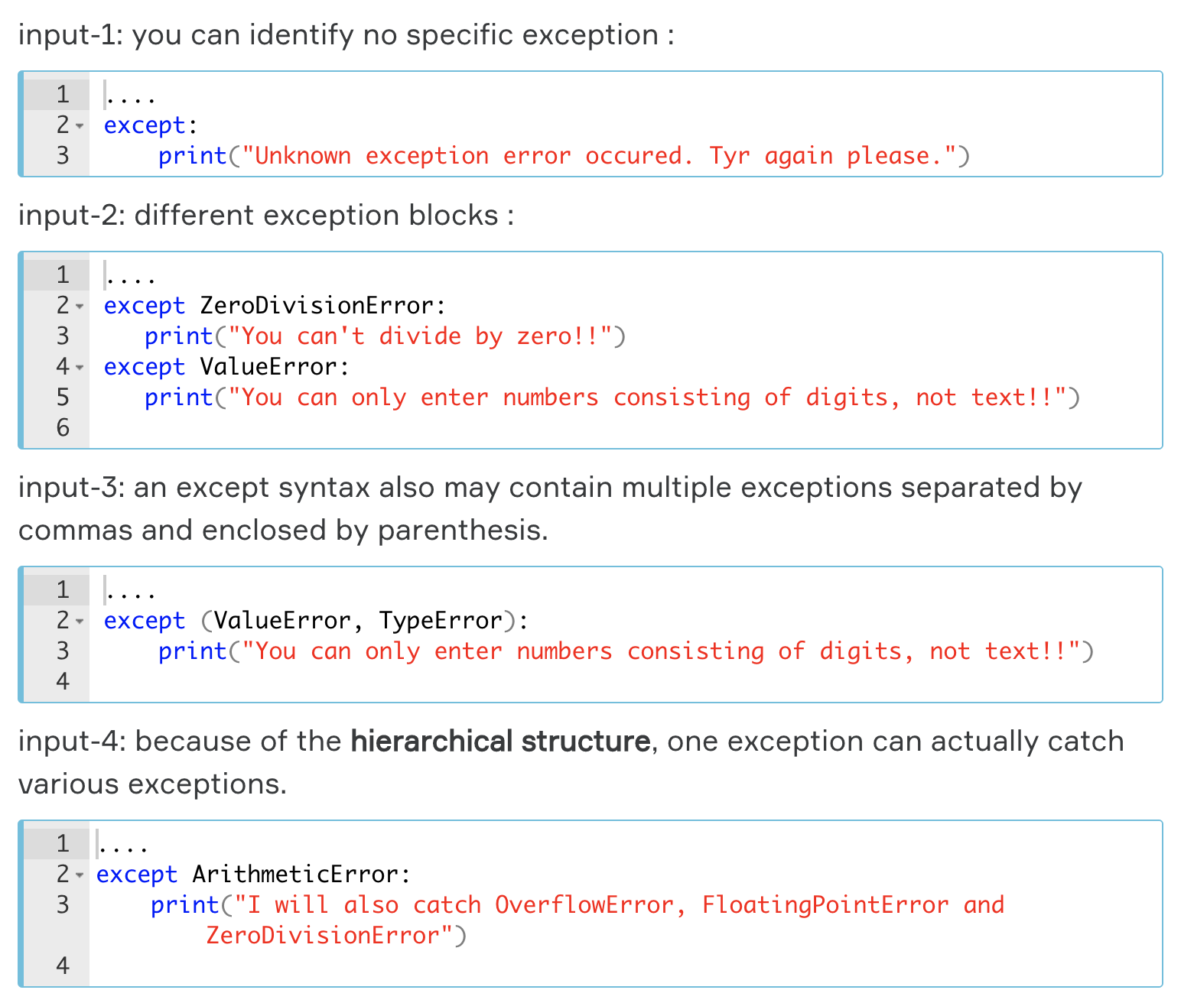

You can find all the built-in Python exceptions in the [official documentation](https://docs.python.org/3/library/exceptions.html#built-in-exceptions).

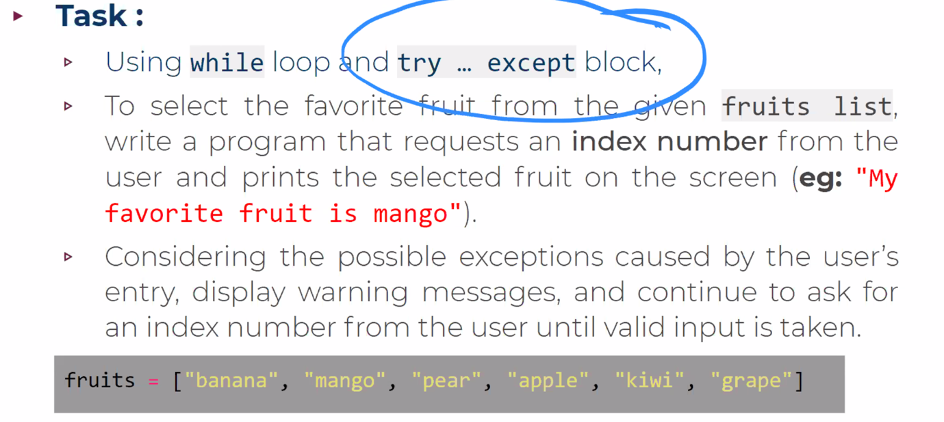

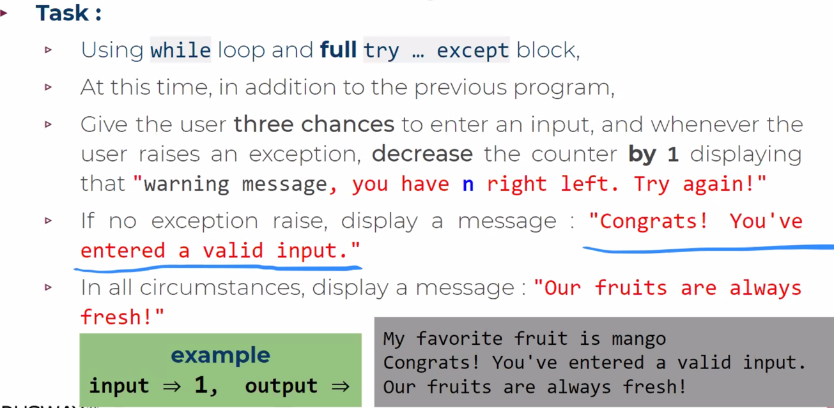

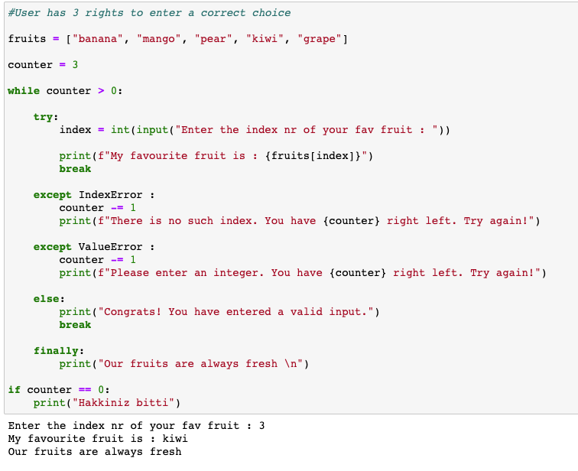

## ****Object-Oriented Programming****

**Object-oriented programming (OOP)** is a programming paradigm based on the concept of **objects** that interact with each other to perform the program functions. Each object can be characterized by a state and behavior. An object keeps the current state in the **fields** and the behavior in the **methods**.

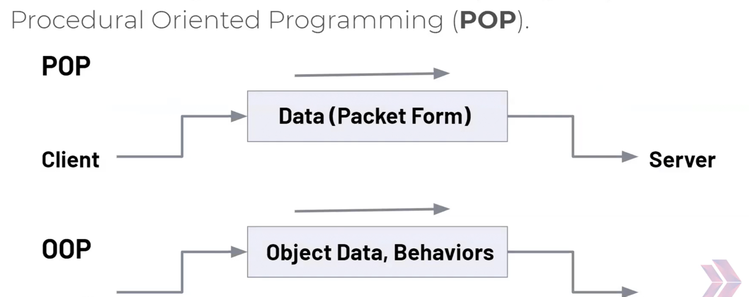

### Basic Principles of OOP

There are four basic principles of OOP. They are **encapsulation, abstraction, inheritance,**and **polymorphism.**

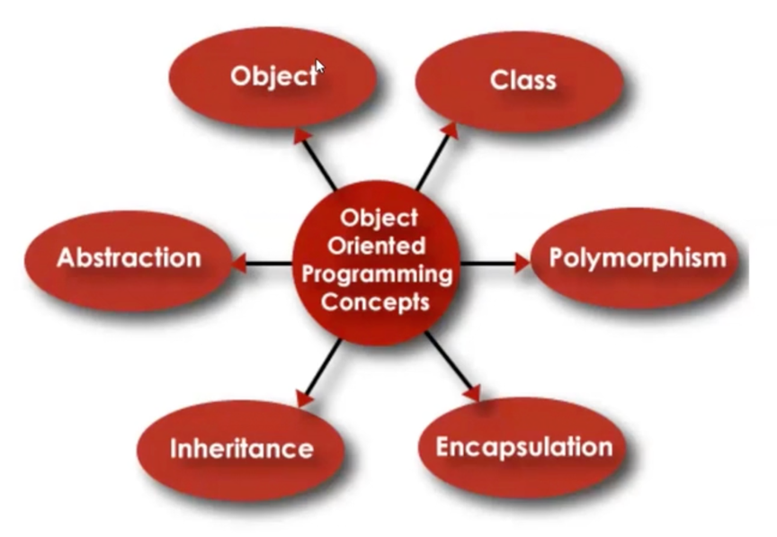

* Data encapsulationis the mechanism of hiding the internal data of objects from the world. All interaction with the object and its data are performed through its public methods. Encapsulation allows programmers to protect the object from inconsistency.
* Data abstractionmeans that objects should provide the simplified, abstract version of their implementations. The details of their internal work usually aren't necessary for the user, so there's no need to represent them. Abstraction also means that only the most relevant features of the object will be presented.
* Inheritanceis a mechanism for defining parent-child relationships between classes. Often objects are very similar, so inheritance allows programmers to reuse common logic and at the same time introduce unique concepts into the classes.
* Polymorphism literally means one name and many forms, and it concerns the inheritance of the classes. Just as the name suggests, it allows programmers to define different logic of the same method. So, the name (or interface) stays the same, but the actions performed may be different. In practice, it is done with overloading or overriding.

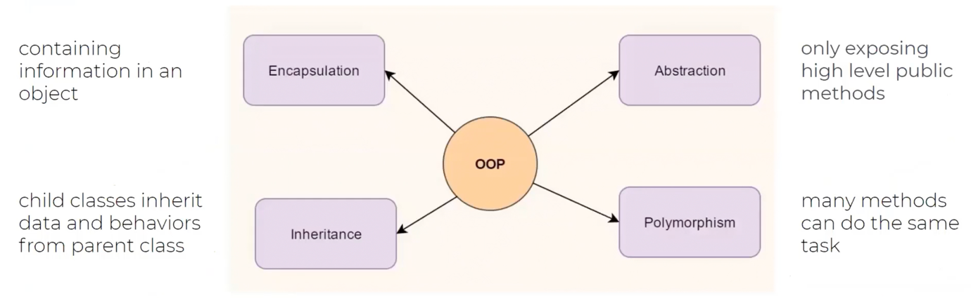

**💡Tips:**

* These are the key concepts of OOP. Each object-oriented language implements these principles in its own way, but the essence stays the same from language to language.

### Objects

The key notion of the OOP is, naturally, an **object.**There are a lot of real-world objects around you: pets, buildings, cars, computers, planes, you name it. Even a computer program may be considered as an object.

It's possible to identify some important characteristics of real-world objects. For instance, for a building, we can consider a number of floors, the year of construction and the total area. Another example is a plane that can accommodate a certain number of passengers and transfer you from one city to another.

These characteristics constitute the object's attributes and methods. Attributes characterize objects' data or states, and

Methods — its behavior.

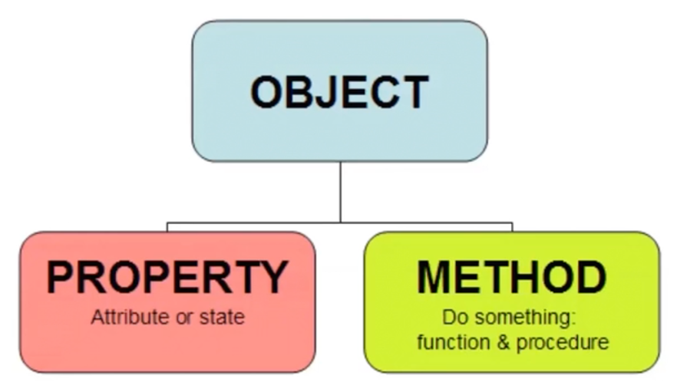

**💡Tips:**

* In OOP, everything can be considered an object.

Programs are made from different objects interacting with each other. An object's state and behavior are usually placed together, but it's not always so. Sometimes, we will see objects without a state or method. This, of course, depends on the purpose of the program and the nature of an object.

### Classes

Often, many individual objects have similar characteristics. We can say these objects belong to the same **type** or **class**.

A class is another important notion of OOP. A class describes a common structure of similar objects: their fields and methods. It may be considered a template or a blueprint for similar objects. An object is an individual **instance** of a class.

Let's look at some examples below:

**Example 1. The building class**



**An abstract building for describing buildings as a type of object (class)**

Each building has the same attributes:

* the number of floors (an integer number);
* area (a floating-point number, square meters);
* year of construction (an integer number).

Each object of the building type has the same attributes but different values.

For instance:

* Building 1: the number of floors = 4, area = 2400.16, year of construction = 1966;
* Building 2: the number of floors = 6, area = 3200.54, year of construction = 2001.

**💡Tips:**

* It's quite difficult to determine the behavior of a building. But this example demonstrates attributes pretty well.

**Example 2. The plane class**

Unlike the building, it is easy to define the behavior of a plane. It can fly and transfer you between two points on the planet.



**An abstract plane for describing all planes as a type of object (class)**

Each plane has the following attributes:

* a name (a string, for example, "Airbus A330" or "Boeing 737");
* passengers capacity (an integer number);
* standard speed (an integer number);
* current coordinates (they are needed to navigate).

Also, it has a behavior (a method): transferring passengers from one geographical point to another. This behavior changes the state of a plane, namely, its current coordinates.

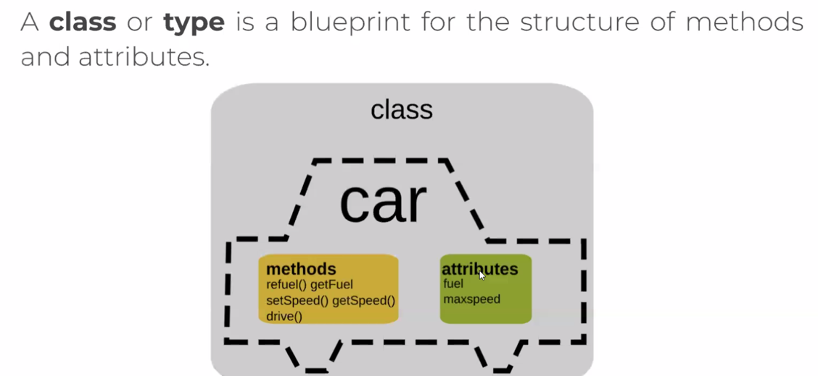

RECAP:

⚠️ Attention !:

To put it concisely, you should remember the following:

* an object-oriented program consists of a set of interacting objects;
* as a rule, the internal state of an object is hidden;
* an object may have characteristics: fields and methods;
* an object is an instance of a class (type);
* a class is a more abstract concept than an individual object; it may be considered a template or blueprint that describes the common structure of a set of similar objects.

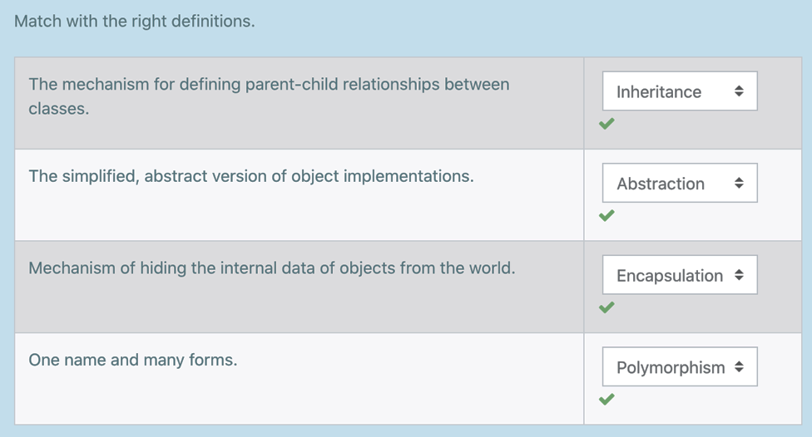

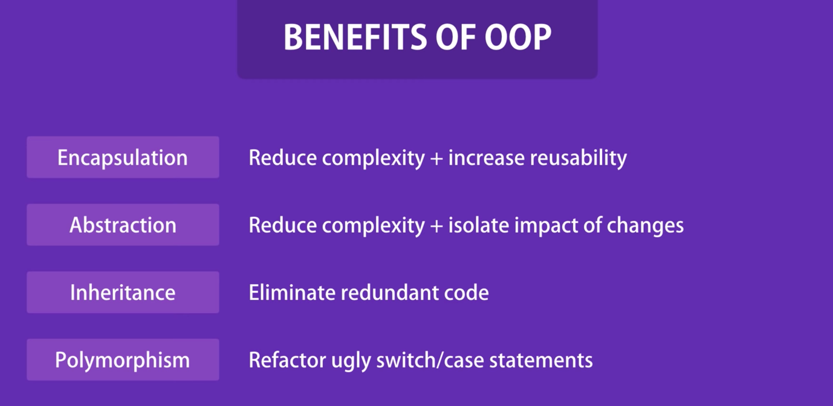

### Encapsulation

Once you enter the software development, you will most likely start sharing your code with other programmers. Sometimes, being unaware of your intentions, they might use the code in unexpected ways.

It could be such a shame when you discover that they've changed the variables and called the methods from inner implementation that you were hoping they wouldn't use. Here comes the question: can your code be more precise about what parts of it are for the public access and what are not?

**💡Tips:**

* Most programming languages that implement the object-oriented paradigm can provide you with those tools.